**Docker**

Docker is an open-source **containerization platform** that packages an application and all its dependences including libraries and configuration files into a single standardized unit called a container, ensuring the application runs seamlessly across any environment. Docker is an open-source platform designed to help developers build, share, and run container applications.

Docker is a container runtime technology that allows you to build, test and deploy applications faster than traditional methods. Docker is an open source containerization platform for developing, shipping, and running applications.

Docker is an OS‑level virtualization (or containerization) platform, which allows applications to share the host OS kernel instead of running a separate guest OS like in traditional virtualization. This design makes Docker containers lightweight, fast, and portable, while keeping them isolated from one another.

Docker is a software platform that allows you to build, test, and deploy applications quickly. Docker packages software into standardized units called [containers](https://aws.amazon.com/containers/) that have everything the software needs to run including libraries, system tools, code, and runtime. Using Docker, you can quickly deploy and scale applications into any environment and know your code will run.

**Containerization:**

Containerization is a software deployment process that bundles an application’s code with all the files and libraries it needs to run on any infrastructure. Traditionally, to run any application on your computer, you had to install the version that matched your machine’s operating system. For example, you needed to install the Windows version of a software package on a Windows machine. However, with containerization, you can create a single software package, or [container](https://aws.amazon.com/containers/), that runs on all types of devices and operating systems. The primary and most popular containerization tool is Docker.

Containerization is the packaging of software code with just the operating system (OS) libraries and dependencies required to run the code to create a single lightweight executable called a [container](https://www.ibm.com/topics/containers) that runs consistently on any infrastructure.

Containerization is packaging an application with its dependencies, such as libraries and other binaries, into a single unit called a[container](https://www.simplilearn.com/tutorials/docker-tutorial/containers-in-devops). Containers (each package) allow for consistent development and deployment environments for applications, and they are isolated from each other and can run on any platform supporting container technology.

Containerization has many benefits, including portability, increased security, and improved resource utilization. Containers are lightweight and can be quickly deployed, and they are also easy to scale up or down as needed. This Containerization enables the application to run quickly and reliably from one environment to another without the need to install and configure dependencies separately.

Containerization also makes deploying and scaling applications easy, as all the dependencies are packaged together. Containerization is becoming increasingly popular as a way to package and deploy applications. Many companies are using containers to ship their applications to customers.

**What are the benefits of containerization?**

Developers use containerization to build and deploy modern applications because of the following advantages.

* **Portability:** Software developers use containerization to deploy applications in multiple environments without rewriting the program code. They build an application once and deploy it on multiple operating systems. For example, they run the same containers on Linux and Windows operating systems. Developers also upgrade legacy application code to modern versions using containers for deployment.
* **Scalability:** Containers are lightweight software components that run efficiently. For example, a virtual machine can launch a containerized application faster because it doesn't need to boot an operating system. Therefore, software developers can easily add multiple containers for different applications on a single machine. The container cluster uses computing resources from the same shared operating system, but one container doesn't interfere with the operation of other containers.
* **Fault tolerance:** Software development teams use containers to build fault-tolerant applications. They use multiple containers to run microservices on the cloud. Because containerized microservices operate in isolated user spaces, a single faulty container doesn't affect the other containers. This increases the resilience and availability of the application.
* **Agility:** Containerized applications run in isolated computing environments. Software developers can troubleshoot and change the application code without interfering with the operating system, hardware, or other application services. They can shorten software release cycles and work on updates quickly with the container model.

**What are containerization use cases?**

The following are some use cases of containerization.

* **Cloud migration:** Cloud migration, or the*lift-and-shift* approach, is a software strategy that involves encapsulating legacy applications in containers and deploying them in a cloud computing environment. Organizations can modernize their applications without rewriting the entire software code.
* **Adoption of microservice architecture:** Organizations seeking to build cloud applications with microservices require containerization technology. The microservice architecture is a software development approach that uses multiple, interdependent software components to deliver a functional application. Each microservice has a unique and specific function. A modern cloud application consists of multiple microservices. For example, a video streaming application might have microservices for data processing, user tracking, billing, and personalization. Containerization provides the software tool to pack microservices as deployable programs on different platforms.
* **IoT devices:** Internet of Things (IoT) devices contain limited computing resources, making manual software updating a complex process. Containerization allows developers to deploy and update applications across IoT devices easily.

**Container Image:**

A container image is a standardized package or template that includes all of the files, binaries, libraries, and configurations to run a container. It is used to create one or more containers.

A Docker container image is a lightweight, standalone, executable package of software that includes everything needed to run an application: code, runtime, system tools, system libraries and settings. Container images become containers at runtime and in the case of Docker containers – images become containers when they run on [Docker Engine](https://www.docker.com/products/container-runtime). Available for both Linux and Windows-based applications, containerized software will always run the same, regardless of the infrastructure. Container image can now run on any host with Docker installed on it and is guaranteed to run the same way everywhere.

A [Docker Image](https://www.geeksforgeeks.org/devops/what-is-docker-image/)is a file made up of multiple layers that contains the instructions to build and run a Docker container. It acts as an executable package that includes everything needed to run an application — code, runtime, libraries, environment variables, and configurations.

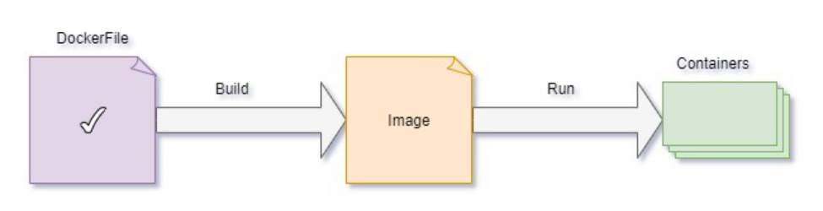

There are two important principles of images:

1. Images are immutable. Once an image is created, it can't be modified. You can only make a new image or add changes on top of it.
2. Container images are composed of layers. Each layer represents a set of file system changes that add, remove, or modify files.

**Containers:**

A container is a standard unit of software that packages an application’s code along with its dependencies, configuration files, and libraries, allowing it to run consistently across different computing environments. Containers create isolated environments for applications, enhancing security, consistency, and portability. They enable developers to deploy applications seamlessly, ensuring that the application works the same way regardless of where it is run.A container is a standard unit of software that packages up code and all its dependencies, so the application runs quickly and reliably from one computing environment to another.

[Containers](https://www.ibm.com/think/topics/containers) are standardized, executable components that combine application source code with the operating system (OS) libraries and dependencies required to run that code in any environment. Containers are running instances of images that are isolated and have their own environments and set of processes. Diff types of containers are LXC, LXD, LXCFC etc. Docker utilizes LXC containers.

A [Docker Container](https://www.geeksforgeeks.org/devops/docker-containers-shells/)is a lightweight, runnable instance of a Docker Image. It packages the application code together with all its dependencies and runs it in an isolated environment. Containers allow applications to run quickly and consistently across different environments — whether on a developer’s laptop, test servers, or production.

* A container is created when a **Docker Image is executed**.
* It runs as an isolated process on the host machine but shares the host’s operating system kernel.
* Multiple containers can run on the same system without interfering with each other.

[Containers](https://www.ibm.com/topics/containers) are lightweight, executable application components that combine application source code with all the operating system (OS) libraries and dependencies required to run the code in any environment. Containers are a powerful way for developers to package and deploy their applications. They are lightweight and provide a consistent, portable software environment for applications to easily run and scale anywhere.

Containers isolate software from its environment and ensure that it works uniformly despite differences for instance between development and staging. Docker containers that run on Docker Engine:

* **Standard**: Docker created the industry standard for containers, so they could be portable anywhere
* **Lightweight**: Containers share the machine’s OS system kernel and therefore do not require an OS per application, driving higher server efficiencies and reducing server and licensing costs
* **Secure**: Applications are safer in containers and Docker provides the strongest default isolation capabilities in the industry

A Container is a lightweight, standalone package that encapsulates a complete runtime environment including an application and its dependencies (libraries, binaries, and any additional configuration files), increasing an application’s portability, scalability, security, and agility. Containers are similar to virtual machines except they all share the same OS kernel.

**What’s the Difference Between Docker Images and Containers?**

Docker images and containers are application deployment technologies. Traditionally, to run any application, you had to install the version that matched your machine’s operating system. However, now you can create a single software package, or container, that runs on all types of devices and operating systems. Docker is a software platform that packages software into containers. Docker images are read-only templates that contain instructions for creating a container. A Docker image is a snapshot or blueprint of the libraries and dependencies required inside a container for an application to run.

An image is a package or a template just like a VM template that you might have worked with in the virtualization world. It is used to create one or more containers. Containers are running instances of images that are isolated and have their own environments and set of processes.

* **Docker Image** → Blueprint (static, read-only).
* **Docker Container** → Running instance of that image (dynamic, executable)

**Comparing Containers and Virtual Machines:**

Containers and virtual machines have similar resource isolation and allocation benefits, but function differently because containers virtualize the operating system instead of hardware. Containers are more portable and efficient.

**CONTAINERS**: Containers are an abstraction at the app layer that packages code and dependencies together. Multiple containers can run on the same machine and share the OS kernel with other containers, each running as isolated processes in user space. Containers take up less space than VMs (container images are typically tens of MBs in size), can handle more applications and require fewer VMs and Operating systems.

**VIRTUAL MACHINES**: Virtual machines (VMs) are an abstraction of physical hardware turning one server into many servers. The hypervisor allows multiple VMs to run on a single machine. Each VM includes a full copy of an operating system, the application, necessary binaries and libraries – taking up tens of GBs. VMs can also be slow to boot.

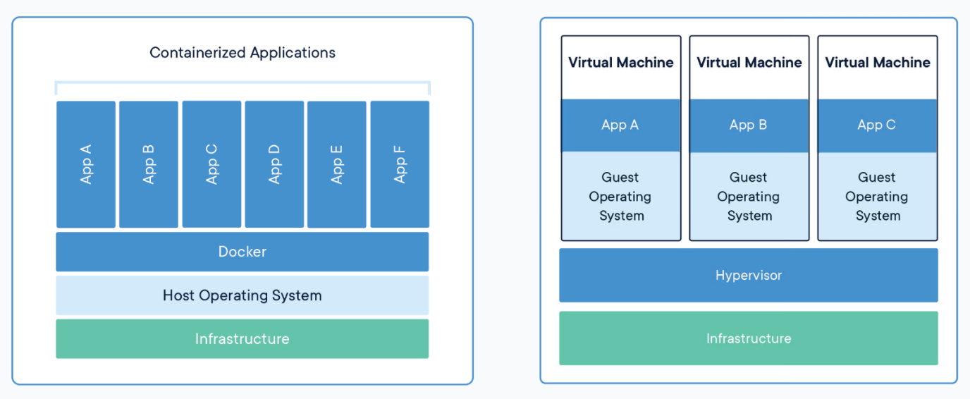

In case of virtual machines. We have the hypervisor like EXS on the hardware and then the virtual machines on them. As you can see each virtual machine has its own OS inside it. Then the dependencies and then the application the overhead causes higher utilization of underlying resources as there are multiple virtual operating systems and kernel running the virtual machines also consume higher this space as each VM is heavy and is usually in gigabytes in size whereas docker containers are lightweight and are usually in megabytes in size. This allows Docker containers to boot up faster usually in a matter of seconds whereas VMs as we know takes minutes to boot up as it needs to boot up the entire operating system.

Unlike hypervisors, Docker is not meant to virtualize and run different operating systems and kernels on the same hardware. The main purpose of Docker is to package and containerize applications and to ship them and to run them anywhere, anytime, as many times as you want. It is also important to note that Docker has less isolation as more resources are shared between the containers, like the kernel, whereas VMs have complete isolation from each other since VMs don't rely on the underlying OS or kernel. You can run different types of applications built on different OSes, such as Linux based or windows-based apps on the same hypervisor.

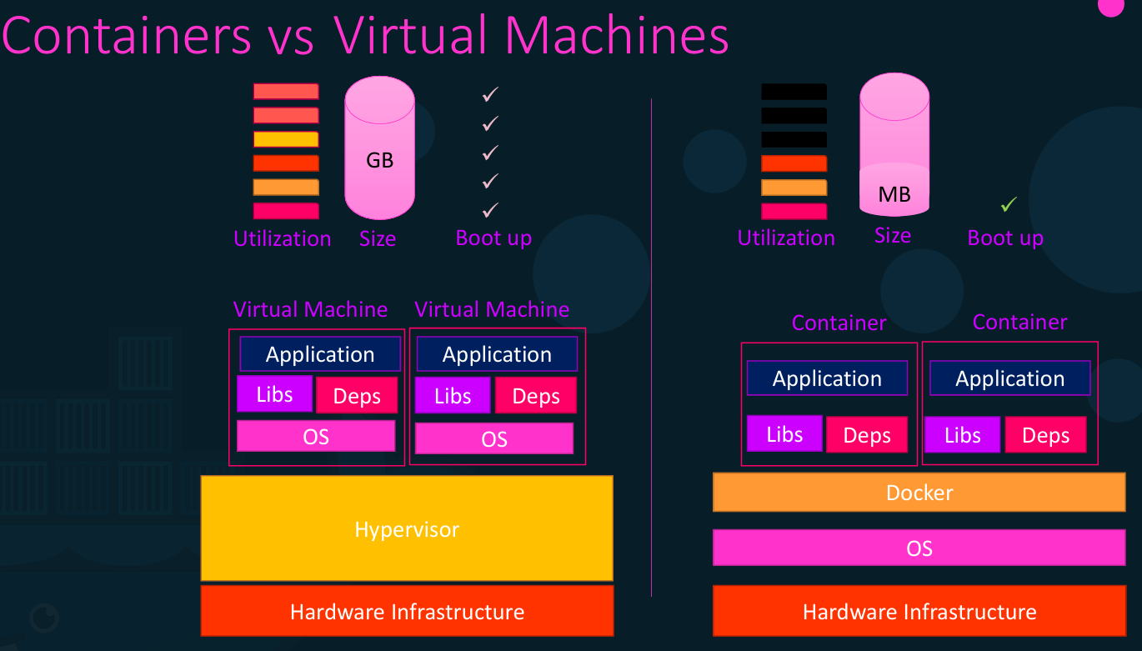

**Containers and Virtual Machines Together**

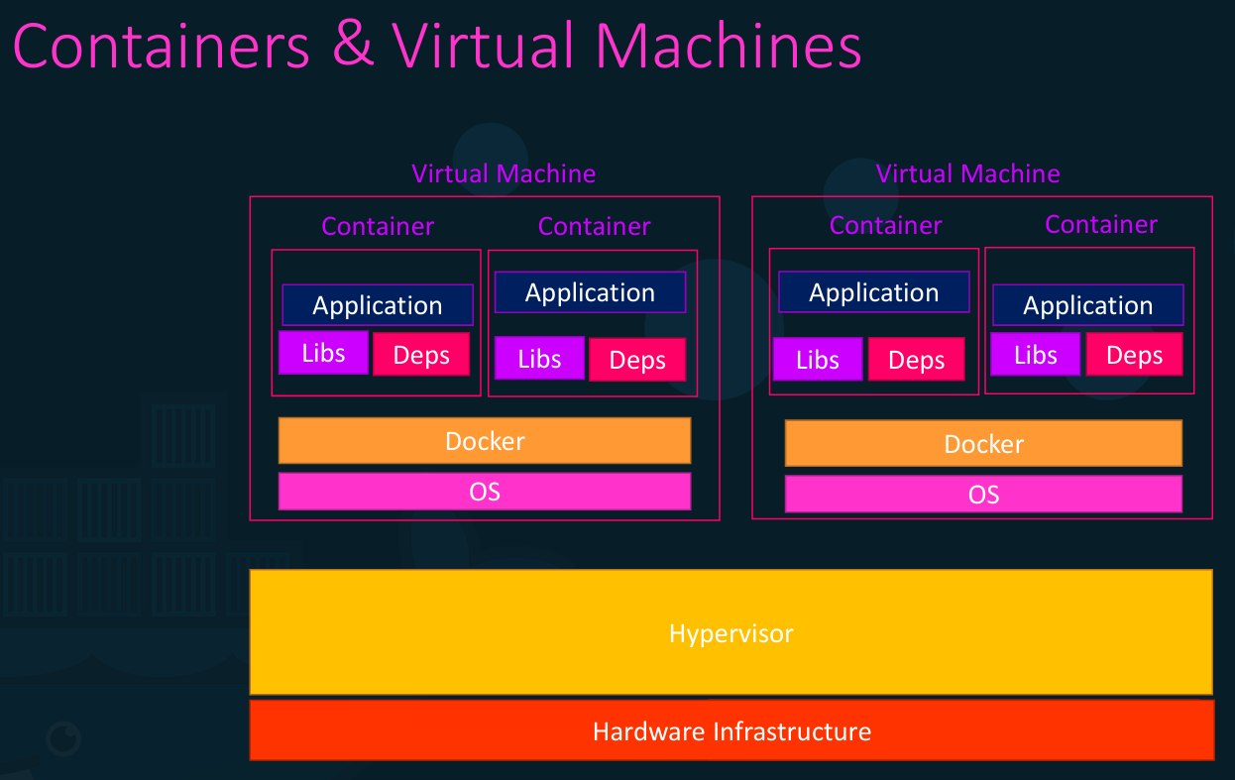

Containers and VMs used together provide a great deal of flexibility in deploying and managing apps. So, it's not an either container or virtual machine situation. It's containers and virtual machines. Now when you have large environments with thousands of application containers running on thousands of docker hosts you will often see containers provisioned on virtual docker hosts. That way we can utilize the advantages of both technologies we can use the benefits of virtualization to easily provision or decommission docker hosts as required at the same time make use of the benefits of Docker to easily provision applications and quickly scale them as required. Containers and VMs used together provide a great deal of flexibility in deploying and managing apps. But remember that in this case we will not be provisioning that many virtual machines as we used to before because earlier, we provisioned a virtual machine for each application. Now you might made provision a virtual machine for hundreds or thousands of containers.

**Docker and Kubernetes: How They Work Together**

Docker and Kubernetes are two of the most popular technologies for containerized development. Docker is used to package applications into containers, while Kubernetes is used to orchestrate and manage those containers in production.

Kubernetes changed how we develop and deploy containerized applications, providing a powerful orchestration platform that automates tasks such as scaling, load balancing, and self-healing. To realize the full potential of Kubernetes orchestration, your applications must be well-prepared and efficiently and securely developed from the start. That’s where Docker’s development tools come into play.

Docker is the original container engine that powers Kubernetes. Over the years, Docker’s suite of developer tools has significantly evolved to provide a comprehensive ecosystem for building, shipping, and running secure containers. Leveraging Docker’s tools with Kubernetes orchestration, developers can streamline the development process, ensure application security, and accelerate deployment.

**A harmonious development and deployment process**

Docker and Kubernetes work in harmony to create a complete ecosystem for containerized development, deployment, and management. Once developers have packaged their applications into secure containers using Docker, Kubernetes can orchestrate these containers, automating much of the work involved in managing and deploying them in production.

The benefits organizations will see from these seamless workflows include:

* **Streamlined development**: Features like automated builds, vulnerability recommendations, and consistent environments help speed up developer efficiency. They no longer have to manage multiple environments and tools, and they know certain tasks will be delivered in a consistent manner.
* **Improved application security**: Developers experience fewer disruptions in production because problems are identified and fixed earlier in their build process. Additionally, using a repository like Docker Hub helps developers avoid using insecure images that could contain malware or other vulnerabilities.
* **Accelerated deployment**: Because developers are more efficient and productive upfront, they deploy more rapidly against their schedule. Developers are freed to work on more complex and interesting tasks, while Docker and Kubernetes’ automation capabilities handle the more tedious work.

Kubernetes offers orchestration capabilities for container-based applications, including automated deployment and scaling (with minimal errors). The Docker platform complements Kubernetes, enhancing development, security, and efficiency.

Using Docker with Kubernetes helps to:

* Stabilize development environments
* Streamline testing
* Reduce errors
* Optimize resource usage

Docker and Kubernetes are better together, providing powerful capabilities that enable rapid deployment, scalability, consistency, and security.

**Docker Desktop:**

**Docker Desktop** is a local development platform that lets you build, run, test, and debug containerized applications on your laptop (Windows, macOS, Linux) without setting up servers or complex tooling.

An application that provides the entire environment needed to develop and run Linux, Windows, and macOS containers locally. Docker Desktop provides a consistent and secure environment for developers to build and test their applications and automates many of the tasks needed to set up a container.

Docker Desktop is an easy-to-install application for your Mac, Windows, or Linux environment that enables you to build and share containerized applications and microservices. Docker Desktop includes the Docker daemon (dockerd), the Docker client (docker), Docker Compose, Docker Content Trust, Kubernetes, and Credential Helper.

Docker Desktop is a one-click-install application for your Mac, Linux, or Windows environment that lets you build, share, and run containerized applications and microservices.

It provides a straightforward GUI (Graphical User Interface) that lets you manage your containers, applications, and images directly from your machine.

Docker Desktop reduces the time spent on complex setups so you can focus on writing code. It takes care of port mappings, file system concerns, and other default settings, and is regularly updated with bug fixes and security updates.

Docker Desktop integrates with your preferred development tools and languages, and gives you access to a vast ecosystem of trusted images and templates via Docker Hub. This empowers teams to accelerate development, automate builds, enable CI/CD workflows, and collaborate securely through shared repositories.

**Key features**

* Ability to containerize and share any application on any cloud platform, in multiple languages and frameworks.
* Quick installation and setup of a complete Docker development environment.
* Includes the latest version of Kubernetes.
* On Windows, the ability to toggle between Linux and Windows containers to build applications.
* Fast and reliable performance with native Windows Hyper-V virtualization.
* Ability to work natively on Linux through WSL 2 on Windows machines.
* Volume mounting for code and data, including file change notifications and easy access to running containers on the localhost network.

**Products inside Docker Desktop**

* Docker MCP Toolkit and Catalog
* Docker Model Runner
* Ask Gordon
* Docker Offload
* Docker Engine
* Docker CLI client
* Docker Build
* Docker Compose
* Docker Scout
* Kubernetes

An Operating System (OS) is core software that manages computer hardware and software resources, acting as a bridge between users and the machine by handling tasks like memory, processes, files, and devices, making it possible to run applications and use the computer efficiently, with examples being Windows, macOS, and Linux. It works through a central part called the kernel, which manages hardware, and provides an interface (GUI/CLI) for users, ensuring smooth, secure, and efficient operation for multiple tasks simultaneously. If you look at operating systems like ubuntu, fedora, Suse or CentOS, they all consist of two things an OS kernel and a set of software. The OS kernel is responsible for interacting with the underlying hardware, while the OS kernel remains the same, which is Linux. In this case, it's the software above it that makes these operating systems different. This software may consist of a different user interface, drivers, compilers, file managers, developer tools, etc. so you have a common Linux kernel shared across all OSes and some custom software that differentiate operating systems from each other.

**Core Functions**

* **Resource Management**: Allocates CPU time (Process Scheduling), RAM (Memory Management), storage, and I/O devices (like printers, keyboards) to different programs.
* **Process Management**: Manages running applications (processes), switching between them rapidly (multitasking) so they seem simultaneous.
* **File Management**: Organizes, stores, retrieves, and protects files and folders.
* User Interface: Provides a way for users to interact with the computer, either graphically (GUI) or via text commands (CLI).
* **Security**: Controls access, authenticates users, and protects system resources and data.

**Key Components**

* **Kernel**: The core, always running component that directly controls hardware and manages system calls from applications. A kernel is a computer program at the core of a computer's operating system that always has complete control over everything in the system. The kernel is also responsible for preventing and mitigating conflicts between different processes.
* **Shell**: The user interface (like the Windows Desktop or Linux Terminal) that communicates with the kernel.
* **Drivers**: Software that lets the OS communicate with specific hardware (e.g., graphics card, Wi-Fi).

**Kernel Sharing: The Foundation of Containers**

At the core of containerization is the concept of kernel sharing. Containers share the underlying kernel of the host operating system, providing a lightweight and efficient way to isolate applications. So, what does that actually mean? Sharing the kernel. Let's say we have a system with an ubuntu OS with Docker installed on it. Docker can run any flavor of OS on top of it, as long as they are all based on the same kernel in this case, Linux. If the underlying OS is ubuntu docker can run a container based on another distribution like Debian, fedora, Susi or CentOS. Each Docker container only has the additional software that makes these operating systems different. And Docker utilizes the underlying kernel of the Docker host which works with all OSs above.  
  
However, this is where the limitations arise when it comes to Windows and Linux. Windows and Linux have fundamentally different kernels, each designed to handle specific hardware and software requirements. These differences make it impossible for a Linux kernel to directly support Windows applications, and vice versa.

Containers share the underlying OS kernel and as a result we cannot have a windows container running on Linux host or vice versa. Containers are using the underlying operating system resources and drivers, so Windows containers can run on Windows only, and Linux containers can run on Linux only. Docker for Windows allows you to simulate running Linux containers on Windows, but under the hood a Linux VM is created, so still Linux containers are running on Linux, and Windows containers are running on Windows.

**Why Linux Containers Can Run On Windows Host?**

The key point is that Docker container typically share the same underlying kernel as the host operating system.

1. **On Linux hosts**: Docker containers share the host Linux kernel directly. The exact kernel version depends on the host OS distribution and version.
2. **On Windows and macOS**: Docker uses a lightweight Linux VM (Moby VM) to run Linux containers, and all containers share the kernel of this VM. The Moby VM uses a custom Linux kernel based on LinuxKit and uses Hyper-V technologies on Windows.

**How Linux Container Run On Windows ?**

1. When you run a Linux container on Windows, Docker creates a new instance of the Moby VM if it’s not already running. This VM acts as a bridge between the Windows host and the Linux container.
2. The Linux container then runs inside this VM, sharing its kernel and resources
3. From the perspective of the container, it appears to be running natively on Linux, even though it’s actually running in a VM on Windows
4. The Docker client on Windows communicates with the Docker daemon running inside the Moby VM to manage the containers

**Docker Commands:**To list the help on any command just execute the command, followed by the --help option. For example, $ docker –help, $ docker run --help

The **docker run** command is used to create and run a new container from an image. You were able to run a single instance of an application using the docker CLI by running the **docker run** command.

Running the **docker run nginx** command will run an instance of the nginx application on the docker host If it already exists. If the image is not present on the host it will go out to docker hub and pull that image down. So, you can simply run a **docker run centos**. And that should first try and find out if there's a CentOS image available locally. If not, it's just going to go out and download the latest image or latest version of the CentOS image. But this is only done the first time, for the subsequent executions the same image will be reused. Say you were to run a docker container from an ubuntu image when you run the **docker run ubuntu** command it runs an instance of ubuntu image and exits immediately. If you were to list the running containers (**docker ps**) you wouldn't see the container running. If you list all containers (**docker ps -a**) including those that are stopped, you will see that the new container you ran is in an exited stage. Now why is that unlike virtual machines. Containers are not meant to host an operating system. Containers are meant to run a specific task or process such as to host an instance of a web server or application server or a database or simply to carry some kind of computation or analysis task. Once the task is complete the container exits a container only lives as long as the process inside it is alive. If the web service inside the container is stopped or a crash then the container exits. This is why when you run a container from an ubuntu image it stops immediately because Ubuntu is just an image of an operating system that is used as the base image for other applications. There is no process or application running in it by default. If the image isn't running any service as is the case with ubuntu you could instruct Docker to run a process with the docker run command for example a sleep command with a duration of five seconds (**docker run ubuntu sleep 5**). When the container starts it runs to sleep command and goes into sleep for five seconds post to it the sleep command exits and the container stops. What we just saw was executing a command when we run the container.

We could use the **docker run redis** command to run a container, running a redis service (creates a new container from the redis image). This command pulls the **latest version of the redis image** from Docker Hub (if it is not already available locally) and starts a new redis container using that image. But what if we want to run another version of this? Like, for example, an older version, say, 4.0. Then you specify the version separated by a colon. This is called a tag. In that case, Docker pulls an image of the 4.0 version of redis and runs that (**docker run redis:4.0**). Also notice that if you don't specify any tag as in the first command, Docker will consider the default tag to be latest. Latest is a tag associated to the latest version of that software, which is governed by the authors of that software.

By default, the Docker container does not listen to a **standard input (stdin)**, even though you are attached to its console. It is not able to read any input from you. It doesn't have a terminal to read inputs from. It runs in a non-interactive mode. If you'd like to provide your input, you must map the standard input of your host to the Docker container using the -it parameter. With the combination of -it, we are now attached to the terminal as well as in an interactive mode on the container.

The **docker run -it** command is used to start a container interactively with a terminal.   
For e.g. **docker run -it ubuntu bash** this command creates a new container from the ubuntu image and starts a bash shell inside it. **docker exec -it ubuntu bash** with this command you’ll be dropped inside an existing running ubuntu container’s Bash shell.

**docker exec <container_id> ps -eaf** command display a list of processes that are currently running inside the contained **docker exec -it =** start interactive terminal with currently running container  
**docker run -it =** create and run a new container and then start interactive terminal

The **--name** parameter in the docker run command is used to assign a custom name to a container. It makes the container **easier to identify** instead of using an auto-generated name. So you can **refer to the container by name** in other Docker commands (instead of using the container ID). In short, --name helps you manage containers more easily and clearly.   
For example,  
**>>** **docker run --name my_app nginx >> docker run -p 8080:8080 --name myjenkins jenkins/jenkins**

The **docker ps** command is used to list all running docker containers and some basic information about them such as the container I.D. the name of the image we used to run the containers, current status and the name of the container. Each container automatically gets a random I.D. and name created for it by Docker. To see all containers running or not use the -a option.The **docker ps -a** command is used to display all docker containers on your host, regardless of their current state. This outputs all running as well as previously stopped or exited containers.

The **docker stop** command is used to gracefully stop one or more running containers but you must provide either the container I.D. or the container name. The **docker start** command is used to start one or more stopped containers.

The **docker kill** command is used to immediately stop one or more running containers. The primary difference is that **docker stop** initiates a graceful shutdown, allowing the container time to clean up resources, whereas **docker kill** forces an immediate termination without a chance for cleanup.

The **docker rm** command is used to remove(delete) one or more containers form your system. The **docker rmi** command is used to remove(delete) one or more images form your system. But you must ensure that no containers are running off that image before attempting to remove the image. You must stop and delete all dependent containers to be able to delete an image.

The **docker images** command is used to see a list of available images and their sizes on your system(host). The underlying host where Docker is installed is called **Docker host** or **Docker engine**.

The **docker pull** command is used to download an image from a registry (i.e. docker hub) on our host. Use the docker pull command to only pull that image and not run the container with that image.

The **docker rename** command is used to change the name (rename) of an existing Docker container.

The **docker restart** command is used to restart one or more containers from your system.

The **docker create** command is used to create a new container from an image without starting it immediately.

The **docker exec** command is used to execute a command on a running container. Let's say you would like to see the content of the /etc/hosts file inside particular container run **docker exec <container_name> cat /etc/hosts** command. **docker exec =** enter a running container  
**docker run =** create and run a new container

The **docker build** command is used to build a Docker image from a Docker file

**>> docker build -t web-app .**

* **-t web-app**

-t stands for tag.

web-app is the name given to the Docker image.

* **. (dot)**

Specifies the current directory as the build context.

* Docker automatically looks for a file named **Dockerfile** in the current directory and executes the instructions inside it.

By default, Docker looks for a file named Dockerfile when building an image. If you want to use a Dockerfile with a different name, you must specify it using the -f (file) flag.

For example, to build a Docker image using a Dockerfile named Dockerfile2, use the following command:

**>> docker build -f Dockerfile2 -t web-app2 .**

The **docker push** command is used to upload an image to a registry. The docker push command is used to upload a Docker image from your local machine to a remote container registry (like Docker Hub, AWS ECR, or a private registry).

The **docker login** command is used to authenticate to registry so you can push or pull images. The **docker logout** command is used to log out from a Docker registry, removing the saved credentials from your system. This is useful if you’re switching accounts or want to secure your login info.

The **docker search** command is used to search for Docker images on a registry (like Docker Hub) from the command line. It helps you find official or community images that you can pull and use.

The **docker cp** command is used to copy files/folders between a container and the local filesystem

The **docker commit** is used to create a new image from a container's current state. This is useful if you’ve made changes inside a running container (like installing packages or modifying files) and want to save those changes as a new image.

To run the docker container in the **background (detached mode)**, use the -d flag (for e.g. **docker run -d <image_name>**). This will run the docker container in the background mode and you will be back to your prompt immediately. Now if you would like to attach back to the running container later run the **docker attach** command and specify the name or I.D. of the docker container. The **docker attach** command is used to attach local standard input, output, and error streams to a running container.

The **docker logs** command is used to fetch and view the logs generated by a Docker container, specifically capturing the application's STDOUT (standard output) and STDERR (standard error) streams. Use docker logs command and specify the container name or ID to see the logs of a container we run in the background (i.e. ran the container in a detached mode using -d flag)

**Port mapping or Port publishing on containers**

Port mapping or port publishing in Docker is used to make a container’s application accessible outside the Docker host. When you create or run a container using **docker create** or **docker run on Docker host.** Remember the underlying host where Docker is installed is called Docker host or Docker engine.Every Docker container gets an IP assigned by default. But remember that this is an internal IP and is only accessible within the Docker host, all ports of containers on bridge networks are accessible from Docker host and other containers connected to the same network. Ports are not accessible from outside the host or, with the default configuration, from containers in other networks. Since this is an internal IP, users outside of the Docker host cannot access it using this IP. For this, we could use the IP of the Docker host. But for that to work, you must have mapped the port inside the Docker container to a free port on the Docker host.

Use the **--publish** or **-p** flag **(-p hostPort:containerPort**) to make a port available outside the host, and to containers in other bridge networks. For example, if I want the users to access my application through Port 80 on my Docker host, I could map Port 80 of local host to port 5000 on the docker container using the -p parameter in my run command like this (**docker run -p 80:5000 redis**). All traffic on port 80 on my docker host will get routed to port 5000 inside the Docker container. This way you can run multiple instances of your application and map them to different ports on the docker host or run instances of different applications on different ports.

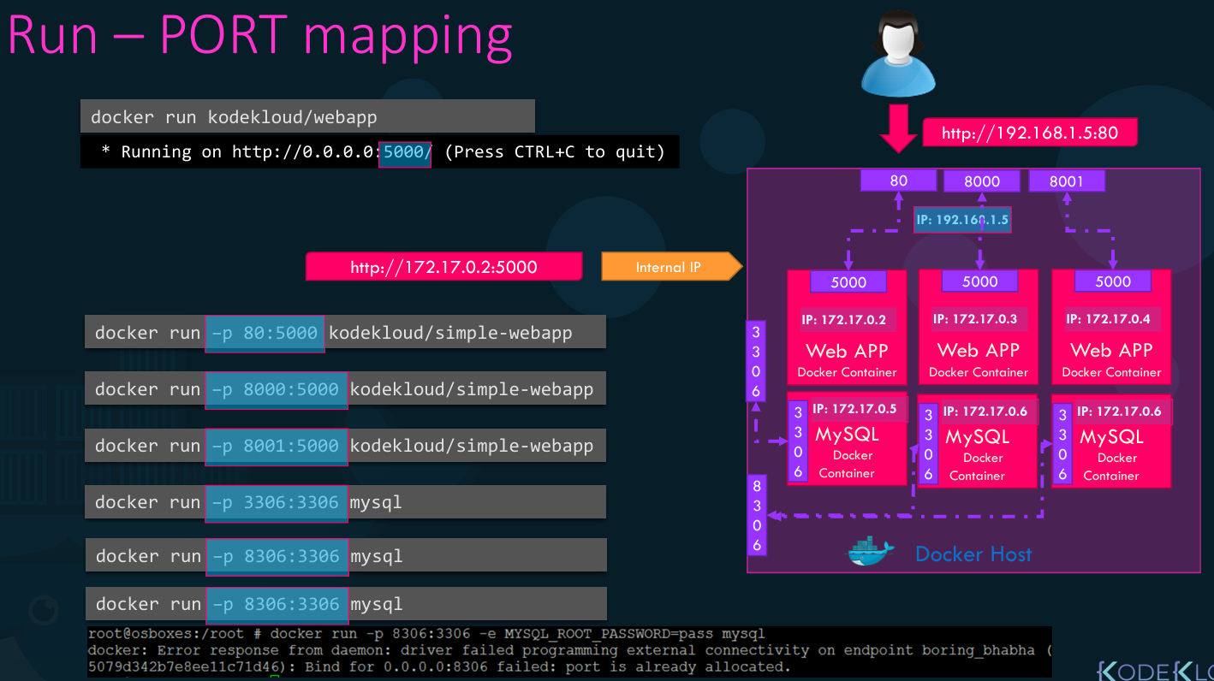

This creates a firewall rule in the host, mapping a container port to a port on the Docker host to the outside world. Here are some examples:

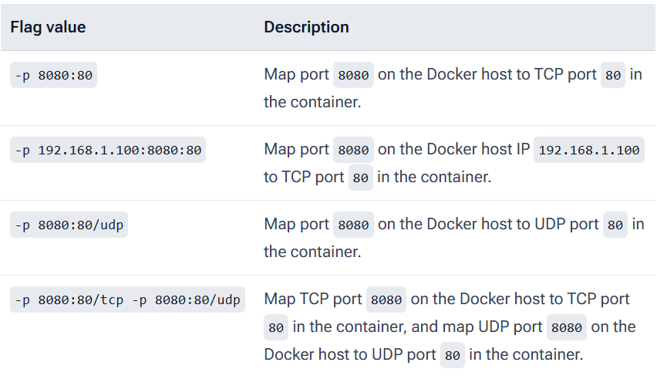

Run an instance of kodekloud/simple-webapp:blue and name the container blue-app, mapping port 8080 on the container to port 38282 on the host. You can run this container in the background after adding the -d flag. **>> docker run -d -p 38282:8080 --name blue-app kodekloud/simple-webapp:blue**

**Accessing containers through external web browser**

Users outside of the Docker host cannot access Docker container using container’s internal IP. For this, we could use the IP of the Docker host. But for that to work, you must have mapped the port inside the Docker container to a free port on the Docker host.

In WSL (Windows Subsystem for Linux), the Docker host is usually the WSL virtual machine itself, not Windows directly. Here are the common ways to find its IP address.

**Run this in your WSL terminal:**

>> hostname -I 

✅ **172.22.117.51 — WSL (Linux VM) IP**

* This is the WSL host IP
* Use this IP to access services running in Docker containers from outside WSL (for example, from Windows or another machine on the same network, if ports are exposed)

❌ **172.17.0.1 — Docker bridge IP**

* This is the Docker bridge (docker0) gateway
* It is used only for container ↔ host communication
* You generally cannot access containers externally using this IP

**Use 172.22.117.51 to access your container externally, assuming:**

* The container port is published (-p hostPort:containerPort)
* No firewall is blocking the connection

**A) Nginx container**

**1) Run nginx container using port mapping to access the container externally through Docker host IP**>> docker run -d -p 8080:80 nginx



**2) Check the container is up and running**

>> docker ps



**3) Access the container externally**To access the container use Docker host IP: Host post (i.e 172.22.117.51:8080)  
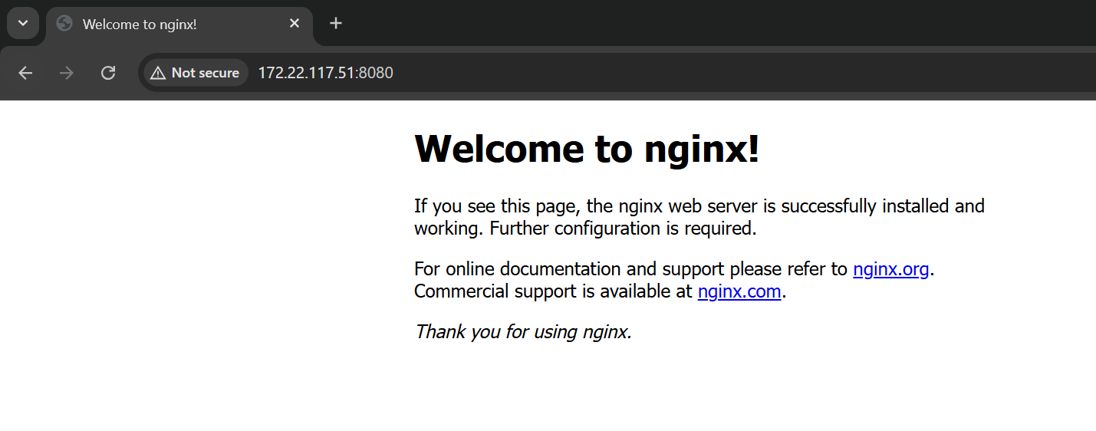

**4) Stop the container**

>> docker stop <container_id>

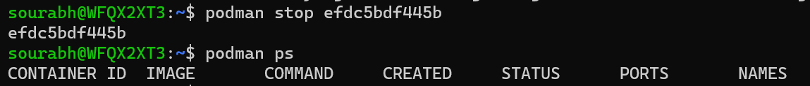

Once you stop the container you won’t able to access the container externally

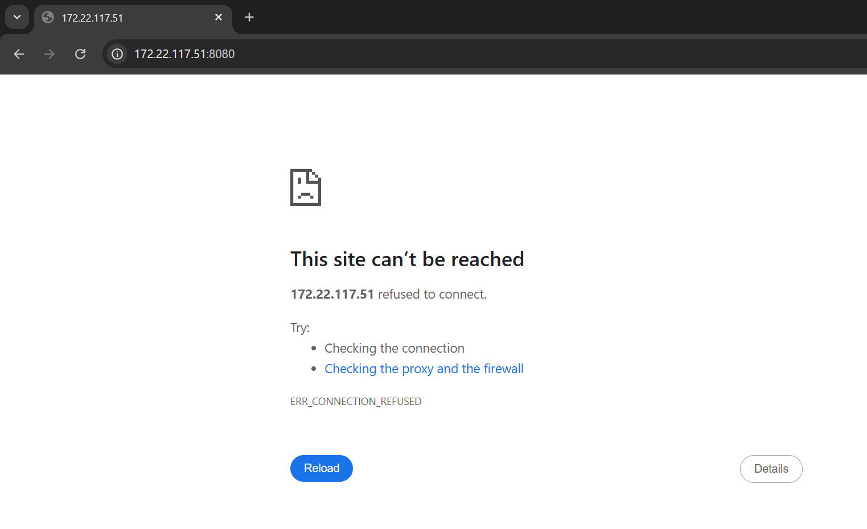

**B) Jenkins container**

**1) Run Jenkins container using port mapping**

>> docker run -d -p 8080:8080 jenkins/jenkins



**2) Check the container is up and running**

>> docker ps



3) **Access the container externally**To access the container use Docker host IP: Host post (i.e 172.22.117.51:8080) 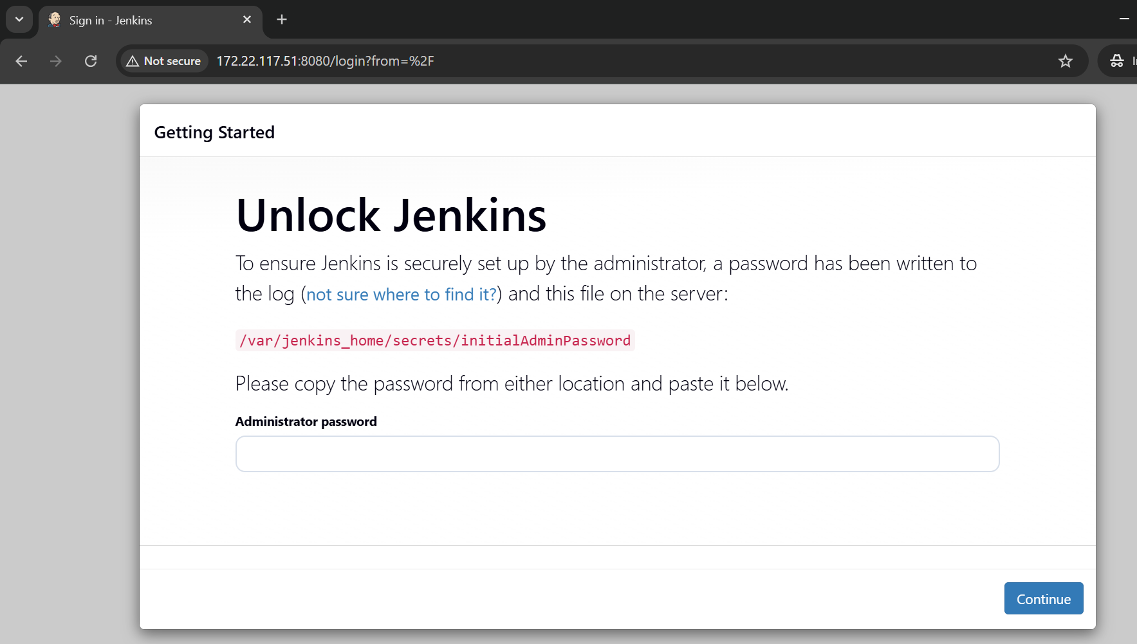

We can find the password in the output of the docker run command. Since the container was started in the background (detached mode) using the -d flag, the output was not visible. If you run the container after removing the -d flag, the password will be displayed in the output as shown below.

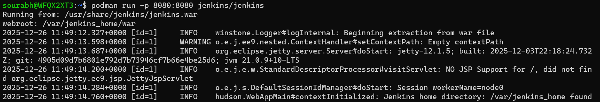

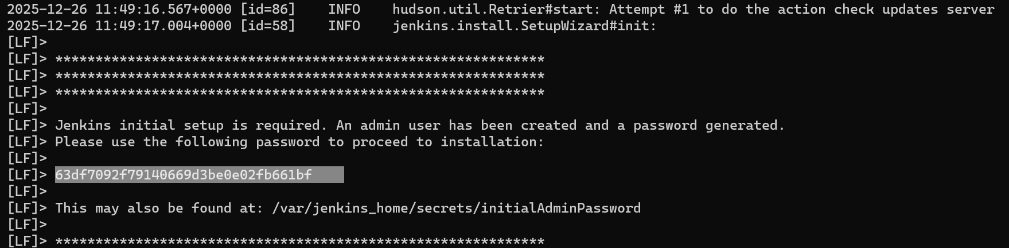

**4) Stop the container**

>> docker stop <container_id>



Once you stop the container you won’t be able to access the container externally.



**Volume mapping**

Let's now look at how data persisted in a Docker container. Volumes are persistent data stores for containers, created and managed by Docker.   
For example, let's say you were to run a MySQL container when databases and tables are created the data files are stored in location /var/lib/mysql inside the docker container. Remember, the docker container has its own isolated file system and any changes to any files happen within the container. Let's assume you dump a lot of data into the database. What happens if you were to delete the MySQL container and remove it? As soon as you do that, the container, along with all the data inside, gets blown away, meaning all your data is gone. If you would like to persist data, you would want to map a directory outside the container on the docker host to a directory inside the container. In this case, I create a directory called /opt/datadir and map that to /var/lib/mysql inside the docker container using the -v **(-v host_volume:container_volume**) option and specifying the directory on the Docker host followed by a colon and the directory inside the docker container. This way, when Docker container runs, it will implicitly mount the external directory to a folder inside the Docker container. This way all your data will now be stored in the external volume at /opt/datadir and thus will remain even if you delete the docker container.

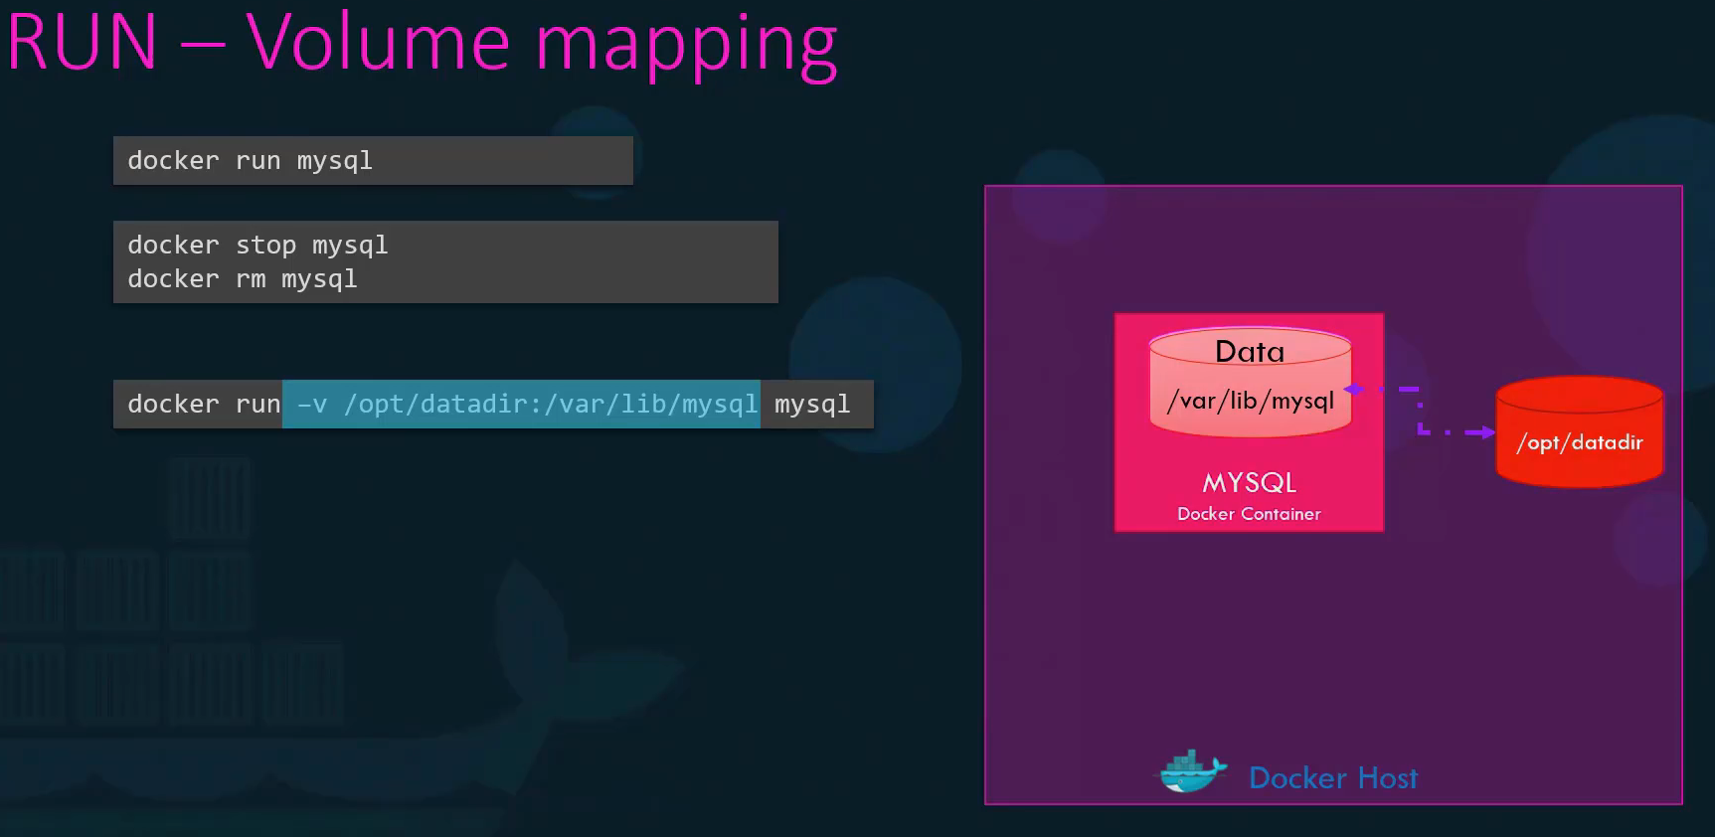

For e.g. run a jenkins container with port mapping **>> docker run -d -p 8080:8080 jenkins/jenkins** This will store the workspace in /var/jenkins_home. **So by default jenkins store the data in our jenkins_home inside of the jenkins container**. All jenkins data lives in there – including plugins and configuration. If you would like to persist data, you would want to map a directory outside the container on the docker host to a directory inside the container.

**>>** **docker run -p 8080:8080 -v /your/home:/var/jenkins_home jenkins/jenkins** This will store the data in /your/home directory on the host. This will automatically create a '/your/home' [docker volume](https://docs.docker.com/storage/volumes/) on the host machine. Docker volumes retain their content even when the container is stopped, started, or deleted. Ensure that the directory on the host is accessible by the jenkins user inside the container (jenkins user - uid 1000) or use -u some_other_user parameter with docker run.  
This shows that all the custom data generated by the Docker container is actually stored locally on the Docker host. As a result, every time a new Jenkins container is started, we can map the same folder, and Jenkins will automatically pick up all the existing configuration and data when the container runs.

**Inspect Container**

The docker ps command is good enough to get basic details about containers like their names and IDs. But if you'd like to see additional details about a specific container, use the **docker inspect** command and provide the container name or ID. It returns all details of a container in a JSON format, such as the state mounts configuration, data, network settings etc. By default docker inspect will render results in a JSON array. To find out the **internal IP of the docker** **container**, run the docker inspect command followed by the container ID. The Ip address can be found under the **Networks** section in the command output.

**Docker Images**

Docker builds images by reading the instructions from a Dockerfile. A Dockerfile is a plain text file containing a set of instructions used to build a Docker image. Docker file is a text file written in a specific format that Docker can understand. It's in an instruction and argument format. Each instruction defines a step in creating the image, such as selecting a base image (FROM), copying files (COPY), installing packages (RUN), or setting environment variables (ENV). A Dockerfile is a text document that contains all the commands a user could call on the command line to assemble an image.

A **Dockerfile** is a simple text file that contains a script of instructions for building a Docker image. Think of it as a **recipe** for creating your application's environment. The Docker engine reads this file and executes the commands in order, layer by layer, to assemble a final, runnable image. This automated process is the foundation of containerization's power, ensuring that your application runs the same way everywhere—from your local machine to a production server.

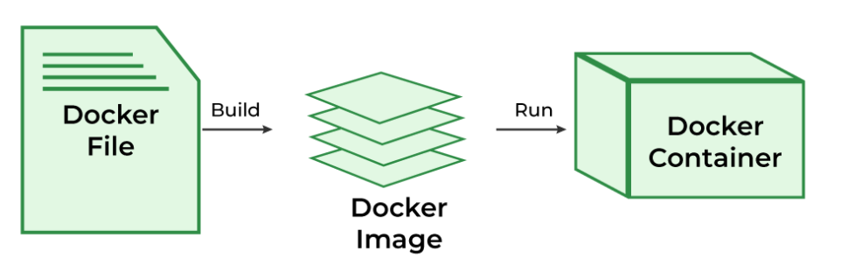

Before we dive into the instructions, let's quickly clarify two core concepts:

**1) Docker Image**: This is a lightweight, standalone, executable package that includes everything needed to run a piece of software: the code, runtime, system tools, libraries, and settings. It's the blueprint or the "cake" made from the Dockerfile recipe. Docker images consist of layers. Each layer is the result of a build instruction in the Dockerfile. Layers are stacked sequentially, and each one is a delta representing the changes applied to the previous layer. You can see this information if you run the docker history Command followed by the image name. All the layers built are cached by Docker. So in case a particular step was to fail and you were to fix the issue and rerun Docker build. It will reuse the previous layers from cache and continue to build the remaining layers. The same is true if you were to add additional steps in the Docker file. This way rebuilding your image is faster and you don't have to wait for Docker to rebuild the entire image each time. This is helpful, especially when you update source code of your application as it may change more frequently. Only the layers above the updated layers needs to be rebuilt.

**2) Docker Container**: This is a running instance of an image. You can create, start, stop, and delete containers. If the image is the cake, a container is a slice of that cake that you are actively using.

**The Dockerfile supports the following instructions.** The instruction is not case-sensitive. However, convention is for them to be UPPERCASE to distinguish them from arguments more easily. Each of these instruct Docker to perform a specific action while creating the image.

| **Instruction** | **Description** |
| --- | --- |
| [**ADD**](https://docs.docker.com/reference/dockerfile/#add) | Add local or remote files and directories. |
| [**ARG**](https://docs.docker.com/reference/dockerfile/#arg) | Use build-time variables. |
| [**CMD**](https://docs.docker.com/reference/dockerfile/#cmd) | Specify default commands. |
| [**COPY**](https://docs.docker.com/reference/dockerfile/#copy) | Copy files and directories. |
| [**ENTRYPOINT**](https://docs.docker.com/reference/dockerfile/#entrypoint) | Specify default executable. |
| [**ENV**](https://docs.docker.com/reference/dockerfile/#env) | Set environment variables. |
| [**EXPOSE**](https://docs.docker.com/reference/dockerfile/#expose) | Describe which ports your application is listening on. |
| [**FROM**](https://docs.docker.com/reference/dockerfile/#from) | Create a new build stage from a base image. |
| [**HEALTHCHECK**](https://docs.docker.com/reference/dockerfile/#healthcheck) | Check a container's health on startup. |
| [**LABEL**](https://docs.docker.com/reference/dockerfile/#label) | Add metadata to an image. |
| [**MAINTAINER**](https://docs.docker.com/reference/dockerfile/#maintainer-deprecated) | Specify the author of an image. |
| [**ONBUILD**](https://docs.docker.com/reference/dockerfile/#onbuild) | Specify instructions for when the image is used in a build. |
| [**RUN**](https://docs.docker.com/reference/dockerfile/#run) | Execute build commands. |
| [**SHELL**](https://docs.docker.com/reference/dockerfile/#shell) | Set the default shell of an image. |
| [**STOPSIGNAL**](https://docs.docker.com/reference/dockerfile/#stopsignal) | Specify the system call signal for exiting a container. |
| [**USER**](https://docs.docker.com/reference/dockerfile/#user) | Set user and group ID. |
| [**VOLUME**](https://docs.docker.com/reference/dockerfile/#volume) | Create volume mounts. |
| [**WORKDIR**](https://docs.docker.com/reference/dockerfile/#workdir) | Change working directory. |

The **default filename** to use for a Dockerfile is Dockerfile, without a file extension. Using the default name allows you to run the docker build command without having to specify additional command flags.

In the Docker file, everything on the left in caps is an instruction in this case and everything on the right is an argument to those instructions.

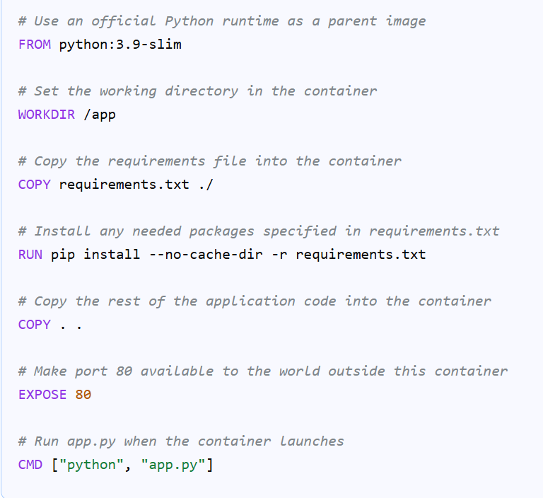

Here are some of the most common ones you’ll use explained in more detail:

**1) FROM <image>** (Defines a base for your image.)  
FROM is usually the first line in your Dockerfile. It's important to note that all Dockerfiles must start with a FROM instruction. It refers to an existing image that becomes the base for your build. All subsequent instructions apply on top of the referenced image’s filesystem.



**2) COPY <source> <destination>** (Copy files and directories)

Copies new files or directories from <source> and adds them to the filesystem of the container at the path <destination>. The copy instruction copies files from the local system onto the Docker image. COPY adds files and folders to your image’s filesystem. It copies between your Docker host and the work-in-progress image.



**3) ADD <url>** (Add local or remote files and directories)

ADD works similarly to COPY but additionally supports remote file URLs and automatic archive extraction. Archives will be extracted into the destination path in your container. Decompression of gzip, bzip2, and xz formats is supported.



**4)** **RUN <command>** (Execute build commands)

RUN runs a command inside the image you’re building. It creates a new [image layer](https://spacelift.io/blog/docker-image-layers) on top of the previous one; this layer will contain the filesystem changes that the command applies. RUN instructions are most commonly used to install and configure packages that your image requires. The RUN instruction instructs Docker to run a particular command on those base images.



**5) ENV** (Set environment variables)

The ENV instruction is used to set environment variables that will be available within your containers. Its argument looks similar to a variable assignment in your shell: specify the name of the variable and the value to assign, separated by an equals character.\



**6)** **WORKDIR <directory>** (Change working directory)

The WORKDIR instruction sets the working directory for subsequent instructions (i.e. RUN, CMD, ENTRYPOINT, COPY, and ADD instructions) in the Dockerfile. It eliminates the need to use absolute paths repeatedly, improving readability and reducing errors. If the directory does not exist, it will be created automatically.



7) **CMD <command>** (Specify default commands)

The main purpose of the CMD command is to start the process inside the container and it can be overridden. Lets you define the default program that is run once you start the container based on this image. Each Dockerfile only has one CMD, and only the last CMD instance is respected when multiple exist.



8) **ENTRYPOINT <command>**(Specify default executable)

ENTRYPOINT allows us to specify a command that will be run when the image is run as a container. A container that will function as an executable is configured by ENTRYPOINT. When you start the Docker container, a command or script called ENTRYPOINT is executed. It can't be overridden. The only difference between [CMD and ENTRYPOINT](https://www.geeksforgeeks.org/linux-unix/difference-between-run-vs-cmd-vs-entrypoint-docker-commands/) is CMD can be overridden and ENTRYPOINT can't.



**Dockerfile**

FROM python:3.12-alpine

# Set working directory

WORKDIR /opt

# Install dependencies first (better caching)

RUN pip install --no-cache-dir flask

# Copy application code

COPY app.py .

# Expose Flask port

EXPOSE 8080

# Environment variables for Flask

ENV FLASK_APP=app.py

ENV FLASK_RUN_HOST=0.0.0.0

ENV FLASK_RUN_PORT=8080

# Run Flask

CMD ["flask", "run"]

**Application file** **(app.py)**

from flask import Flask

app = Flask(__name__)

@app.route("/")

def hello():

return "Hello from Docker!"

Build a docker image using the Dockerfile, name it webapp-color and tag it lite.

**>> docker build -t webapp-color:lite .**

Run an instance of the new image webapp-color:lite and publish port 8080 on the container to 8383 on the host. To run the container in the background, add the -d flag.

**>> docker run -p 8383:8080 webapp-color:lite**

Access the container outside the docker host through docker host IP and host port

**>> host_ip:hostPort** (i.e. 172.22.117.51:8383)

**Environment Variables:**

Environment variables are key-value pairs used to configure applications. Instead of hard-coding values (such as passwords or database URLs), you can store them as variables and access them from your code.

Environment variables and interpolation in Docker Compose help you create reusable, flexible configurations. This makes Dockerized applications easier to manage and deploy across environments. You can set environment variables directly in your container's environment with the [environment attribute](https://docs.docker.com/reference/compose-file/services/#environment) in your compose.yaml

Once your application gets packaged into a Docker image. It would then run it within Docker run command followed by the name of the image. However if you wish to pass the environment variable you would now use the docker run commands **-e** option to set an environment variable within the container

**For e.g.** Let us start with a simple web application written in Python. This piece of code is used to create a web application that displays a web page with a background color. If you look closely into the application code you will see a line that sets the background color to red. Now that works just fine. However if you decide to change the color in the future you will have to change the application code.

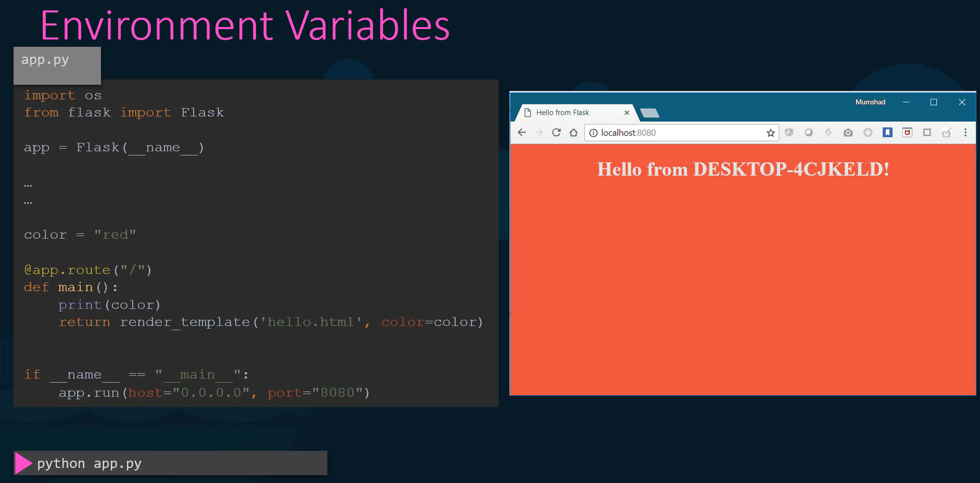

It is a best practice to move such information out of the application code and into say an environment variable called APP_COLOR. The next time you run the application set an environment variable called APP_COLOR to a desired value and the application now has a new color

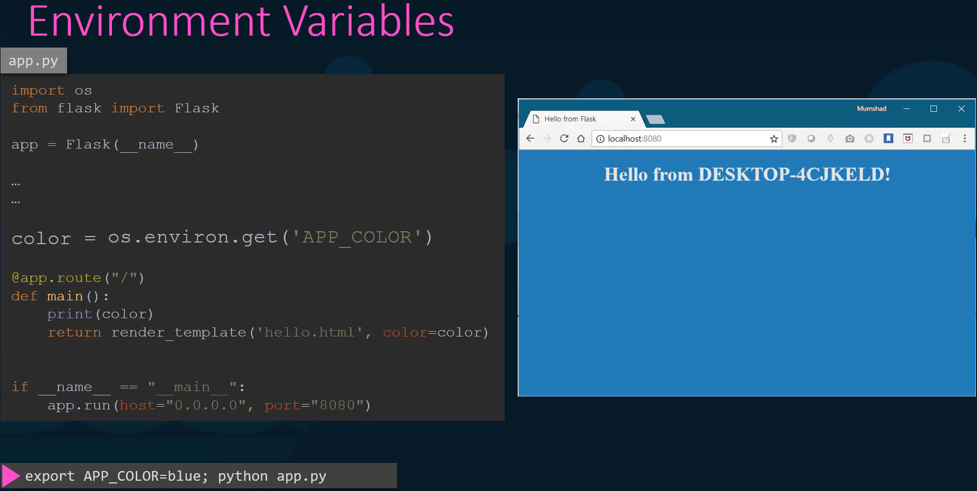

Once your application gets packaged into a Docker image. It would then run it within Docker run command followed by the name of the image. However if you wish to pass the environment variable as it did before you would now use the docker run commands -e option to set an environment variable within the container to deploy multiple containers with different colors.

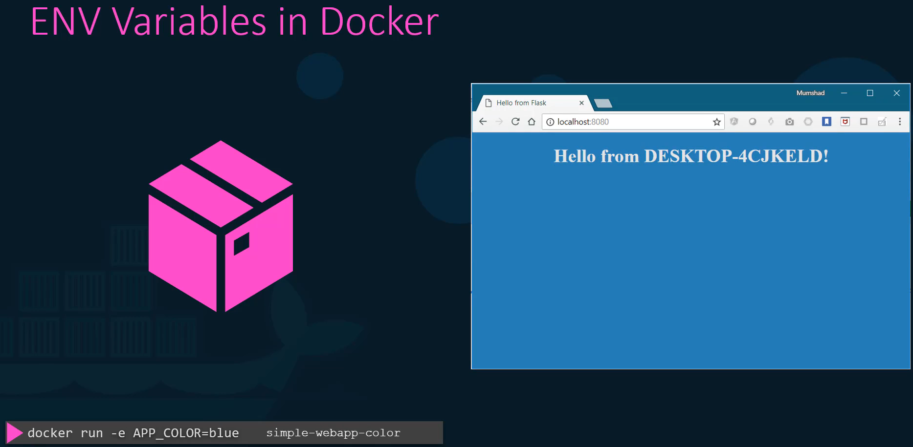

You would run the docker command multiple times and set a different value for the environment variable each time.

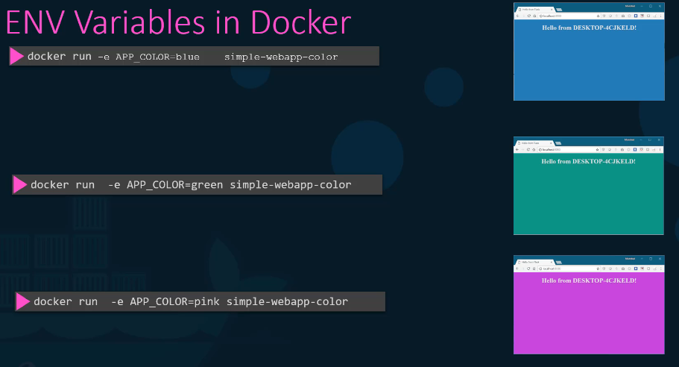

So how do you find the environment variable set on a container that's already running. Use the docker inspect command to inspect the properties of a running container under the config section you will find the list of environment variables set on the container.

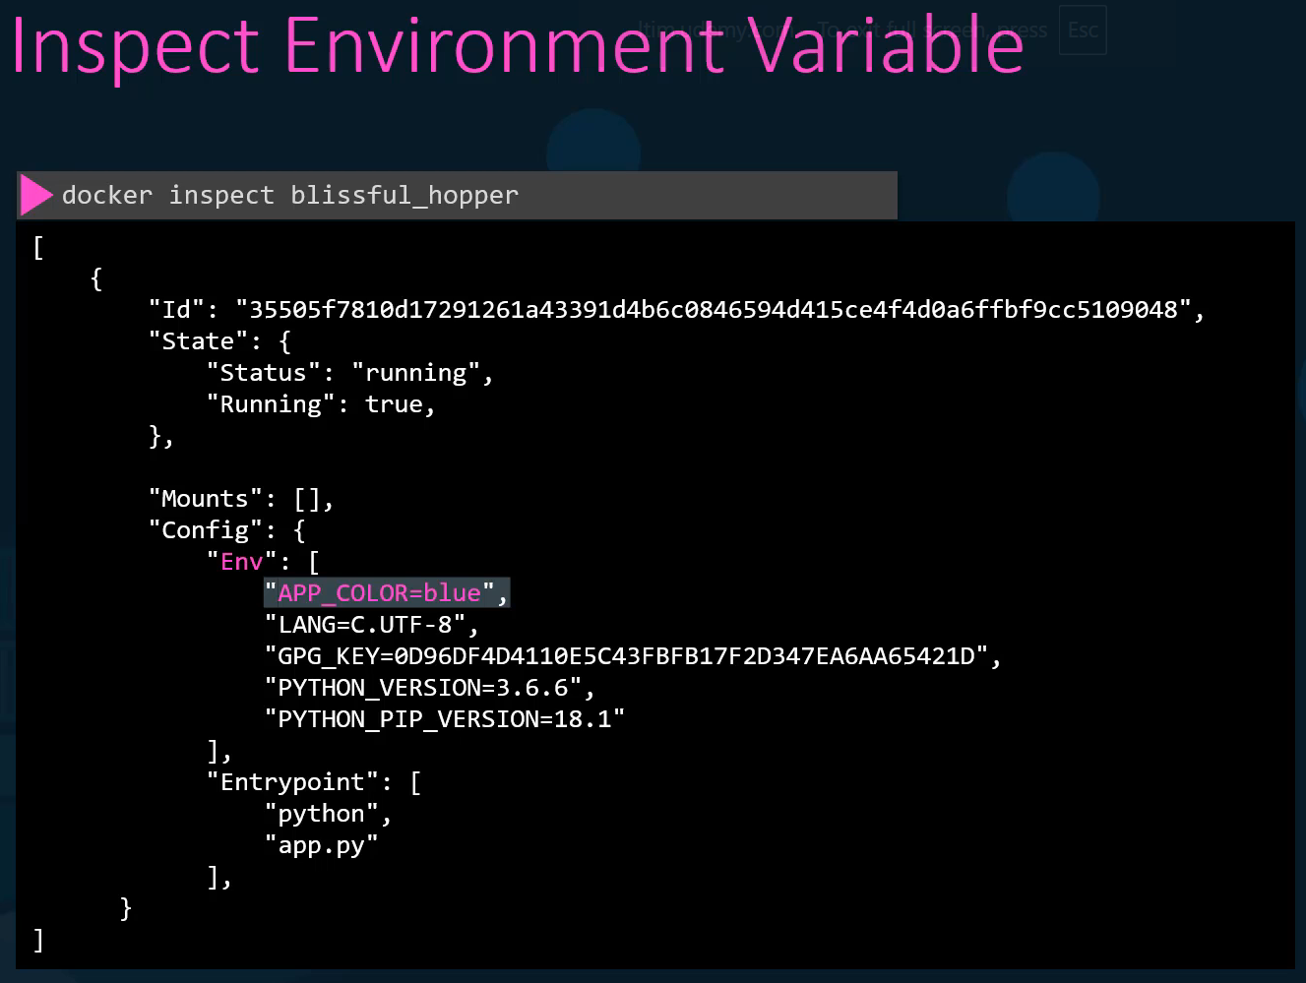

**1)** Run a container named blue-app using image kodekloud/simple-webapp and set the environment variable APP_COLOR to blue. Make the application available on port 38282 on the host. The application listens on port 8080.

**>> docker run -p 38282:8080 --name blue-app -e APP_COLOR=blue -d kodekloud/simple-webapp**To know the env field from within a webapp container, run

**>> docker exec -it blue-app env**

**2)** Run a mysql container named mysql-db using the mysql image. Set database password to db_pass123. Note: Remember to run it in the detached mode.

**>> docker run -d --name mysql-db -e MYSQL_ROOT_PASSWORD=db_pass123 mysql**To know the env field from within a mysql-db container, run

**>> docker exec -it mysql-db env**

**Why Use Environment Variables in Docker Compose?**

When you’re using Docker Compose to spin up multi-container applications, environment variables help you:

* Avoid hardcoding sensitive data in your docker-compose.yml
* Easily switch between development, staging, and production setups
* Keep your configuration clean and reusable

Environment variables in Docker are used to configure containers and applications without modifying the image itself. They can be set during the image build process or when a container is run.

There are several methods for defining and using environment variables:

**1. In a Dockerfile**

You can use the ENV instruction in a Dockerfile to set persistent environment variables in the image.

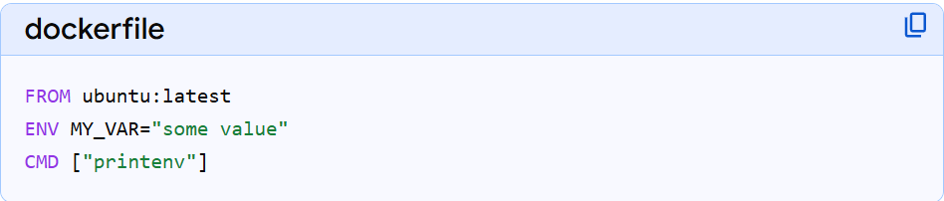

These variables are available to all subsequent instructions in the build and also persist in containers started from the final image.

**2. When Running a Container**

You can pass environment variables to a container at runtime using the --env or -e flag with the docker run command. This will override any default values set in the Dockerfile.

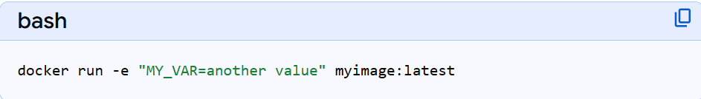

If you only provide the variable name (e.g., -e MY_VAR), Docker will attempt to take the value from your host machine's environment.

**3. Using an Environment File (--env-file)**

For managing many variables, or to keep sensitive data out of your command line history, you can use a file with one VAR=VALUE pair per line.

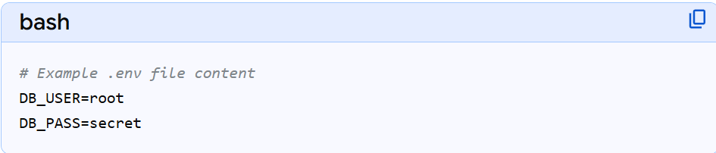

Then, pass the file to the docker run command:

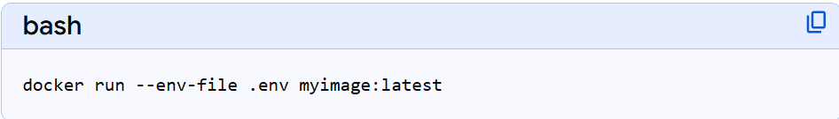

**4. With Docker Compose**

Docker Compose has native support for environment variables and variable interpolation.

* **In the compose.yml file:** Use the environment attribute under a service.

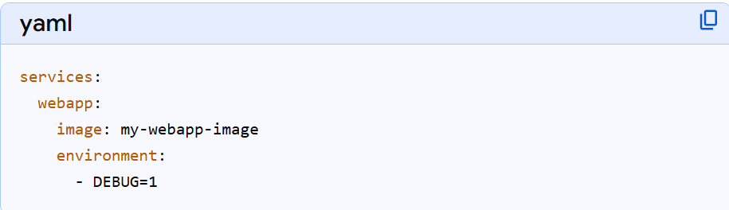

* **Using a .env file:** By default, Compose automatically looks for a file named .env in the project directory to load variables for interpolation into the compose.yml file.

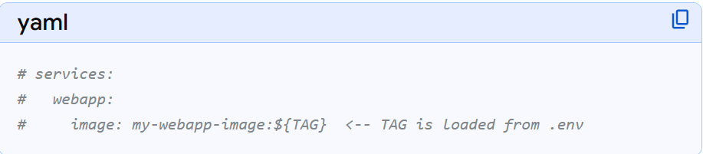

* **Using env_file attribute:** This passes a specific environment file's contents directly to the containers, separate from the default .env file used for interpolation.

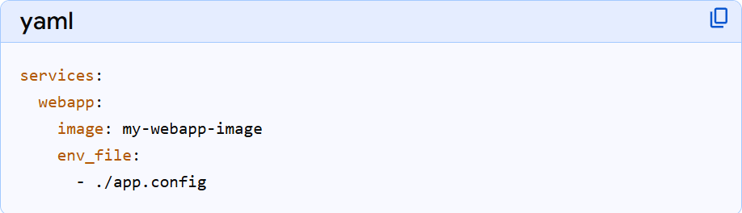

**Important Distinction: ENV vs. ARG**

* **ENV variables** persist in the final image and are available to running containers (runtime).
* **ARG variables** are only available during the *build* process and are not included in the final image by default. They are useful for dynamic build configurations, such as specifying a version number to install.

**Security Note:** Avoid storing sensitive information like passwords or API keys directly in Dockerfiles or environment files that might be committed to version control. Use Docker Secrets or external key management services for better security practices.

**CMD VS Entrypoint**

Say you were to run a docker container from an Ubuntu image. When you run the Docker run Ubuntu command, it runs an instance of Ubuntu image and exits immediately. Now, if you were to list the running containers, you wouldn't see the container running. If you list all containers, including those that are stopped, you will see that the new container that you ran is in an exited state.

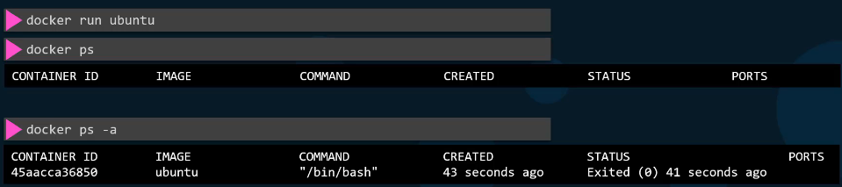

Now, why is that? Unlike virtual machines, containers are not meant to host an operating system. Containers are meant to run a specific task or process, such as to host an instance of a web server or an application server or a database, or simply to carry out some kind of computation or analysis tasks. Once the task is complete, the container exits. A container only lifts as long as the process inside it is alive. If the web service inside the container is stopped or crashes, the container exits.

So who defines what process is run within the container? If you look at the Docker file for popular Docker images like Nginx or you will see an instruction called CMD, which stands for Command that defines the program that will run within the container. When it starts, it runs the nginx command for the MySQL image. It is the MySQL command.

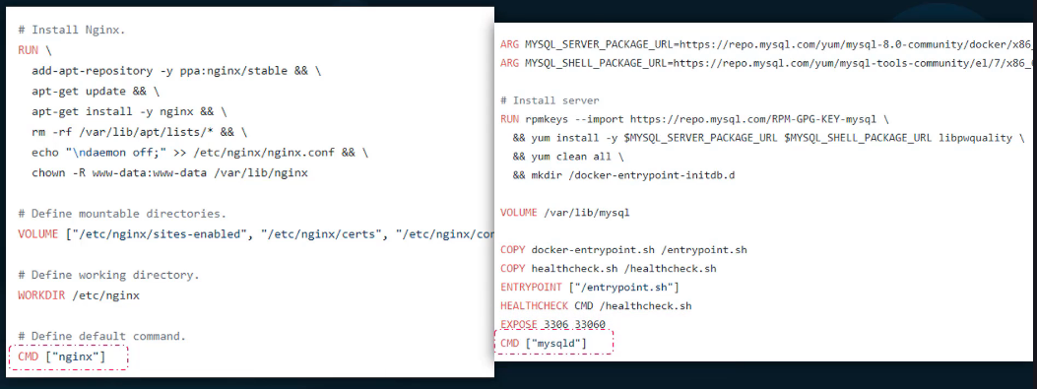

What we tried to do earlier was to run a container with a plain Ubuntu operating system. Now let us look at the Docker file for this image. And you will see that it uses Bash as the default command. Now, Bash is not really a process like a web server or database server. It is a shell that listens for inputs from a terminal. If it cannot find a terminal, it exits. So when we ran the Ubuntu container earlier, Docker created a container from the Ubuntu image and launched the bash program. By default Docker does not attach a terminal to a container when it is run, and so the bash program does not find the terminal and so it exits since the process that was started when the container was created finished, the container exits as well.

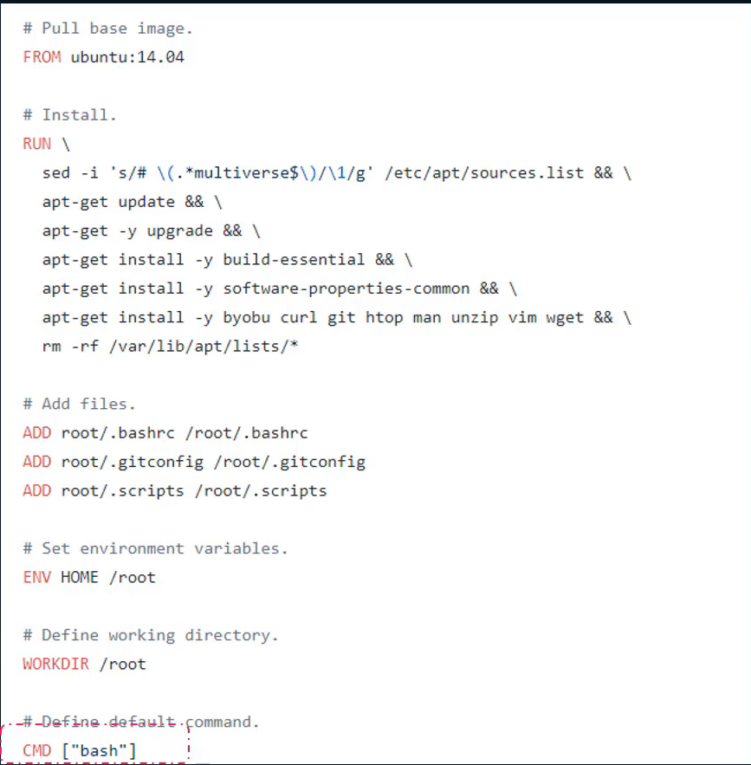

So how do you specify a different command to start the container? Now one option is to append a command to the Docker run command, and that way it overrides the default command specified within the image. In this case I run the Docker run Ubuntu command with the sleep 5 command as the added option. This way when the container starts, it runs. The sleep program, waits for 5 seconds and then exits.

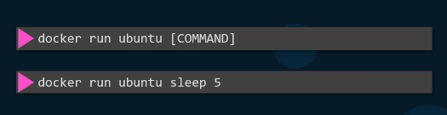

But how do you make that change permanent? Say you want the image to always run the sleep command when it starts. You would then create your own image from the base ubuntu image and specify a new command. There are different ways of specifying the command, either the command simply as in in a shell form or in a JSON array format like this. But remember when you specify it in a JSON array format, the first element in the array should be the executable.

So I now build my new image using the Docker build command and name it as ubuntu-sleeper and I could now simply run the ubuntu, the Docker Ubuntu sleeper command and get the same results. It always sleeps for 5 seconds and exits.   
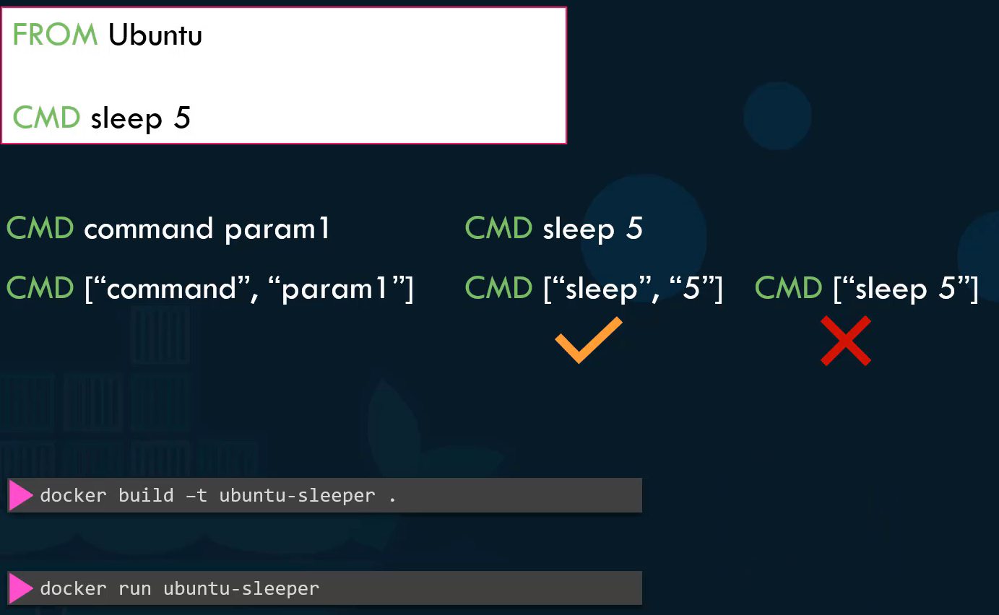  
But what if I wish to change the number of seconds it sleeps? Currently it is hardcoded to 5 seconds as we learned before. One option is to run the Docker run command with the new command appended to it. In this case sleep 10. And so the command that will be run at startup will be sleep ten, but it doesn't look very good. The name of the image ubuntu-sleeper in itself implies that the container will sleep, so we shouldn't have to specify the sleep command again. Instead, we would like to be for it to be something like this. Docker run ubuntu-sleeper 10. We only want to pass in the number of seconds. The container should sleep and the sleep command should be invoked automatically. And that is where the entry point instruction comes into play. **ENTRYPOINT** allows us to specify a command that will be run when the image is run as a container. So the command that will be run when the container starts is sleep 10. In case of the CMD instruction, the command line parameters past will get replaced entirely, whereas in case of entry point, the command line parameters will get appended. Now, in the second case, what if I run the Ubuntu Sleeper image command without appending the number of seconds, then the command at startup will be just sleep and you get the error that the operand is missing.

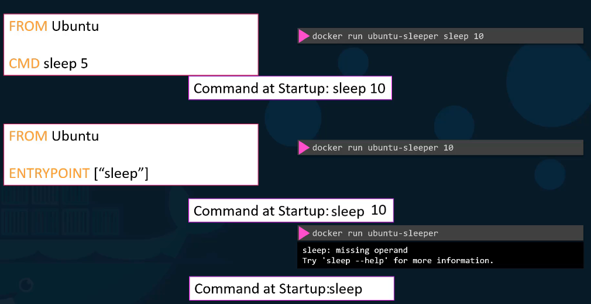

So how do you configure a default value for the command if one was not specified in the command line, that's where you would use both entry point as well as the command instruction (CMD). The main purpose of the **CMD** command is to start the process inside the container and it can be overridden. In this case, the command instruction will be appended to the entry point instruction. So at startup the command would be sleep 5 if you didn't specify any parameters in the command line, if you did, then that will override the command instruction. And remember, for this to happen, you should always specify the entry point and command instructions in a JSON format. And finally, what if you really, really want to modify the entry point during runtime, say, from sleep to an imaginary, let's say sleep 2.0 command or something? Well, in that case, you can override it by using the entry point option in the Docker run command. So the final command at startup will then be sleep 2.0 10.

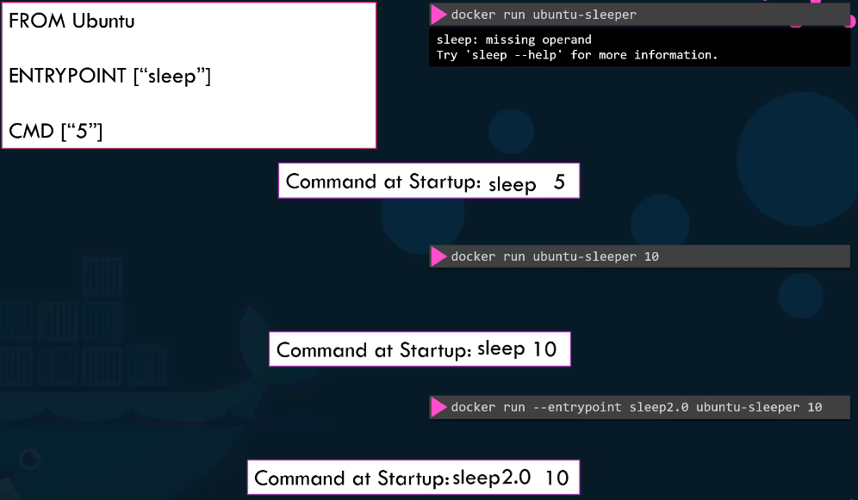

**Docker Compose**

Docker Compose is a tool for defining and running multi-container applications. It is the key to unlocking a streamlined and efficient development and deployment experience. With Docker Compose you use a YAML configuration file, known as the [Compose file](https://docs.docker.com/compose/intro/compose-application-model/#the-compose-file), to configure your application’s services, and then you create and start all the services from your configuration with the [Compose CLI](https://docs.docker.com/compose/intro/compose-application-model/#cli).

Compose simplifies the control of your entire application stack, making it easy to manage services, networks, and volumes in a single YAML configuration file. Then, with a single command, you create and start all the services from your configuration file. Compose works in all environments - production, staging, development, testing, as well as CI workflows. It also has commands for managing the whole lifecycle of your application:

* Start, stop, and rebuild services
* View the status of running services
* Stream the log output of running services
* Run a one-off command on a service

If we needed to set up a complex application running multiple services, a better way to do it is to use Docker Compose.

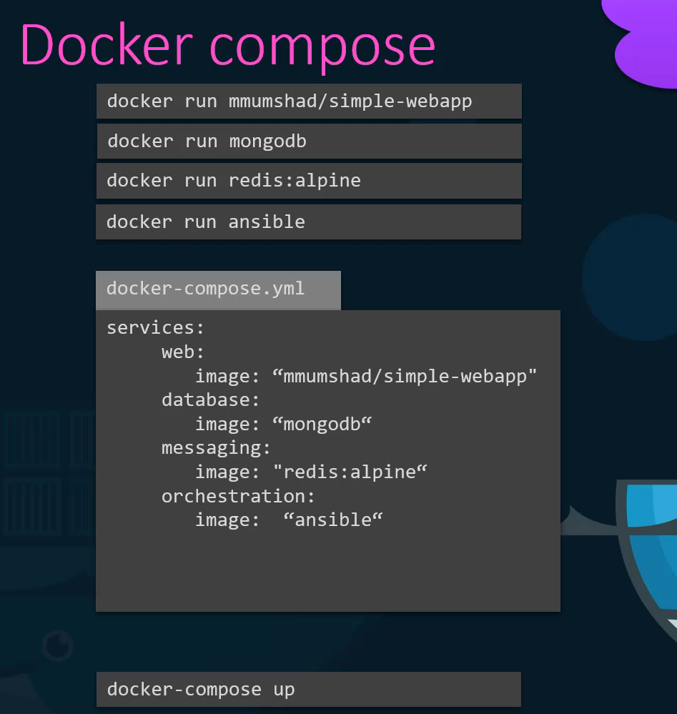

With Docker Compose we could create a configuration file in YAML format called docker-compose.yams and put together the different services and the options specific to this to running them in this file. Then we could simply run a docker-compose up command to bring up the entire application stack. This is easier to implement, run and maintain as all changes are always stored in the Docker compose configuration file. However, this is all only applicable to running containers on a single Docker host.

That was a really simple application that I put together. Let us look at a better example.

This is a sample **voting application** (**source code**: <https://github.com/dockersamples/example-voting-app>) which provides an interface for a user to vote and another interface to show the results. The application consists of various components such as the **voting app**, which is a web application developed in Python to provide the user with an interface to choose between two options a cat and a dog. When you make a selection, the vote is stored in readis. In this case serves as a **database in memory**. This vote is then processed by the worker, which is an application written in .NET. The **worker** application takes the new vote and updates the **persistent database**, which is a PostgreSQL. The PostgreSQL simply has a table with the number of votes for each category, cats and dogs. In this case, it increments the number of votes for cats as our vote was for cats. Finally, the result of the vote is displayed in a web interface, which is another web application developed in Node.js. **Result application** reads the count of votes from the Post SQL database and displays it to the user. So that is the architecture and data flow of this sample voting application stack. As you can see, this sample application is built with a combination of different services, different development tools and multiple different development platforms such as Python, Node.js, .NET etc.. This sample application will be used to showcase how easy it is to set up an entire application stack consisting of diverse components in Docker.

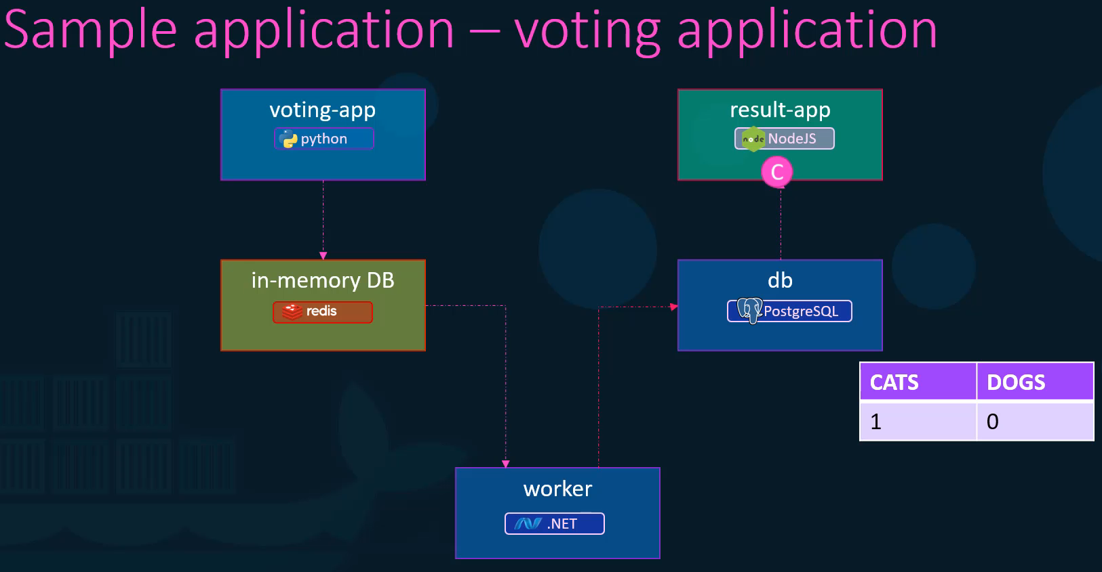

Let us keep aside Docker Swarm, services and stacks for a minute and see how we can put together this application stack on a single Docker engine using first Docker run commands and then Docker compose. Let us assume that all images of applications are already built and are available on Docker Repository. Let us start with the data layer.

* First, we run the Docker run command to start an instance of Redis by running the **docker run redis** command. We will add the -d parameter to run this container in the background and we will also name the container redis. Now naming the containers is important. Why is that important? We will get to know later.
* Next, we will deploy the PostgreSQL database by running the **docker run postgres** Command. This time too we will add the -d option to run this in the background and name this container db.
* Next, we will start with the application services. We will deploy a front end app for voting interface by running an instance of voting-app image. Run the docker run command and name the instance vote. Since this is a web server, it has a web UI instance running on Port 80. We will publish that port to 5000 on the host system so we can access it from a browser.
* Next, we will deploy the results web application that shows the results to the user. For this, we deploy a container using the result-app image and publish port 80 to port 5001 on the host. This way we can access the web UI of the resulting app on a browser.
* Finally, we deploy the worker by running an instance of the worker image.

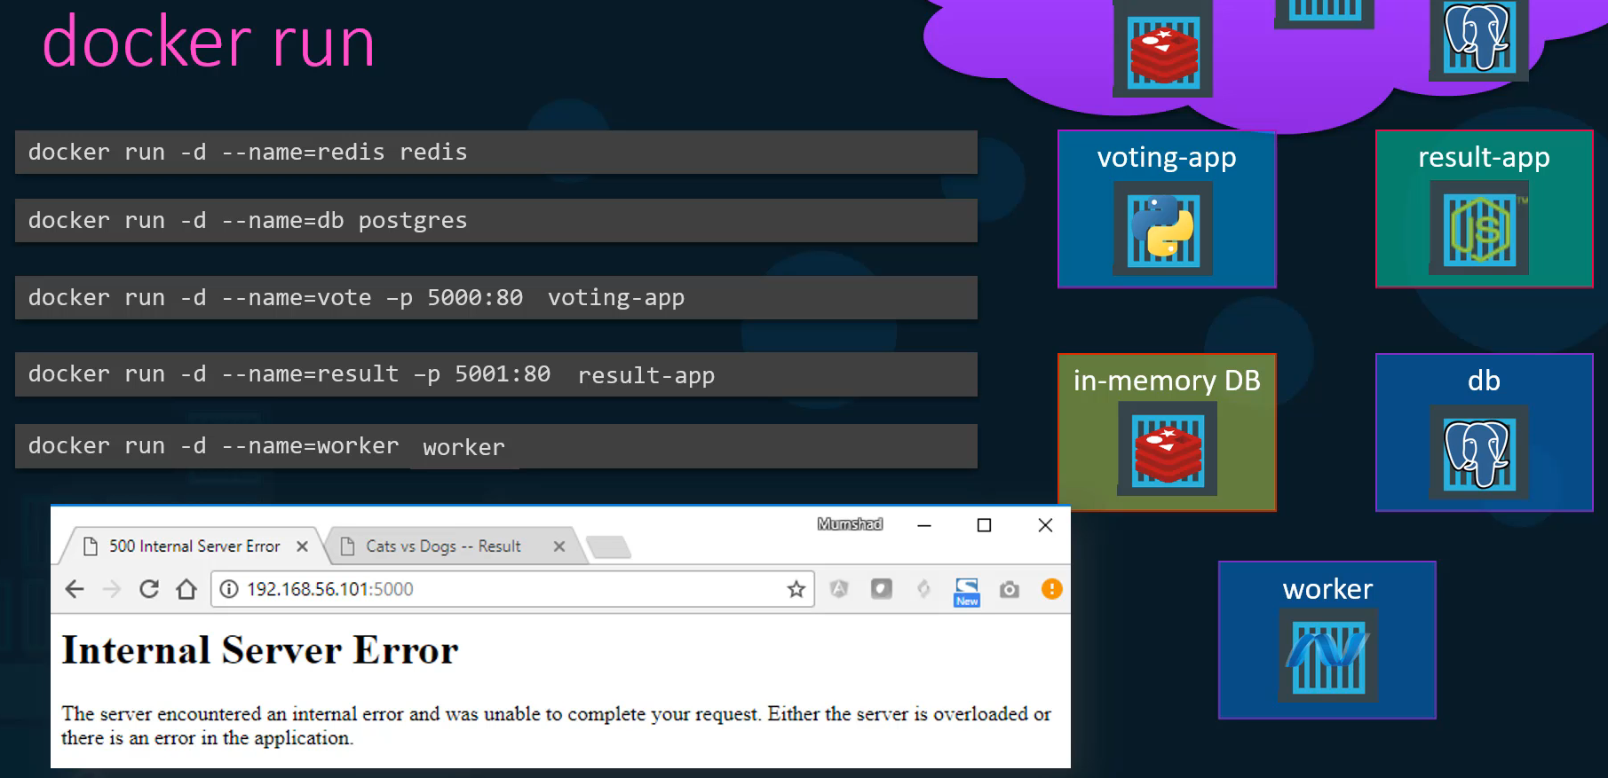

Now this is all good. And we can see that all the instances are running on the host. But there is some problem. It just does not seem to work. The problem is that we have successfully run all the different containers, but we haven't actually linked them together. As in, we haven't told the voting web application to use this particular redis instance. There could be multiple red instances running. We haven't told the worker and the resulting app to use this particular PostgreSQL database that we ran.

So how do we do that? That is where we use links. Link is a command line option which can be used to link two containers together. For example, the voting app web service is dependent on the redis service. When the web server starts as you can see in this piece of code on the web server it looks for a readis service running on host Redis, but the voting app container cannot resolve a host by the name Redis. To make the voting app aware of the redis service we add a link option while running the voting app container to link it to the redis container. Adding a --link option to the docker run command and specifying the name of the redis container, which in this case is redis followed by a colon and the name of the host that the voting app is looking for, which is also redis in this case. Remember that, this is why we named the container when we ran it the first time so we could use its name while creating a link. What this is in fact doing is it creates an entry into the /etc/hosts file on the voting app container, adding an entry with the host name redis with the internal IP of the redis container.

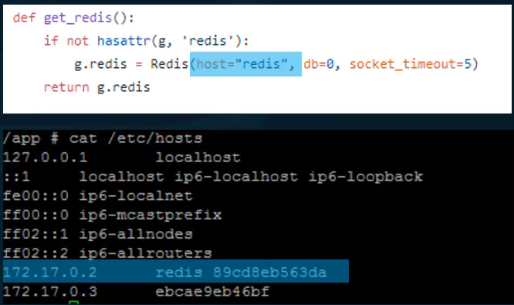

Similarly, we add a link for the result app to communicate with the database by adding a link option to refer the database by the name db. As you can see in this source code of the application, it makes an attempt to connect to a postgres database on host db.

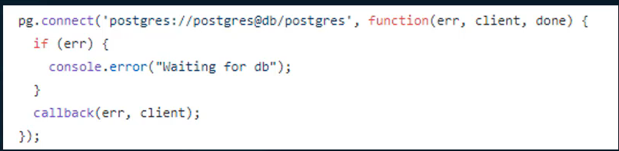

Finally, the worker application requires access to both the redis as well as the postgres database. So we add two links to the worker application, one link is to link the redis and the other link is to link postgres database.

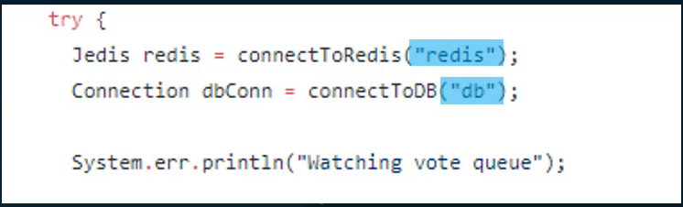

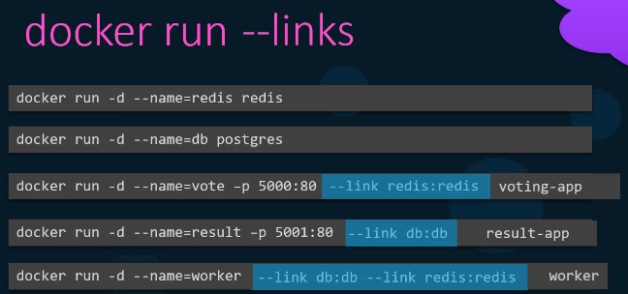

Note that using links this way is deprecated and the support may be removed in future in Docker. This is because, as we will see in some time, advanced and newer concepts in Docker Swarm and networking supports better ways of achieving what we just did here with links.

Once we have the Docker run commands tested and ready, it is easy to generate a Docker compose file from it.

We start by creating a dictionary of container names. We will use the same name we used in the Docker run commands, so we take all the names and create a key with each of them. Then under each item we specify which image to use. The key is the image and the value is the name of the image to use. Next, inspect the commands and see what are the other options used. We published ports, so let's move those ports under the respective containers. So we create a property called ports and list all the ports that you would like to publish under that. Finally, we are left with links, so whichever container requires the link, create a property under it called links and provide an array of links such as redis or db. Note that you could also specify the name of the link as db, this way without the semicolon and the target name. It will create a link with the same name as the target name. Specifying the db:db is similar to simply specifying db. Now that we are all done with our Docker compose file, bringing up the stack is really simple. Run the **docker compose up** command to bring up the entire application stack.

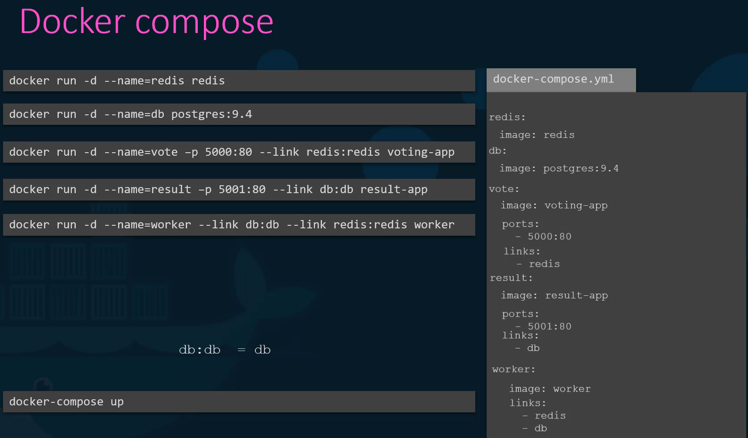

When we looked at the example of the sample voting application, we assumed that all images are already built. Out of the five different components, two of them are redis and postgres images we know are already available on Docker Hub. They are official images from Redis and Postgres, but the remaining three are our own application. It is not necessary that they are already built and available in the Docker registry. If we would like to instruct Docker, compose to run a Docker build instead of trying to pull an image, we could replace the image line with a build line and specify the location of a directory which contains the application code and a Docker file with instructions to build the Docker image. In this example for the voting app, have all the application code in a folder named /vote which contains all application code and a Docker file. This time when you run the docker compose up Command, it will first build the images, give a temporary name for it, and then use those images to run containers using the options you specified before. Similarly use build option to build the two other services from the respective folders.

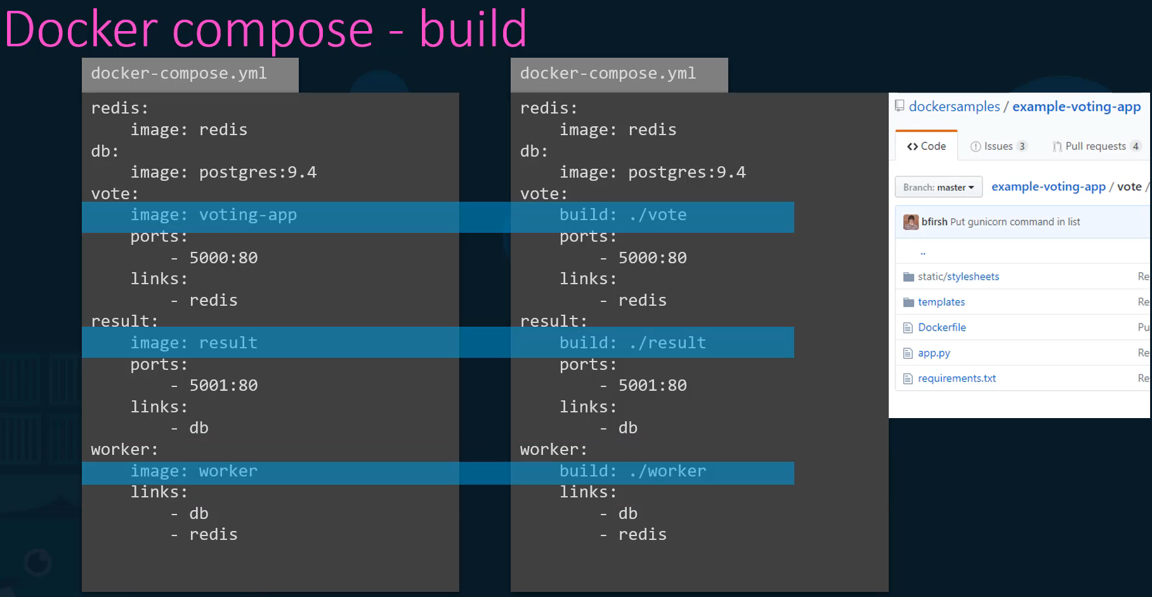

**Docker Compose Versions**

We will now look at different versions of Docker Compose file. This is important because you might see Docker compose files in different formats at different places and wonder why some look different. Docker compose evolved over time and now supports a lot more options than it did in the beginning. For example, this is the trimmed down version of the Docker Campos file we used earlier. This is, in fact, the original version of Docker Campos file, known as version one. This had a number of limitations. For example, if you wanted to deploy containers on a different network other than the default bridge network, there was no way of specifying that in this version of the file. Also say you have a dependency or startup order of some kind. For example, your database container must come up first and only then should the voting application be started. There was no way you could specify that in the version one of the Docker compose file.

Support for these came in version two. With version two and up the format of the file also changed a little bit. You no longer specify your stack information directly as you did before. It is all encapsulated in the services section. So create a property called services in the root of the file and then move all the services underneath that. You will still use the same Docker. Compose up command to bring up your application stack. For Version two and up, you must specify the version of Docker compose file you are intending to use by specifying the version at the top of the file. In this case. version:2. Another difference is with networking. In version one Docker can post attaches. All the containers it runs to the default bridge network. And then use links to enable communication between the containers as we did before. With Version two, Docker Compose automatically creates a dedicated bridge network for this application and then attaches all containers to that new network. All containers are then able to communicate to each other using each other's service name. So you basically don't need to use links in version two of Docker compose. You can simply get rid of all the links you mentioned in version one when you convert a file from version one to version two. And finally, version two also introduces a depends on feature. If you wish to specify a startup order, for instance, say the voting web application is dependent on the redis service. So you need to ensure that redis container is started first and then only the voting web application must be started. We could add a depends on property to the voting application and indicate that it is dependent on redis.

Then comes version three, which is the latest as of today. Version three is similar to version two in the structure, meaning it has a version specification at the top and a services section under which you put all your services, just like in version two. Make sure to specify the version number as three at the top. Version three comes with support for Docker Swarm.

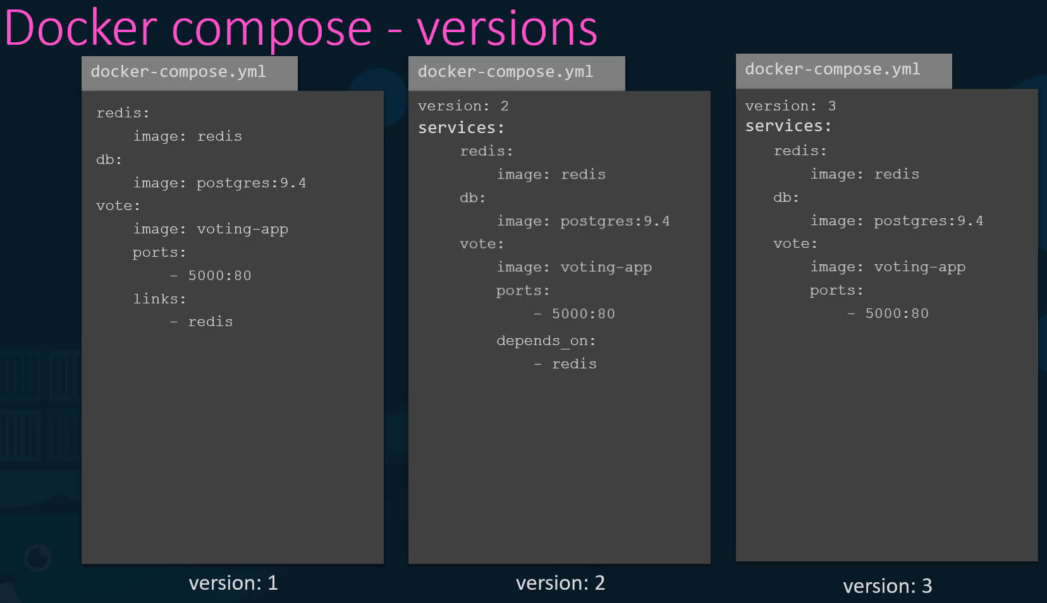

**1)** First create a redis database container called redis, image redis:alpine.

**>> docker run --name redis -d redis:alpine**

**2)** Create a simple container called clickcounter with the image kodekloud/click-counter, link it to the redis container that we created in the previous task and then expose it on the host port 8085. The clickcounter app run on port 5000.

**>> docker run -d --name=clickcounter --link redis:redis -p 8085:5000 kodekloud/click-counter**

**3)** Create a docker-compose.yml file with specification as follows:

a) redis service specification - Image name should be redis:alpine.

b) clickcounter service specification - Image name should be kodekloud/click-counter, app is run on port 5000 and expose it on the host port 8085 in the compose file.

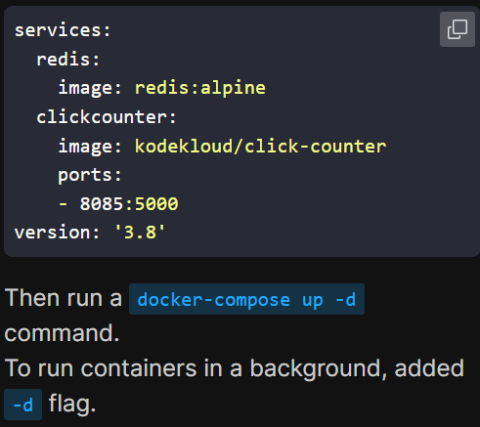

**Network in Docker compose**

Getting back to our voting application, so far we have been just deploying all the containers on the default bridge network. Let us say we modify the architecture a little bit to contain the traffic from the different sources. For example, we would like to separate the user generated traffic from the application's internal traffic. So, we create a frontend network dedicated for traffic from users and a backend network dedicated to traffic within the application. We then connect the user-facing applications, which are the voting app and the result app to the frontend network and all the components to an internal backend network. So back in our docker Campos file, note that we have actually stripped out the port section for simplicity's sake. They're still there, but they're just not shown in the picture. The first thing we need to do if we were to use networks, is to define the networks we are going to use. In our case, we have two networks frontend and backend. So create a new property called networks at the root level adjacent to the services in the docker compose file and add a map of networks we are planning to use. Then under each service, create a network's property and provide a list of networks that service must be attached to. In case of redis and db, it's only the backend network in case of the frontend applications such as the voting app and the result app, they require to be attached to both frontend and backend network. You must also add a section for worker container to be added to the backend network which is not shown in the picture.

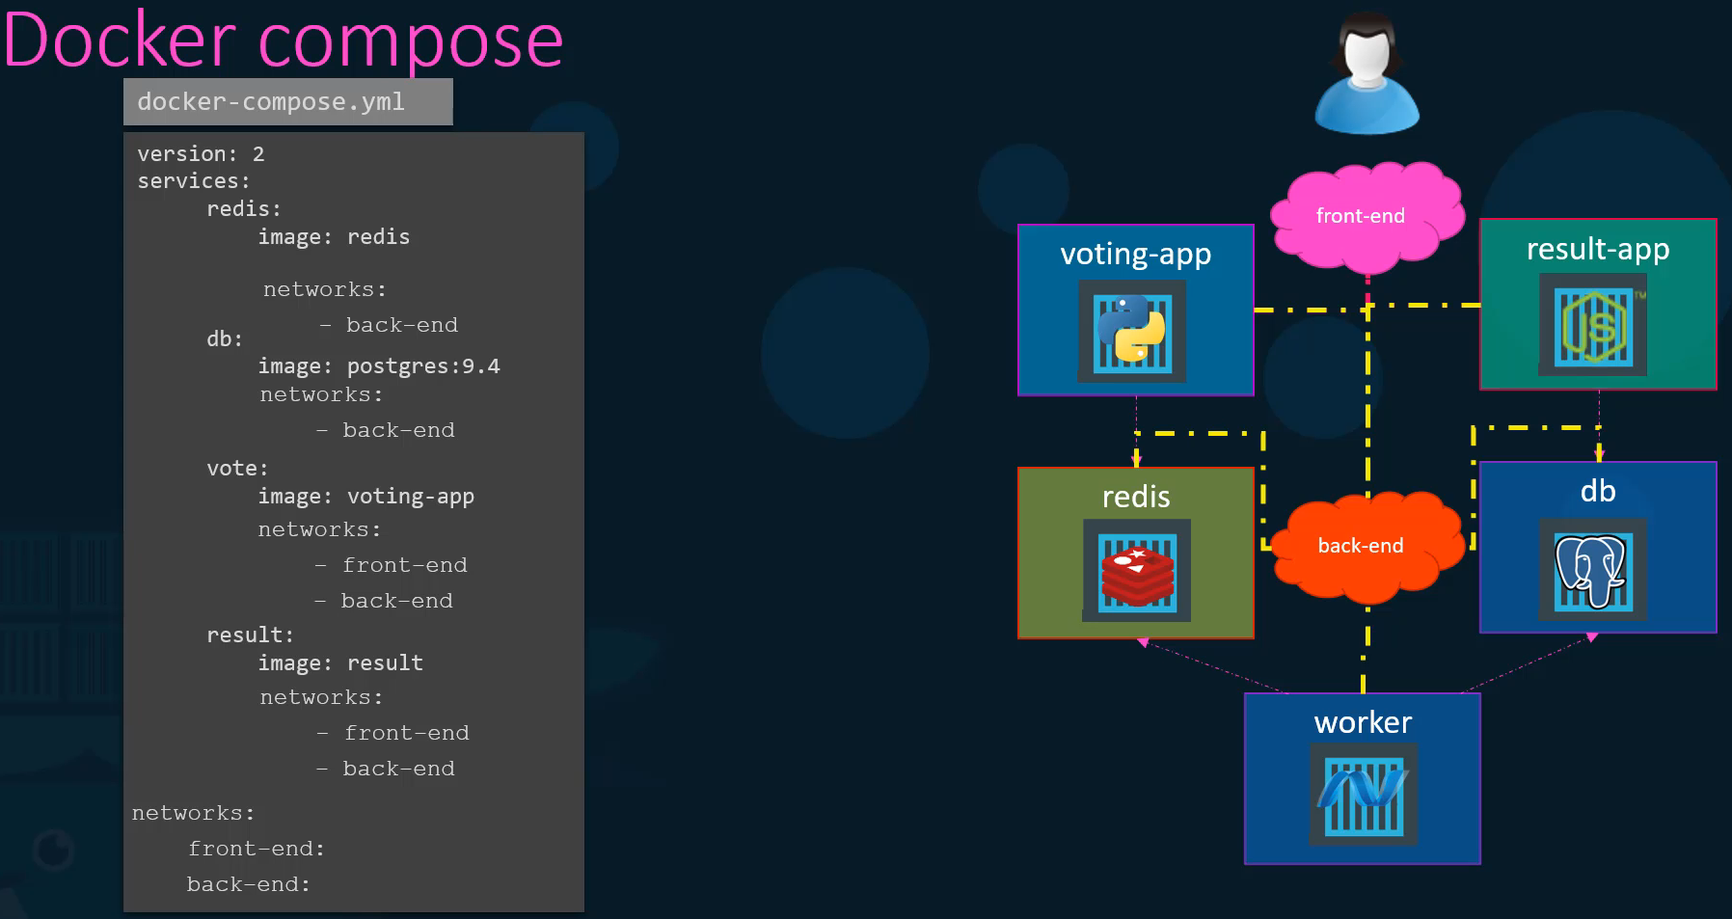

**Dockerfile versus Compose file**

A Dockerfile provides instructions to build a container image while a Compose file defines your running containers. Quite often, a Compose file references a Dockerfile to build an image to use for a particular service.

**Docker Registry** (It's a central repository of all Docker images)

Docker Registry is a centralized storage and distributed system for collecting and managing Docker images. It acts as a server-side application that stores, manages, and distributes container images across environments. An image registry is a centralized location for storing and sharing your container images. It can be either public or private. [Docker Hub](https://hub.docker.com/) (**https://hub.docker.com/**) is a public registry that anyone can use and is the default registry. Docker Hub simplifies development with a powerful container registry for storing, managing, and sharing Docker images. By integrating seamlessly with your tools, it enhances productivity and ensures reliable deployment, distribution, and access to containerized applications. It also provides developers with pre-built images and assets to speed up development workflows.

It is an essential component in the containerization workflow for streamlining the deployment and management of applications. Features of a Docker Registry are :

* Stateless and scalable
* Organized into repositories, where each repository contains multiple versions (tags) of an image.
* Accessible to users for pushing (uploading) and pulling (downloading) images.

Let's look at a simple nginx container. We run the **docker run nginx** command to run an instance of the nginx image. Let's take a closer look at that image name. Now the name is nginx. But what is this image and where is this image pulled from? By default, if you don’t specify user or an organization account in your image name its going to try to pull the image from default user account called **library** on Docker hub. So even though we typed nginx, docker internally treats it as **library/nginx**.  
Nginx here is the image or the repository name. The library prefix is used when no specific account or repository is provided, indicating an official Docker Hub image. The username is usually your Docker Hub account name, or if it is an organization, then it's the name of the organization. Since we have not specified the location where these images are to be pulled from, it is assumed to be on Docker's default registry Docker hub. The DNS name for which is Docker.io.

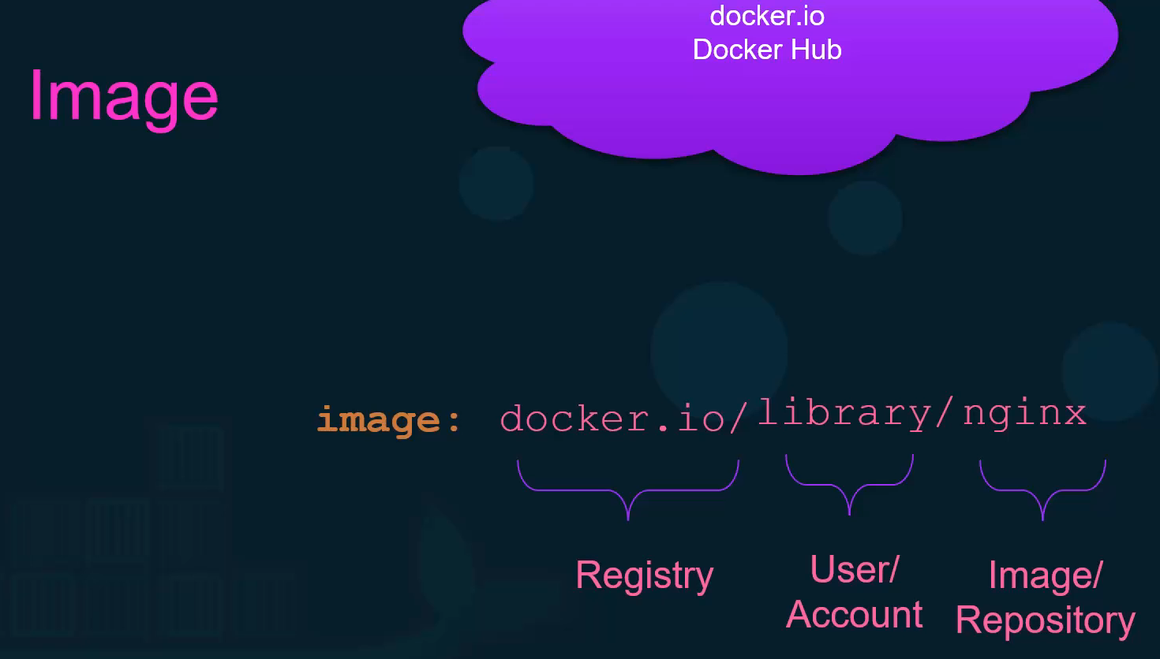

The registry is where all the images are stored. Whenever you create a new image or update an existing image, you push it to the registry and every time anyone deploys this application, it is pulled from that registry.   
When you have applications built in-house that shouldn't be made available to the public. Hosting an internal private registry may be a good solution. Many cloud service providers such as AWS, Azure, or GCP provide a private registry by default when you open an account with them. On any of these solutions, be it Docker Hub or Google Registry or your internal private registry, you may choose to make a repository private so that it can only be accessed using a set of credentials from Dockers perspective. To run a container using an image from a private registry, you first log in to your private registry using the Docker login command. Input your credentials. Once successful, run the application using private registry as part of the image name like this. Now, if you did not log in to the private registry, it will come back saying that the image cannot be found. So, remember to always log in before pulling or pushing to a private registry.

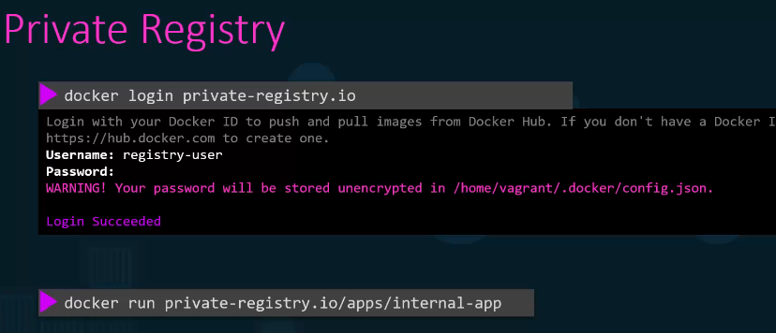

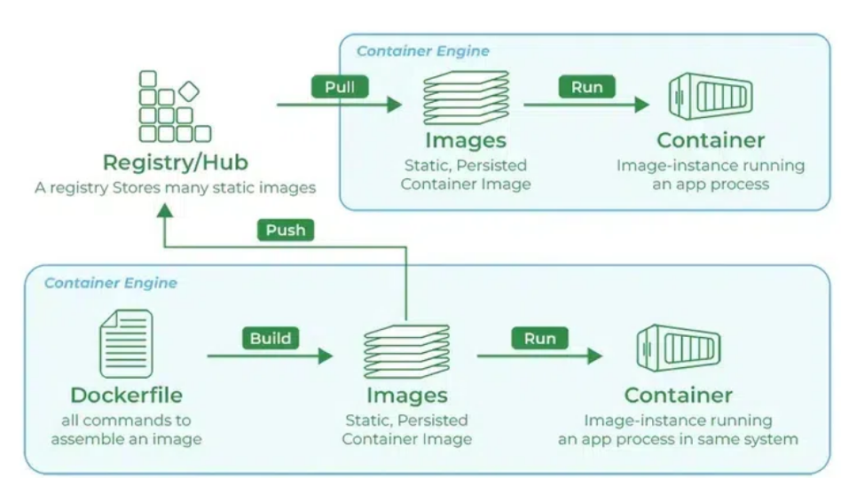

**Docker Image**: A Docker Image is a template (blueprint) used to create Docker Containers.

**Docker Images Registry**: A Docker Registry is a storage system where Docker Images are pushed (uploaded) and pulled (downloaded).

**Docker Hub**: It is the official cloud-based Docker Registry service provided by Docker Inc. It is the default registry where Docker looks for images when you run docker pull or docker run without specifying a registry.

**Docker Login**: It is a Docker CLI command used to authenticate your local Docker client with a Docker Registry (like Docker Hub, AWS ECR, GCP GCR, Azure ACR, or a private registry). It allows you to push (upload) and pull (download) Docker images securely by verifying your username and password or access token.

**Authentication of Dockerhub**: Authentication in Docker Hub ensures secure pushing and pulling of Docker images, especially when dealing with private repositories and DevOps pipelines.

**Different Types of Docker Registries**

While Docker Hub is a popular option, there are many other available container registries available today, including Amazon Elastic Container Registry (ECR), Azure Container Registry (ACR), and Google Container Registry (GCR). You can even run your private registry on your local system or inside your organization. For example, Harbor, JFrog Artifactory, GitLab Container registry etc.

* **Cloud-Hosted / Public Registries**: These are managed services that are easy to use and integrate with other cloud platforms.
* **Docker Hub**: The default and largest public registry, hosting millions of official and community images.
* **Amazon Elastic Container Registry (ECR)**: AWS's managed registry, integrated with its cloud ecosystem.
* **Google Container Registry (GCR)**: Google Cloud's offering, tightly integrated with GKE. Google has announced the Container Registry is deprecated. Artifact Registry is the recommended service for container image storage and management on Google Cloud.
* **Azure Container Registry (ACR)**: Microsoft's registry service for its Azure platform.
* **GitLab Container Registry**: Integrated directly into the GitLab CI/CD platform.
* **Private / Self-Hosted Registries**: These are registries you run on your own infrastructure for maximum control, security, and speed.
* **Docker Registry Image**: Docker provides an official open-source image (registry:2) that allows you to run a basic registry yourself.
* **Harbor**: An open-source, enterprise-grade registry with advanced features like vulnerability scanning and role-based access control.

**Deploy Private Registry:**

We said that cloud providers like AWS or GCP provide a private registry when you create an account with them. But what if you are running your application on premise and don't have a private registry? How do you deploy your own private registry within your organization? The Docker registry is itself another application, and of course it's available as a Docker image. The name of the image is registry and it exposes the API on port 5000. Now that you have your custom registry running at port 5000 on this Docker host, how do you push your own image to it? Use the **docker image tag** command to tag the image with the private registry URL in it. In this case, since it's running on the same docker host, I can use localhost:5000, followed by the image name. I can then push my image to my local private registry using the command **docker push** and the new image name with the docker registry information in it. From there on, I can pull my image from anywhere within this network using either localhost if you're on the same host, or the IP or domain name of my docker host, if I'm accessing from another host in my environment.

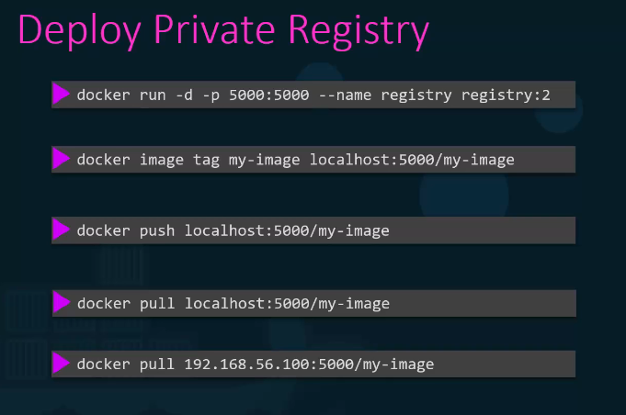

**1)** Run a registry server with name equals to **my-registry** using registry:2 image with host port set to 5000, and restart policy set to always.  
Note: Registry server is exposed on port 5000 in the image.

**>> docker run -d -p 5000:5000 --restart=always --name my-registry registry:2**

**s** Let's push two images for now .i.e. nginx:latest and httpd:latest. Note: Don't forget to pull them first.  
To check the list of images pushed , use curl -X GET localhost:5000/v2/_catalog

Run: **docker pull nginx:latest** then **docker image tag nginx:latest localhost:5000/nginx:latest** and finally push it using **docker push localhost:5000/nginx:latest**  
We will use the same steps for the second image   
**docker pull httpd:latest** and then **docker image tag httpd:latest localhost:5000/httpd:latest** and finally push it using **docker push localhost:5000/httpd:latest**

3) Let's remove all the dangling images we have locally.

**>> docker image prune -a**

4) Now we can pull images from our registry-server as well. Use docker pull [server-addr/image-name] to pull the images that we pushed earlier.

**>> docker pull localhost:5000/nginx  
  
Docker Engine:**

Docker Engine is an open-source containerization technology for building and containerizing your applications. Docker Engine acts as a client-server application with:

* A server with a long-running daemon process [dockerd](https://docs.docker.com/reference/cli/dockerd).
* APIs which specify interfaces that programs can use to talk to and instruct the Docker daemon.
* A command line interface (CLI) client [docker](https://docs.docker.com/reference/cli/docker/).

The CLI uses Docker APIs to control or interact with the Docker daemon through scripting or direct CLI commands. Many other Docker applications use the underlying API and CLI. The daemon creates and manages Docker objects, such as images, containers, networks, and volumes.

Docker engine is simply referred to a host with Docker installed on it. When you install Docker on a linux host you're actually installing three different components. The Docker demon, the REST API server and the docker CLI. The **docker demon** is a background process that manages Docker objects such as the images containers volumes and networks. The **Docker REST API** **server** is the API interface that programs can use to talk to the demon and provide instructions. You could create your own tools using this rest api and the **docker CLI** is nothing but the command line interface that used to perform actions such as running a container stopping containers destroying images etc.

Something to note here is that the Dockers CLI need not necessarily be on the same host. It could be on another system like a laptop and can still work with a remote Docker engine. Simply use the -H option on the docker command and specify the remote Docker engine address and the port. For example to run a container based on and Nginx on a remote Docker host run the command **docker -H=10.123.2.1:2375 run nginx**.

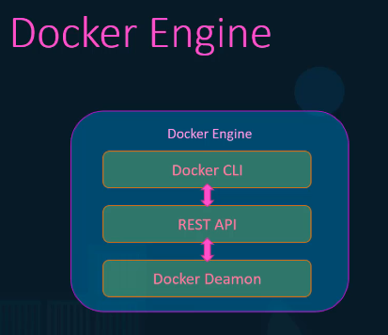 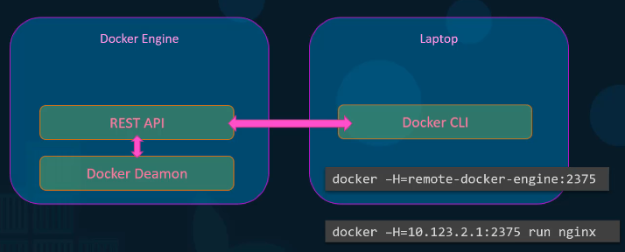

**Components of Docker Engine**

Docker Engine is an open-source technology that includes a server running a background process called a REST API, and a command-line interface (CLI) known as 'docker'. In the following explanation, you will know how the engine works: it runs a server-side daemon that manages images, containers, networks, and storage volumes. The users can interact with this daemon with the help of the CLI, directly through the API.

An essential aspect of Docker Engine is its declarative nature. This means that administrators describe a specific desired state for the system. Docker Engine automatically works at keeping the real state aligned with the desired state at all times.

**Docker Engine Architecture**

Basically, Docker's client-server setup streamlines dealing with stuff like images, containers, networks, and volumes. This makes developing and moving workloads easier. As more businesses use­ Docker for its efficiency and scalability, grasping its engine components, usage, and benefits is key to using container technology properly.

* **Docker Daemon**: The Docker daemon, called dockerd, is essential. It manages and runs Docker containers and handles their creation. It acts as a server in Docker's setup, receiving requests and commands from other components.
* **Docker Client**: Users communicate with Docker through the CLI client (docker). This client talks to the Docker daemon using Docker APIs, allowing for direct command-line interaction or scripting. This flexibility enables diverse operational approaches.
* **Docker Images and Containers**: At Docker's core, you find images and containers. Images act as unchanging blueprints. Containers are created from these blueprints. Containers provide­ the surroundings needed to run apps.
* **Docker Registries**: These are places where Docker images live and get shared. Registries are vital. They enable reusability and spreading of containers.
* **Networking and Volumes**: Docker has networking capabilities. They control how containers talk to one another and the host system. Volumes in Docker allow data storage across containers. This enhances data handling within Docker.

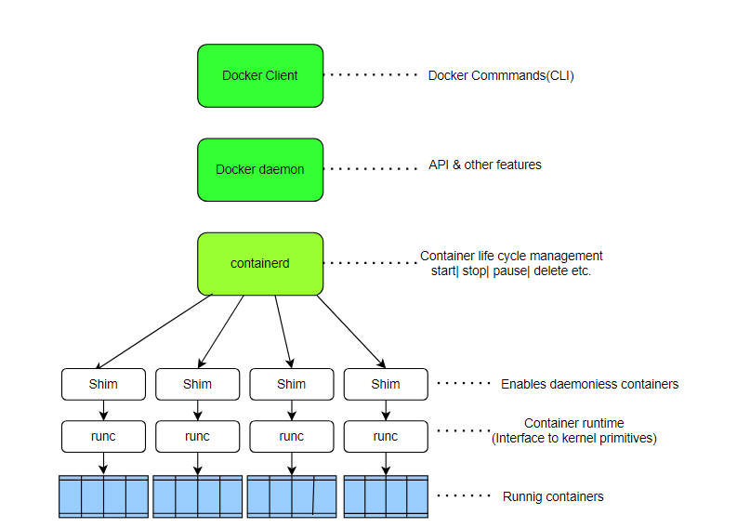

Now let's try and understand how exactly applications are containerized in Docker. Docker uses namespaces to isolate workspace. Process Ids, network, inter process communication, mounts and Unix time sharing systems are created in their own namespace thereby providing isolation between containers.

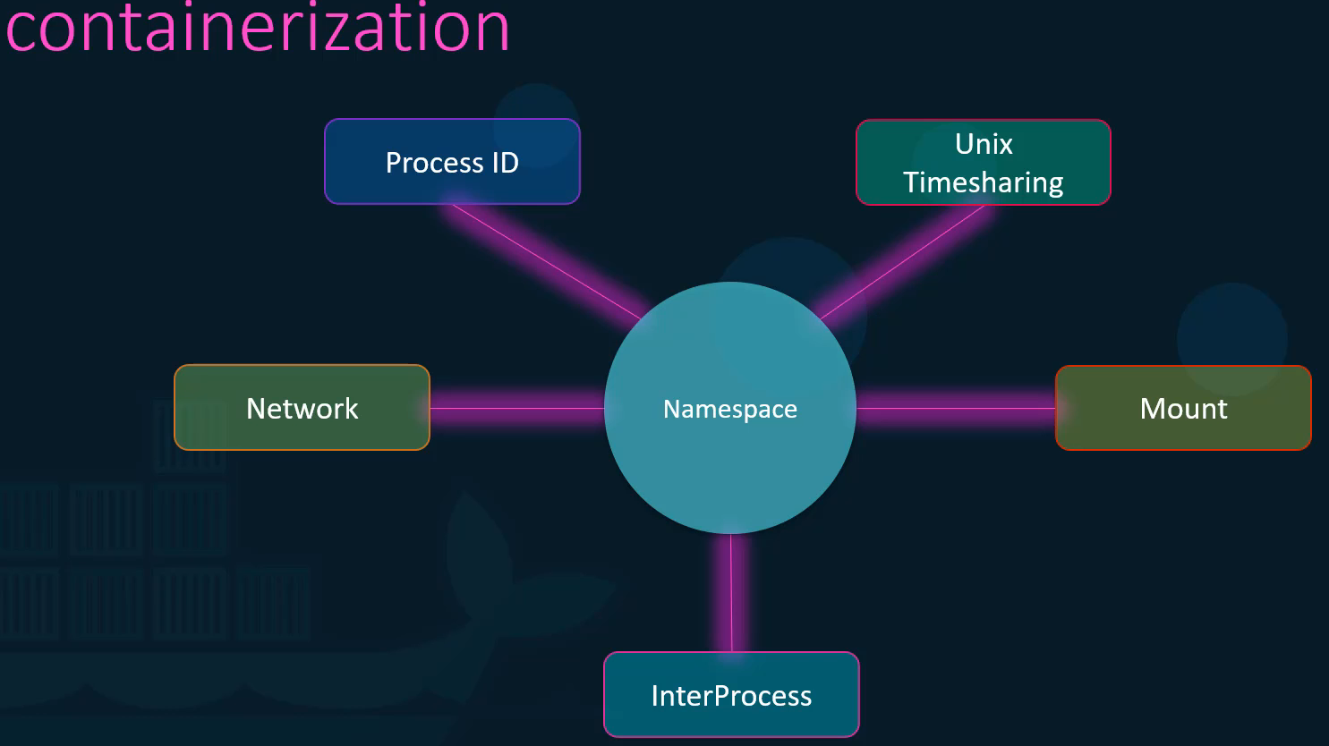

Let's take a look at one of the namespace isolation technique process ID (PID) namespace. Whenever a Linux system boots up it starts with just one process with a process idea of one. This is the root process and kicks off all the other processes in the system. By the time the system boots up completely we have a handful of processes running. This can be seen by running the ps command to list all the running processes. The processes IDs are unique and two processes cannot have the same process I.D. Now if we were to create a container which is basically like a child system within the current system the child system needs to think that it is an independent system on its own and it has its own set of processes originating from a root process with a process I.D. of one. But we know that there is no hard isolation between the containers and the underlying host. So, the processes running inside the container are in fact processes running on the underlying host. And so two processes cannot have the same process. I.D. of one. This is where namespace comes into play. With process id namespaces each process can have multiple process ideas associated with it. For example when the processes start in the container it's actually just another set of processes on the base Linux system and it gets the next available process I.D. In this case five and six. However they also get another process I.D. starting with PD 1 in the container namespace which is only visible inside the container so the container things that it has its own root process tree and so it is an independent system. So how does that relate to an actual system. How do you see this on a host. Let's say I were to run a nginx server as a container. We know that the nginx container runs an nginx service. If we were to list all the services inside the docker container we see that the nginx service running with a process ID of one. This is the process id of the service inside of the container namespace. If we list the services on the docker host we will see the same service but with a different process ID.

That indicates that all processes are in fact running on the same host but separated into their own containers using namespaces

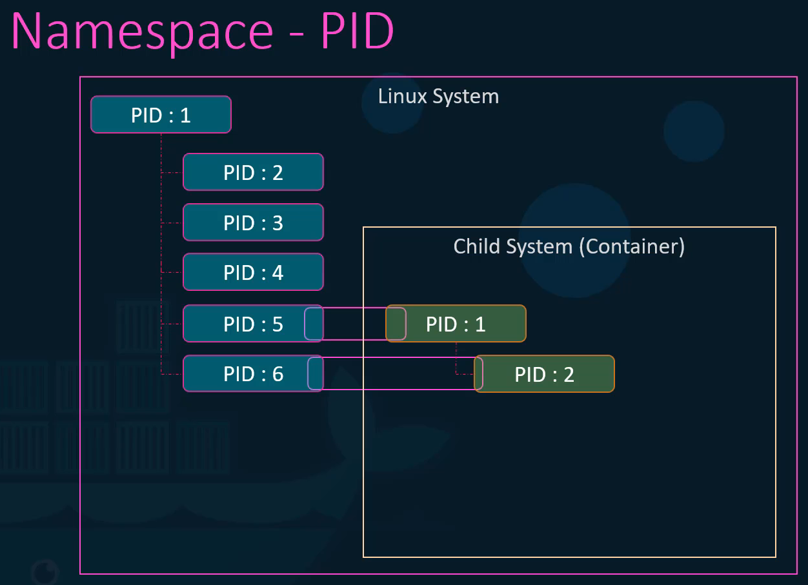

**Resource constraints**

So, we learn that the underlying Docker host as well as the containers shared the same system resources such as CPU and memory. By default, a container has no resource constraints and can use as much of a given resource as the host's kernel scheduler allows. Docker provides ways to control how much memory, or CPU a container can use, setting runtime configuration flags of the docker run command. Docker uses cgroups or control groups to restrict the amount of hardware resources allocated to each container. This can be done by providing the -- cpus option to the docker run command. Providing a value of 0.5 will ensure that the container does not take up more than 50 percent of the host CPU at any given time. The same goes with memory. Setting a value of 100m to the --memory option limits the amount of memory the container can use to 100 megabytes.

Cgroups, or control groups, are a powerful feature of the Linux kernel that allows for precise management of system resources such as CPU, memory, and I/O. When used in Docker, cgroups enable you to effectively allocate and isolate resources for containers, ensuring efficient performance and stability across your applications.

Cgroups (control groups) are a fundamental Linux kernel feature that Docker uses to manage and limit the hardware resources (CPU, memory, disk I/O, and network bandwidth) that a container can consume.

Cgroups help to limit the use of resources so that a single container is not utilizing all the resources available. It allows managing various system resources such as:

* CPU - limit CPU utilization.
* Memory - limit memory usage.
* Disk I/O - limit disk I/O.
* Network - limit network bandwidth.

With the help of cgroups docker engine helps to share available hardware resources with the container and puts a limit on how much resources the container can use.

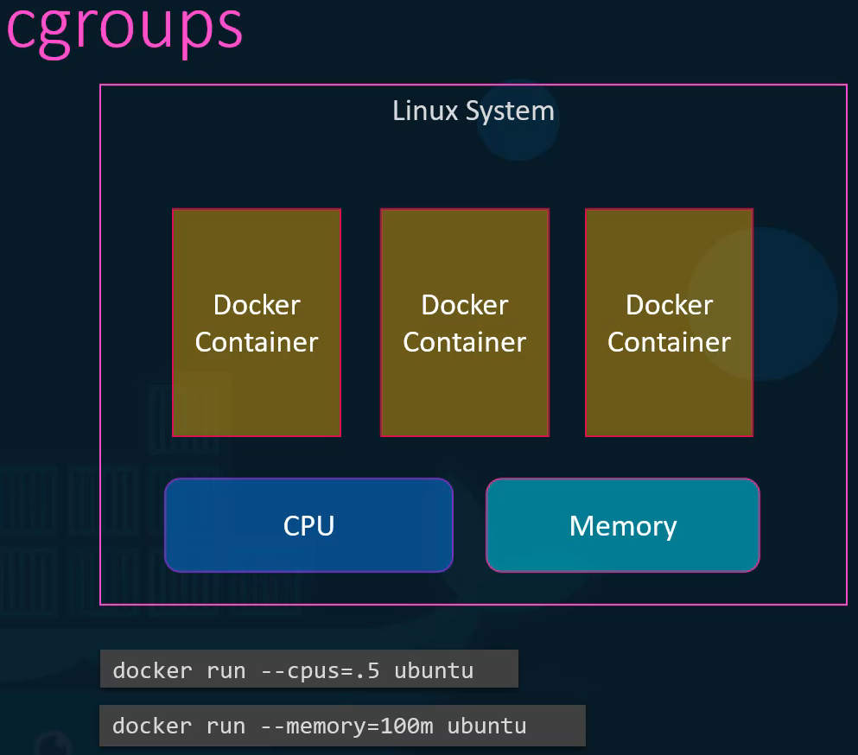

**Docker storage:**

Let’s start with how does a docker stores data on the local file system? When you install Docker on a system it automatically creates this folder structure at **var/lib/docker**. You have multiple folders under it called aufs, containers, image, volumes etc. This is where Doctor stores all its data by default. When I say data, I mean files related to images and containers running on the docker host. For example, all files related to containers are stored under the containers folder and the files related to images are stored under the image folder. Any volumes created by the docker containers are created under the volumes folder.

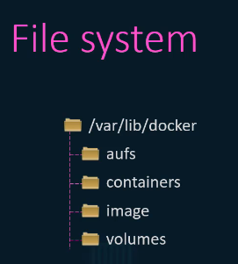 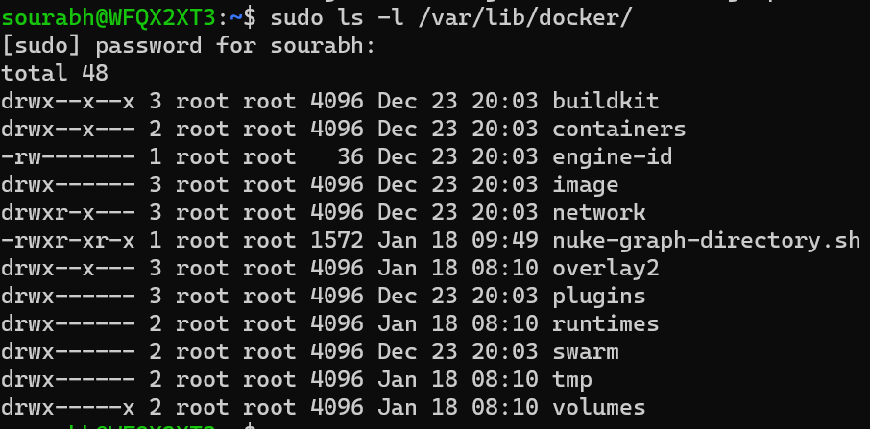

Docker storage covers two different concepts:

* **Container data persistence**: How to store application data outside containers using volumes, bind mounts, and tmpfs mounts. This data persists independently of container lifecycle.
* **Daemon storage backends** (containerd image store and storage drivers): How the daemon stores image layers and container writable layers on disk.

**Container layer basics**

Each line of instruction in the docker file creates a new layer in the Docker image with just the changes from the previous layer.

For example the first layer is a base Ubuntu operating system followed by the second instruction that creates a second layer which installs all the APT packages. And then the third instruction creates a third layer which with the python packages followed by the fourth layer that copies the source code over. And then finally the fifth layer that updates the entry point of the image. Each layer only stores the changes from the previous layer.

To understand the advantages of this layered architecture. Let's consider a second application, this application has a different docker file but is very similar to our first application as it uses the same base image as a ubuntu, uses the same python and flask dependencies but uses a different source code to create a different application. And so a different entry point as well. When I run the docker build command to build a new image for this application, since the first three layers of both the applications are the same docker is not going to build the first three layers. Instead it reuses the same three layers it built for the first application from the cache and only creates the last two layers with the new sources and the new entry point this way Docker builds images faster and efficiently saves disk space. This is also applicable if you want to update your application code whenever you update your application code such as the app.py in this case docker simply reuses all the previous layers from cache and quickly rebuilds the application image by updating the latest source code thus saving us a lot of time during rebuilds and updates.

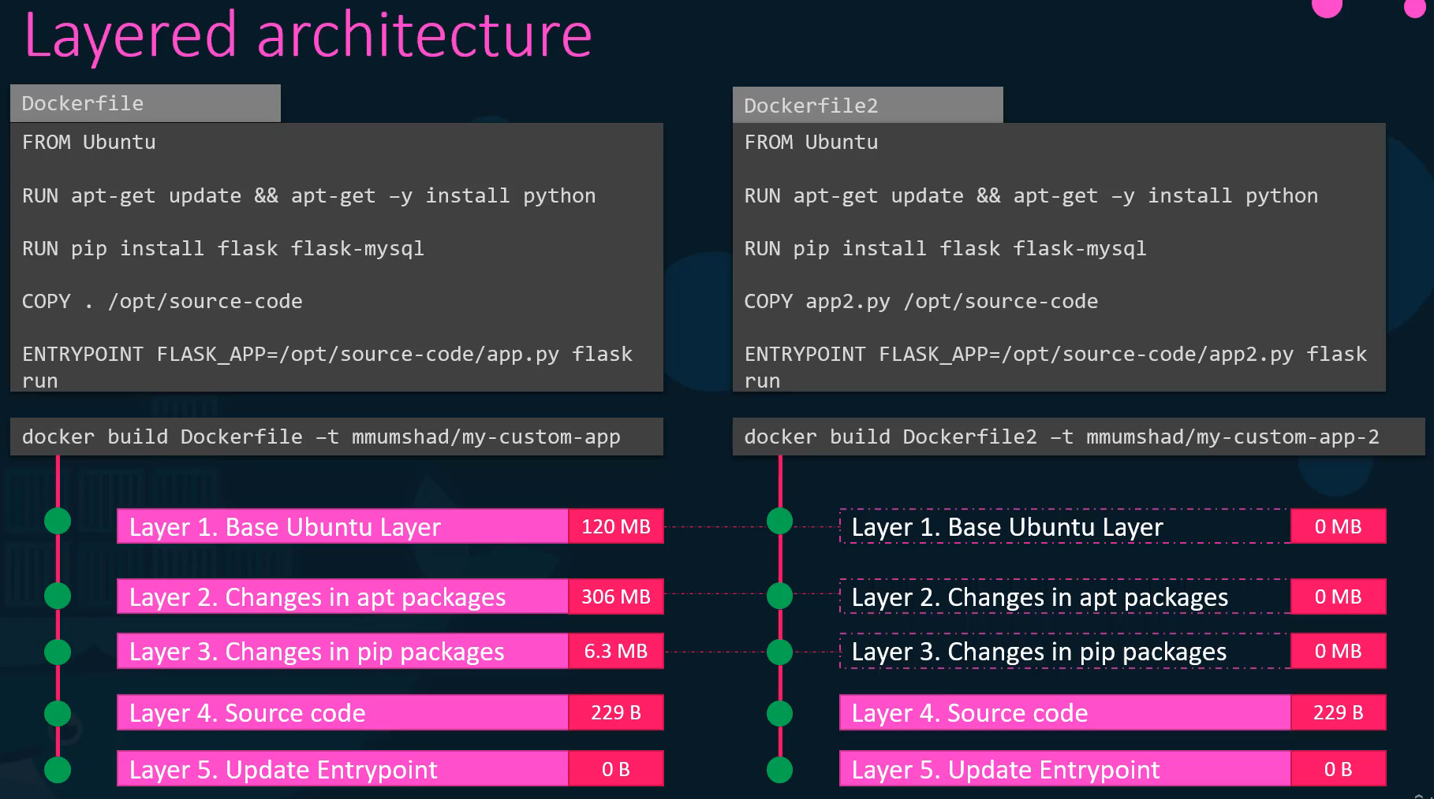

Let's rearrange the layers bottom up so we can understand it better. At the bottom we have the base ubuntu layer then the packages then the dependencies and then the source code of the application and then the entry point all of these layers are created. When we run the docker build command to form the final Docker image so all of these are the docker **image layers**. Once the build is complete you cannot modify the contents of these layers and so they are read only and you can only modify them by initiating a new build. When you run a container based off of this image using the docker run command Docker creates a container based off of these layers and creates a new writable layer on top of the image layer. Remember that the same image layer is shared by all containers created using this image.

By default, all files created inside a container are stored on a writable **container layer** that sits on top of the read-only, immutable image layers. Data written to the container layer doesn't persist when the container is destroyed. This means that it can be difficult to get the data out of the container if another process needs it. The writable layer is unique per container. You can't easily extract the data from the writeable layer to the host, or to another container.

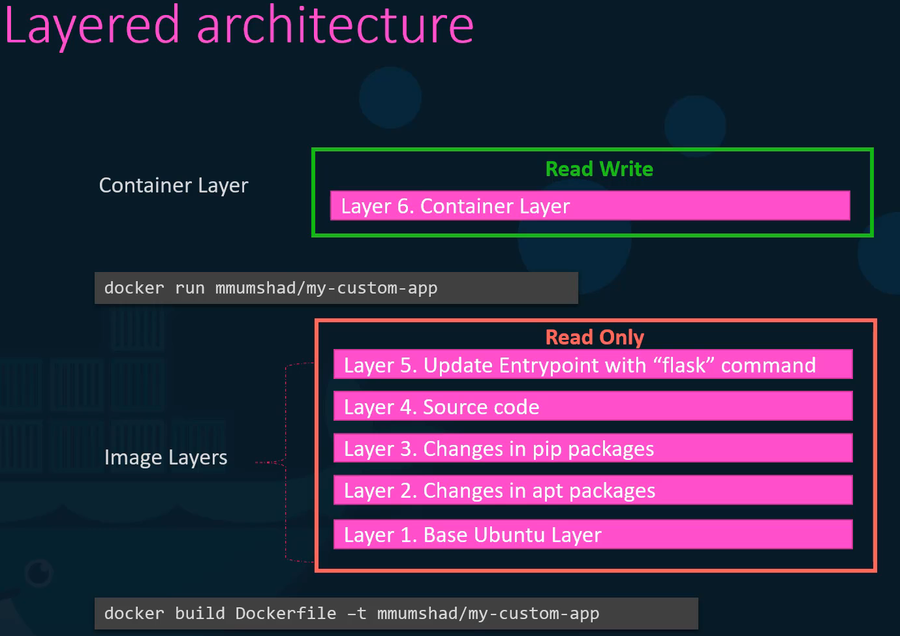

If I want to log into the newly created container and say create a new file called temp.txt. It would create that file in the container layer which is read and write. We just said that the files in the image layer are read only meaning you cannot edit anything in those layers. Let's take an example of our application code since we bake our code into the image. The code is part of the image layer and as such is read only after running a container. What if I wish to modify the source code to say test a change. Remember the same image layer may be shared between multiple containers created from this image. So does it mean that I cannot modify this file inside the container. No, I can still modify this file but before I save the modified file Docker automatically creates a copy of the file in the read write layer and I will then be modifying a different version of the file in the read write layer. All future modifications will be done on this copy of the file in the read write layer. This is called copy on write mechanism. The image layer being read only just means that the files in these layers will not be modified in the image itself so the image will remain the same all the time suntil you rebuild the image using the docker build command.

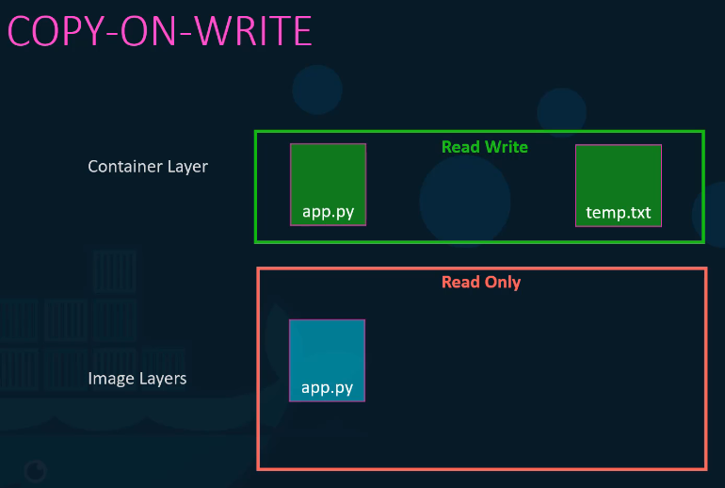

What happens when we get rid of the container all of the data that was stored in the container layer also gets deleted. So, what if we wish to persist this data. For example, if we were working with a database and we would like to preserve the data created by the container we could add a persistent volume to the container to do this first create a volume using the **docker volume create** command. So when we run the **docker volume create data_volume** command it creates a folder called data_volume under the **/var/lib/docker/volumes** directory. Then when I run the docker container using the docker run command I could mount this volume inside the docker containers read write layer using the -v option like this. So I would do a docker run -v then specify my newly created volume name i.e. data_volume followed by a colon and the location inside my container which is the default location where MySQL stored data and that is var/lib/mysql. And then the image name mysql (**docker run -v data_volume:/var/lib/mysql mysql**). This will create a new container and mount the data volume we created into var/lib/mysql folder inside the container, so all data written by the database is in fact stored on the volume created on the docker host. Even if the container is destroyed the data is still active.

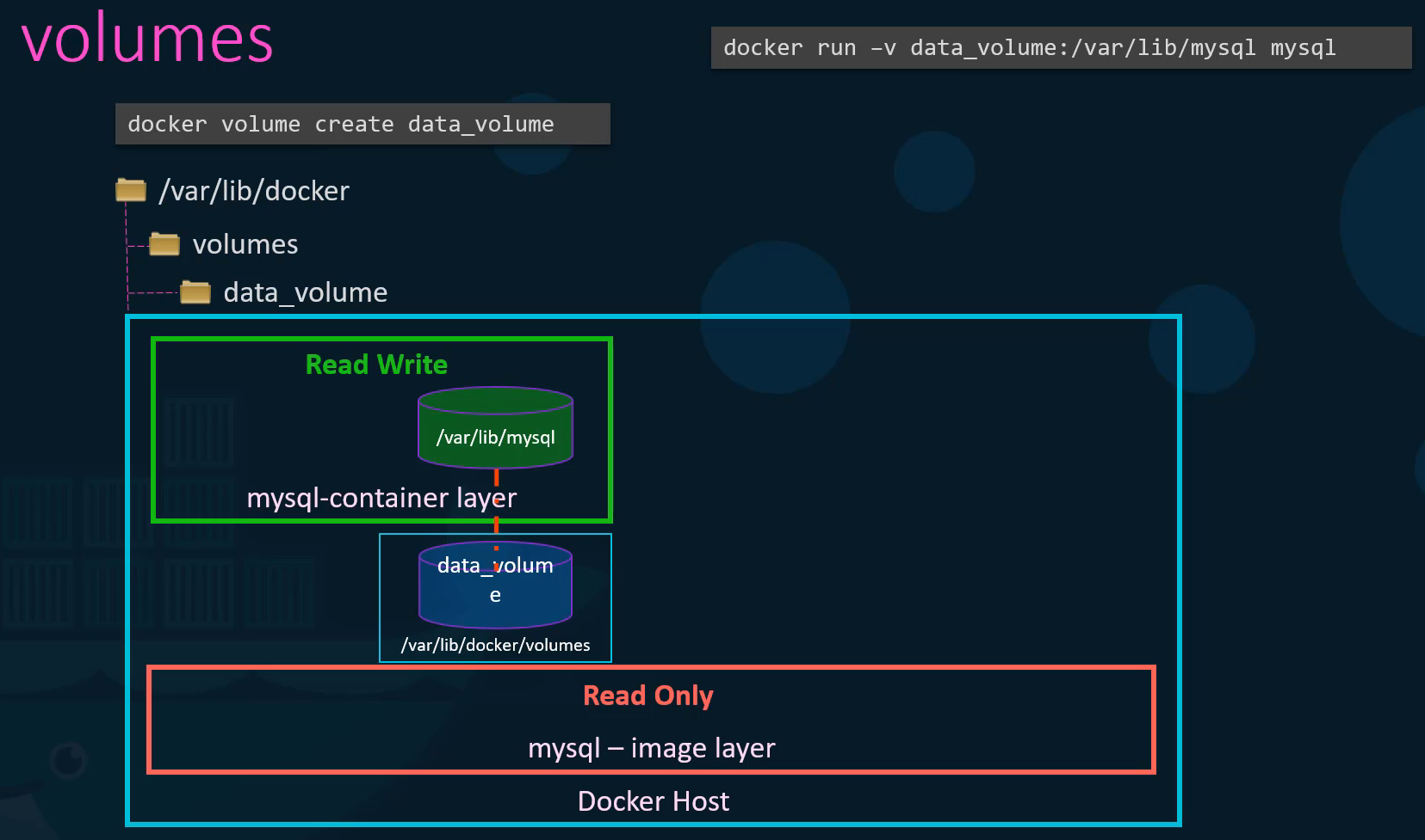

Now what if you didn't run the docker volume create command to create the volume before the docker run command. For example, if I run the docker run command to create a new instance of mysql container with the volume data_volume 2 which I have not created yet. Docker will automatically create a volume named data_volume 2 and mount it to the container. You should be able to see all these volumes if you list the contents of the **/var/lib/docker/volumes** folder. This is called **volume mounting** as we are mounting in volume created by Docker under the /var/lib/docker/volumes folder.

But what if we had our data already at another location for example, let's say we have some external storage on the docker host at **/data** and we would like to store database data on that volume and not in the default /var/lib/docker/volumes folder. In that case we would run a container using the command docker run -v but in this case we will provide the complete part to the folder we would like to mount. That is /data/msql and so it will create a container and mount the folder to the container. This is called **bind mounting**. So, there are two types of mounts a volume mounting and a bind mount volume mount mounts a volume from the volumes directory and bind mount mounts a directory from any location on the docker host.

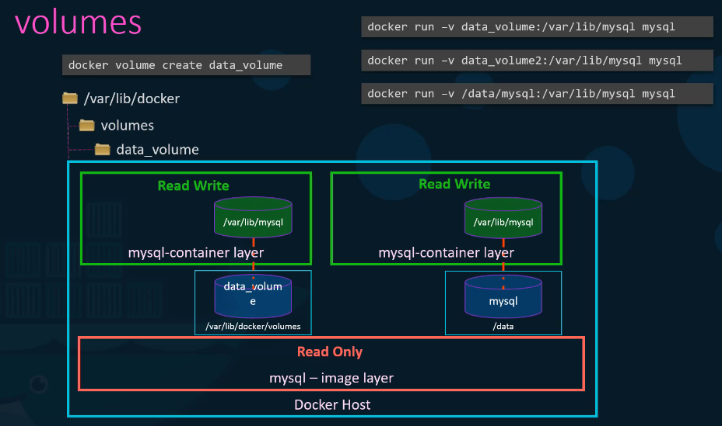

Using the -v is an old style, the new way is to use **--mount** option. The --mount is the preferred way as it is more verbose. So, you have to specify each parameter in a key equals value format. For example, the previous command can be written with the --mount option as this using the type, source and target options. The type in this case is bind the source is the location on my host and target is the location on my container

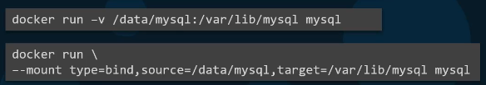

So, who is responsible for doing all of these operations. Maintaining the layered architecture, creating a writable layer, moving files across layers to enable copy and write etc. It's the **storage drivers**. Docker uses storage drivers to store image layers, and to store data in the writable layer of a container. The container's writable layer doesn't persist after the container is deleted, but it is suitable for storing ephemeral data that is generated at runtime. Docker uses storage drivers to enable layered architecture such as creating layers and maintaining the layers and the files related to each layer. Some of the common storage drivers are AUFS, BTRFS, ZFS, device-mapper, overlay and overlay2. The selection of the storage driver depends on the underlying OS being used. For example, with ubuntu the default storage driver is AUFS, whereas this storage driver is not available on other operating systems like fedora or cent OS. In that case device mapper may be a better option. Docker will choose the best storage driver available automatically based on the operating system. To see what is the storage driver being used in this particular system, run **docker info** command. The docker info command lists information about the docker installed on this particular system. The different storage drivers also provide different performance and stability characteristics so you may want to choose one that fits the needs of your application and your organization.

**1)** Run a mysql container named **mysql-db** using the **mysql** image. Set database password to **db_pass123** and map a volume to the container so that the data stored by the container is stored at **/opt/data** on the host. Mysql stores data at **/var/lib/mysql** inside the container. Note: Remember to run it in the detached mode.

**>> docker run -v /opt/data:/var/lib/mysql -d --name mysql-db -e MYSQL_ROOT_PASSWORD=db_pass123 mysql**

**Docker Networking**

Container networking refers to the ability for containers to connect to and communicate with each other, and with non-Docker network services. Docker networking allows containers to communicate with each other, the host system, and external networks. By default, containers are assigned an internal IP address and network connectivity is enabled. Docker uses different network **drivers** to provide various levels of isolation and connectivity based on application requirements. It's a powerful feature that enables you to build complex, multi-container applications that are isolated yet interconnected.

Containers have networking enabled by default, and they can make outgoing connections. A container has no information about what kind of network it's attached to, or whether its network peers are also Docker containers. A container only sees a network interface with an IP address, a gateway, a routing table, DNS services, and other networking details.

**Core Networking Concepts**

To understand how Docker manages this, let's look at a few core Linux networking features that Docker uses:

* **Network Namespaces**: This is a Linux kernel feature that provides network isolation. Each container gets its own network namespace, complete with its own network interfaces, IP addresses, and routing tables. This is why a container can't see the network traffic of another container or the host.
* **Virtual Ethernet Devices (veth pairs)**: To connect a container's isolated namespace to the host's network, Docker uses a veth pair. Think of it as a virtual patch cable. One end is plugged into the container's namespace (appearing as eth0), and the other is plugged into the host's main namespace, usually attached to a virtual bridge.
* **iptables**: Docker uses the host's iptables rules (a firewall utility) to manage port mapping and network address translation (NAT). When you expose a port (e.g., -p 8080:80), iptables rules are created to forward traffic from port 8080 on the host to port 80 inside the container.

**Network Drivers**

Docker Engine has a number of network drivers, as well as the default "bridge". On Linux, the following built-in network drivers are available:

| **Driver** | **Description** |
| --- | --- |
| [bridge](https://docs.docker.com/engine/network/drivers/bridge/) | The default network driver. |
| [host](https://docs.docker.com/engine/network/drivers/host/) | Remove network isolation between the container and the Docker host. |
| [none](https://docs.docker.com/engine/network/drivers/none/) | Completely isolate a container from the host and other containers. |
| [overlay](https://docs.docker.com/engine/network/drivers/overlay/) | Swarm Overlay networks connect multiple Docker daemons together. |
| [ipvlan](https://docs.docker.com/engine/network/drivers/ipvlan/) | Connect containers to external VLANs. |
| [macvlan](https://docs.docker.com/engine/network/drivers/macvlan/) | Containers appear as devices on the host's network. |

* **Bridge (default)**: This is the default driver for standalone containers. It creates a private, internal network on the host. Containers on the same bridge network can communicate with each other using their internal IP addresses. To access them from outside the host, you must map ports. It's highly recommended to create your own user-defined bridge networks rather than using the default one.
* **host**: This driver removes network isolation entirely. Removes network isolation between the container and the Docker host. The container shares the host's network namespace. This means the container uses the host's IP address directly, and any port the container listens on is opened on the host. This can be simpler and offer better performance but sacrifices the security of network isolation.
* **overlay**: This driver is used for multi-host networking and is the preferred choice for Docker Swarm services. It creates a distributed network that spans multiple Docker hosts, allowing containers (and Swarm services) on different hosts to communicate directly and securely. It uses VXLAN to create a virtual network across multiple machines.
* **none**: This driver gives the container a network stack but attaches it to no network. The container is completely isolated and cannot communicate with other containers or the outside world. It's useful for running batch jobs or tasks that require no network access.
* **macvlan**: This advanced driver allows you to assign a MAC address to a container, making it appear as a physical device on your network. This is useful for integrating with legacy applications or network monitoring tools that expect devices to have a physical network presence.
* **ipvlan**: Similar to macvlan, but provides more control over IP addressing and VLAN tagging at Layer 2 or Layer 3, without requiring a unique MAC address per container.

When you install Docker, it creates three networks automatically **bridge**, **none** and **host**. Bridge is the default network a container gets attached to. If you would like to associate the container with any other network, you can specify the network information using **--network** option.

When Docker Engine on Linux starts for the first time, it has a single built-in network called the "**default bridge**" network. When you run a container without the **--network** option, it is connected to the default bridge. The Bridge network is a private internal network created by Docker on the host. Containers attached to the default bridge have access to network services outside the Docker host. By default, all containers connected to this network are assigned an internal IP address. Containers can access each other using this internal IP. If required to access any of these containers from the outside world, map the ports of these containers to ports on the docker host.

Another way to access the containers externally is to associate the container with the **host network**. This takes out any network isolation between the docker host and the docker container. Meaning if you were to run a web server on Port 5000 in a web container it is automatically as accessible on the same port externally without requiring any port mapping as the web container uses the host’s network. This would also mean that unlike before you will now not be able to run multiple web containers on the same host on the same port as the ports are now common to all containers in the host network.

With the **none network** the containers are not attached to any network and doesn't have any access to the external network or other containers. They run in an isolated network.

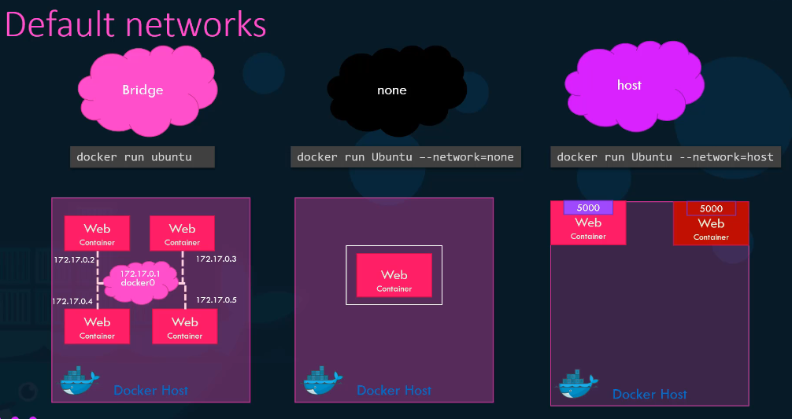

**User-defined network**

Consider a default bridge network with the network id 172.17.0.1 So all containers associated to this default network will be able to communicate with each other.   
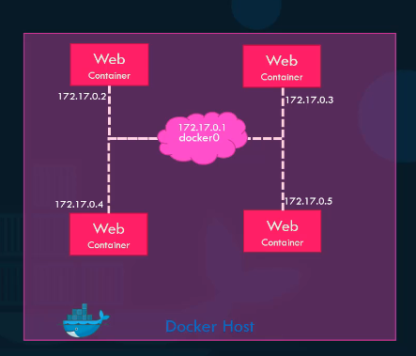  
But what if we wish to isolate the containers within the docker host, for example the first two web containers on internal network 172 (172.17.0.1) and the second two containers on a different internal network like 182 (182.18.0.1). By default, Docker only creates one internal bridge network. We could create our own internal network using the command **docker network create** and specify the driver which is **bridge** in this case and the **subnet** for that network followed by the **custom isolated network** name. Use the **docker network ls** command to list all networks available in Docker.

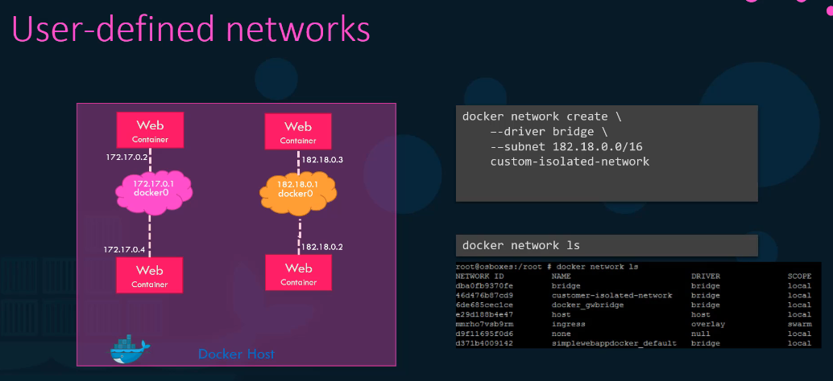

**1)** Create a new network named wp-mysql-network using the bridge driver. Allocate subnet 182.18.0.0/24. Configure Gateway 182.18.0.1

>> **docker network create --driver bridge --subnet 182.18.0.0/24 --gateway 182.18.0.1 wp-mysql-network**

Inspect the created network by **docker network inspect wp-mysql-network**

**2)** Deploy a mysql database using the mysql:5.7 image and name it mysql-db. Attach it to the newly created network wp-mysql-network

Set the database password to use db_pass123. The environment variable to set is MYSQL_ROOT_PASSWORD.

**>> docker run -d -e MYSQL_ROOT_PASSWORD=db_pass123 --name mysql-db --network=wp-mysql-network mysql:5.7**

(**Note**: you can also use attach network like –network wp-mysql-network)

**3)** Deploy a web application named webapp using the kodekloud/simple-webapp-mysql image. Expose the container’s port 8080 to port 38080 on the host.

The application makes use of two environment variable:

1: DB_Host with the value mysql-db.

2: DB_Password with the value db_pass123.

Make sure to attach it to the newly created network called wp-mysql-network.

**>> docker run --network=wp-mysql-network -e DB_Host=mysql-db -e DB_Password=db_pass123 -p 38080:8080 --name webapp --link mysql-db:mysql-db -d kodekloud/simple-webapp-mysql**

**Inspect Network**

To see the network settings and the IP address assigned to an existing container run the **docker inspect** command with the I.D. or name of the container and you will find a section on network settings. There you can see the type of network the container is attached to its internal IP address, mac address and other settings

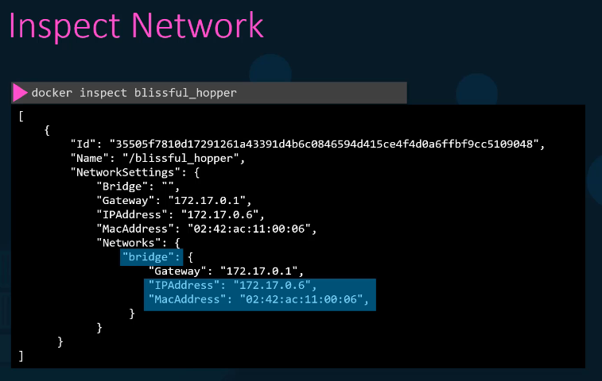

**Embedded DNS**

Containers can reach each other using their names. For example, in this case I have a web server and MySQL database container running on the same node. How can I get my web server to access the database on the database container. One thing I could do is to use the internal IP address assigned to the MySQL container which in this case is 172.70.0.3, but that is not very ideal because it is not guaranteed that the container will get the same IP when the system reboots. The right way to do it is to use the container name. All containers in a docker host can resolve each other with the name of the container. Docker has a built in DNS server that helps the containers to resolve each other using the container name. Note that the built in DNS server always runs at address 127.0.0.11.

So how does Docker implement networking. What's the technology behind it. How were the containers isolated within the host Docker users network namespaces that creates a separate namespace for each container. It then uses virtual ethernet pairs to connect containers together.

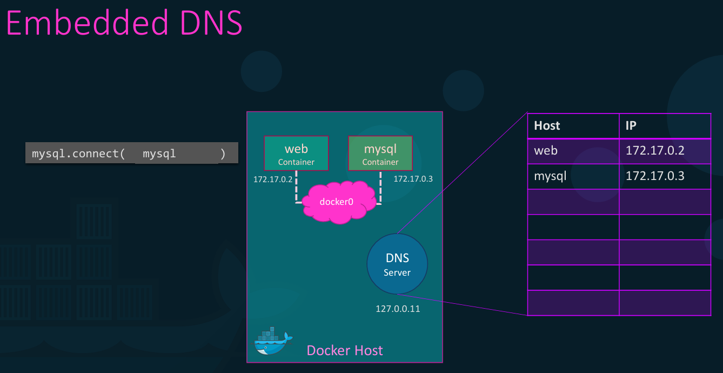

**Docker on windows**

There are two options available for Docker on windows. (**Note**: containers share the underlying OS kernel and as a result we cannot have a Windows container running on Linux host or vice versa)

The first one is Docker on windows using **Docker toolbox** and the second one is the **Docker desktop** for Windows

Both the options will help you run a Linux container on a Windows host. We're not talking about Windows applications or Windows images or Windows containers. It is strictly for Linux containers.

**Docker toolbox**: This was the original support for Docker on Windows. The Docker tool box contains a set of tools like Oracle virtual box, Docker engine, Docker machine, Docker compose and a user interface called kitematic. You must ensure that your operating system is 64 bit Windows 7 or higher and that virtualization is enabled on the system.

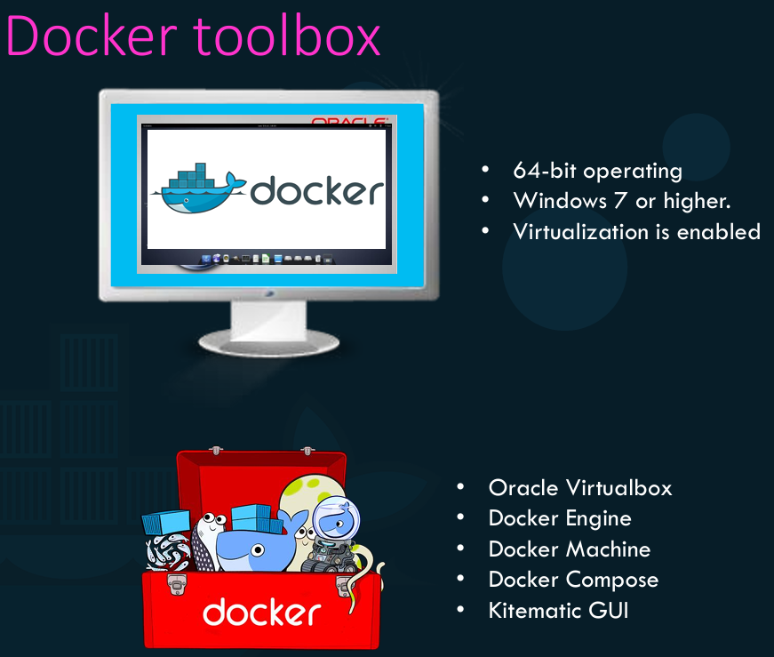

**Docker desktop (Docker for Windows)**: With Docker desktop for Windows, we take out Oracle a virtual box and use the native virtualization technology available with Windows called Microsoft Hyper-V during the installation process for Docker for Windows. It will still automatically create a Linux system underneath but this time it is created on the Microsoft Hyper-V instead of Oracle virtual box and have Docker running on that system. Because of this dependency on Hyper-V this option is only supported for Windows 10 enterprise or professional edition and on Windows Server 2016 because both these operating systems come with hyper v support by default.

With Windows Server 2016. Microsoft announced support for Windows containers. For the first time you can now package Windows applications into Windows docker containers and run them on the windows docker host using Docker desktop for windows. When you install Docker desktop for Windows the default option is to work with Linux containers but if you would like to run Windows containers then you must explicitly configure Docker for Windows to switch to using Windows containers.

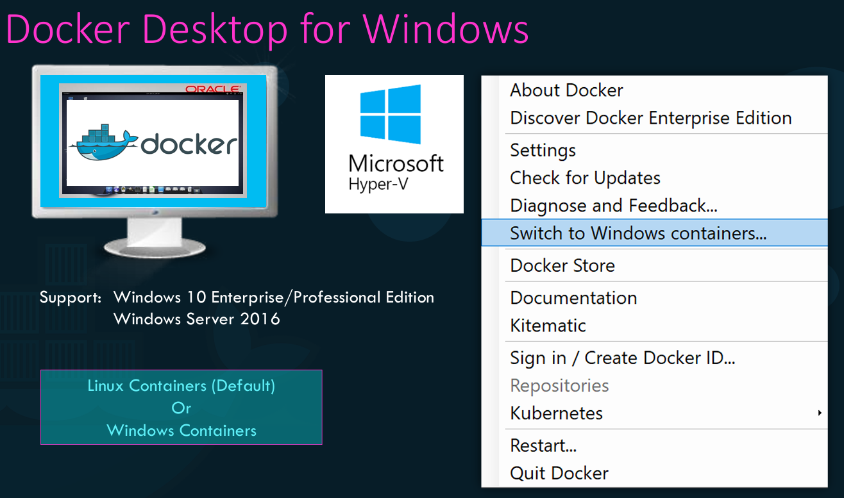

Unlike in Linux there are two types of containers in windows. The first one is a **Windows server** container which works exactly like Linux containers where the OS kernel is shared with the underlying operating system. To allow better security boundary between containers and to allow kernels with different versions and configurations to coexist. The second option was introduced known as **Hyper-V isolation.** With Hyper-V isolation each container is run within a highly optimized virtual machine guaranteeing complete kernel isolation between the containers and the underlying host.

In the Linux world you had a number of base images for Linux systems such as Ubuntu, Debian, fedora, Alpine etc. that is what you specify at the beginning of the docker file. In the windows world we have two options. The **Windows Server Core** and **Nano server.** A nano server is a headless deployment option for Windows Server which runs at a fraction of size of the full operating system. You can think of this like the Alpine image in Linux.

I want to point out one important fact. We saw two ways of running a docker container using virtual box or hyper v. But remember virtual box and hyper we cannot coexist on the same windows host. So, if you started off with docker toolbox with virtual box and if you plan to migrate to hyper v remember you cannot have both solutions at the same time.

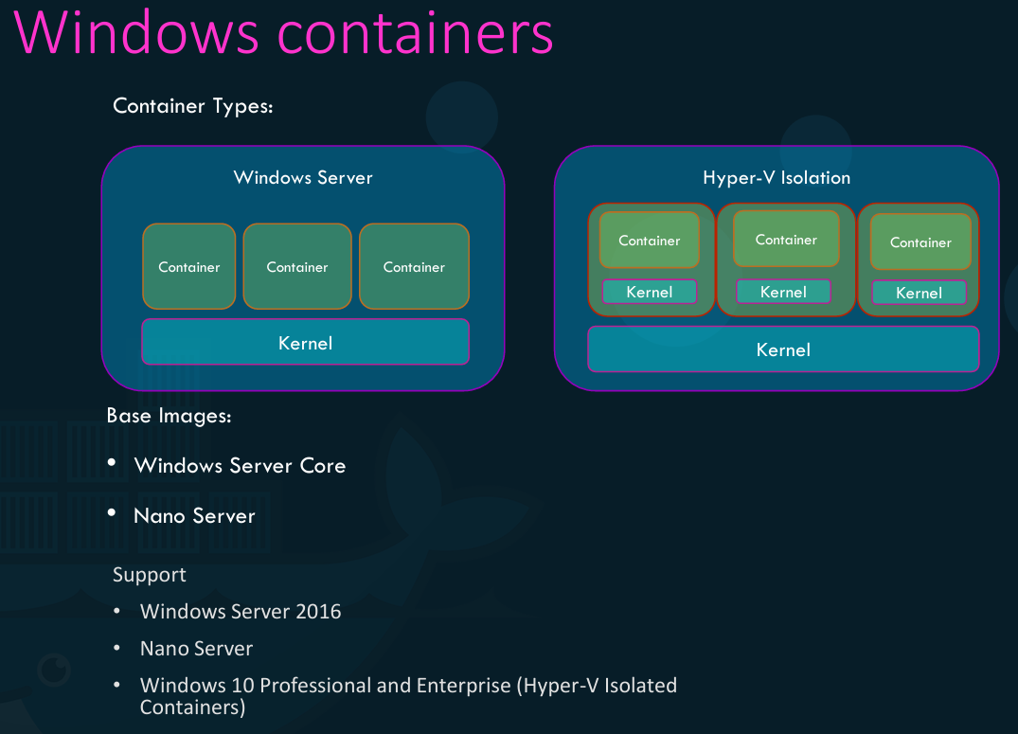

**Summary Points:**

Docker on Windows has two options

**1)** **Docker on Windows using Docker Toolbox** - Docker on Linux VM on Oracle Virtual Box on Windows

* Docker Toolbox Requirements
* 64-bit operating system
* Windows 7 or Higher
* Virtualization enabled on Windows
* Docker Toolbox Contents
* Oracle Virtualbox
* Docker Engine
* Docker Machine
* Docker Compose
* Kitematic GUI

**2)** **Docker For Windows (Docker Desktop for Windows)** - Docker on Linux VM on Windows Hyper-V on Windows

* Docker For Windows Requirements
* Windows 10 Enterprise/Professional Edition
* Windows Server 2016
* Docker For Windows supports Linux Containers (Default) and Windows Containers
* Docker For Windows Container Types:
* Windows Server Core: Windows container on native windows server core
* Hyper-V Isolation: Windows container on an isolated hyper-v kernel

**Container Orchestration (Container Management Tool):**

Now we have our application packaged into a Docker container. But what's next? How do you run it in production? What if your application relies on other containers, such as databases or messaging services or other backend services? What if the number of users increases you need to scale your application? How do you scale down when the load decreases? To enable these functionalities, you need an underlying platform with a set of resources and capabilities. The platform needs to orchestrate the connectivity between the containers and automatically scale up or down based on the load. This whole process of automatically deploying and managing containers is known as container orchestration.

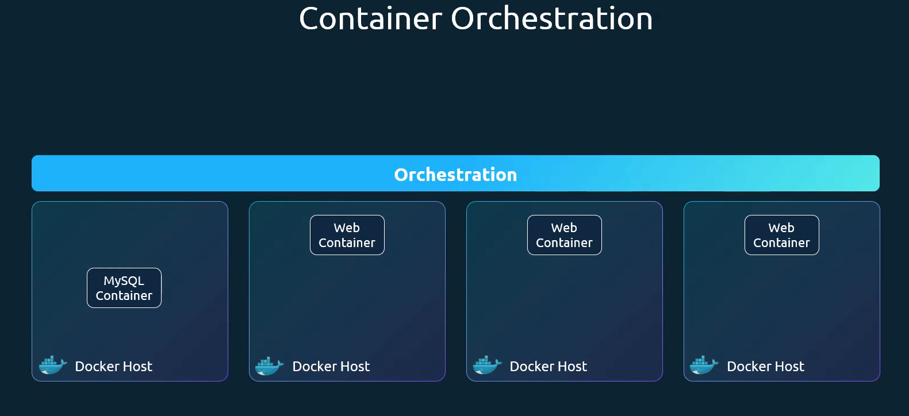

Managing a single containerized application is relatively straightforward, but scaling to hundreds or thousands across a distributed system introduces significant challenges in ensuring availability, interconnectivity, and scalability. Container orchestration addresses these complexities.

**Container orchestration is the system that automatically provisions, deploys, scales, and manages containerized applications without worrying about the underlying infrastructure.**

Container orchestration is a software technology that allows the automatic management of containers. This is necessary for modern cloud application development because an application might contain thousands of microservices in their respective containers. The large number of containerized microservices makes it impossible for software developers to manage them manually.

Container orchestration is the process of automating the deployment, management, scaling, and networking of containers throughout their lifecycle, making it possible to deploy applications consistently across many different environments at scale. Containerization bundles an application’s code with all the files and libraries it needs to run on any infrastructure. Microservices architectures can have hundreds, or even thousands, of containers as applications grow and become more complex. Container orchestration tools aim to simplify container infrastructure management by automating their complete lifecycle—from provisioning and scheduling to deployment and deletion. Organizations can benefit from containerization at scale without incurring additional maintenance overheads. Tools to manage, scale, and maintain containerized applications are called orchestrators. Two of the most popular orchestration tools are **Kubernetes** and **Docker Swarm**. Kubernetes is just a container orchestration technology. There are multiple such technologies available today. Docker has its own tool called Docker Swarm, Kubernetes from Google and Mesos from Apache.

While [Kubernetes](https://cloud.google.com/learn/what-is-kubernetes) is the leading open-source platform for this task, fully managed container orchestration tools, like Google Kubernetes Engine (GKE), simplify the deployment and ongoing management, abstracting away much of the operational burden associated with Kubernetes. Today, [Kubernetes](https://www.ibm.com/topics/kubernetes) is the most popular container orchestration platform, and most leading cloud service providers—including Amazon Web Services (AWS), Google Cloud Platform, IBM Cloud® and Microsoft Azure—offer managed Kubernetes services. Other container orchestration tools include **Docker Swarm** and **Apache Mesos.**

**Popular Tools:** Kubernetes, Docker Swarm, Apache Mesos, OpenShift, GitLab, Spacelift, Rancher

* **Kubernetes (K8s):** The industry standard, powerful and feature rich
* [**Docker Swarm**](https://www.google.com/search?q=Docker+Swarm&sca_esv=0e7ec9ce2aa7d5b4&rlz=1C1GCEB_en&sxsrf=ANbL-n5qcWR5Fb1NjHhnyUjrSWqZ4RyKLA%3A1769065160524&ei=yMpxafDcH_aL4-EPtvTt-Ac&ved=2ahUKEwjEvqasyZ6SAxUayzgGHSMPB_UQgK4QegYIAQgIEAI&uact=5&oq=container+orchestration&gs__QGyBwgwLjYuMTUuMrgHtSnCBwgwLjIuMjAuMsgHdIAIAA&sclient=gws-wiz-serp)**:** Simpler, integrated with Docker
* [**Apache Mesos**](https://www.google.com/search?q=Apache+Mesos&sca_esv=0e7ec9ce2aa7d5b4&rlz=1C1GCEB_en&sxsrf=ANbL-n5qcWR5Fb1NjHhnyUjrSWqZ4RyKLA%3A1769065160524&ei=yMpxafDcH_aL4-EPtvTt-Ac&ved=2ahUKEwjEvqasyZ6SAxUayzgGHSMPB_UQgK4QegYIAQgIEAQ&uact=5&oq=container+orchestration&gs__QGyBwgwLjYuMTUuMrgHtSnCBwgwLjIuMjAuMsgHdIAIAA&sclient=gws-wiz-serp)**:** A distributed systems kernel for large-scale clusters

**Why is container orchestration necessary?**

Containers have become the standard unit of computing for cloud-native applications. Cloud providers offer virtual server instances for running all sorts of computing workloads, and are a perfect fit for container-based workloads. The only requirement to be able to run containers is that the server itself runs a containerization service like Docker. [Docker](https://aws.amazon.com/docker/) is an open source tool for packaging software and associated libraries, system tools, code, and runtime into a container. It is a lightweight solution for running and managing a few containers on a single server instance, but scaling becomes a challenge.

Before managed container orchestration platforms existed, organizations used complex scripting to manage container deployment, scheduling, and deletion across multiple machines. Maintaining these scripts created challenges, like version control, and setup was difficult to scale. Container orchestration automates and resolves these complexities, removing challenges associated with manual management.

**Container orchestration use cases**

Container orchestration tools become necessary when you have to:

* Manage and scale containers across a number of instances.
* Run many different containerized applications.
* Run different versions of applications (for example, test and production across CI/CD) at once.
* Ensure app service continuity in case of a server failure by running multiple duplicate instances (replicas) of a container.
* Run multiple instances of an app across multiple different geographical regions.
* Maximize usage of multiple server instances for budgeting purposes.
* Run large containerized applications comprised of thousands of different microservices.

**What is container orchestration used for?**

Use container orchestration to automate and manage tasks such as:

* Provisioning and deployment
* Configuration and scheduling
* Resource allocation
* Container availability
* Scaling or removing containers based on balancing workloads across your infrastructure
* Load balancing and traffic routing
* Monitoring container health
* Configuring applications based on the container in which they will run
* Keeping interactions between containers secure

**What are the benefits of container orchestration?**

Managing complex container architectures without a container orchestration solution can be difficult. Developers use container orchestration tools to automatically start, stop, and manage containers. Container orchestrators allow developers to scale cloud applications precisely and avoid human errors. For example, you can verify that containers are deployed with adequate resources from the host platform. Container orchestration manages container creation, configuration, scheduling, deployment, and deletion. It also supports:

* Application load balancing and traffic management.
* App service continuity across containers.
* Security across containerization.
* Container status monitoring.
* Resourcing containers from underlying server or instance resources.

The following are more benefits of container orchestrations.

**Built-in resilience**

Simple containerization services typically will not restart a container if it goes offline. Similarly, if the machine that a container is running on goes down, the container won’t be restarted when the machine restarts. Container orchestration solutions can ensure that containers are automatically restarted or that more than one version is running at all times in case of machine failure.

**Enhanced performance**

One of the biggest benefits of container orchestration is that it automates the scalability, availability, and performance of containerized apps. You can configure container orchestration tools to scale based on demand, network availability, and infrastructure restrictions. The container orchestration solution can monitor performance across the container network and automatically reconfigure containers for optimal performance.

**Resource optimization**

Underlying servers and instances cost money to run and must be used efficiently for cost optimization. Container orchestration allows organizations to maximize the usage of each available instance, as well as instantiate on-demand instances if resources run out. This leads to cost savings in infrastructure.

**How does container orchestration work?**

Containers are self-contained Linux-based applications or microservices bundled with all the libraries and functions they need to run on almost any type of machine. Container orchestration works by managing containers across a group of server instances (also called *nodes*). A group of nodes that runs interconnected containers is called a *cluster*.

Container orchestration requires, first, an underlying containerization solution running on every node in the cluster—typically, this will be Docker. The nodes must also run the orchestration tool. A designated master node, with a control plane, is the controller of the orchestration solution itself. The administrator of the solution uses a GUI or command-line controller on the master node to manage and monitor the container orchestration tool.

**Creation and scheduling**

The container orchestration solution reads a declarative configuration file, written in YAML or JSON, to learn the specific required state of the system. Using the information specified in the file, the tool:

1. Obtains container images from a container registry.
2. Provisions the containers with their individual requirements.
3. Determines the networking required between the containers.

The tool then schedules and deploys the multi-container application across the cluster. This best fit between nodes and containers is determined by the container orchestration tool, rather than specified in the configuration file. The tool selects the actual node to run each container based on the node’s resource constraints, such as CPU, memory, and so on, as well as the defined container requirements.

**Management**

Once the containers are running across the cluster, the orchestration tool manages overall system health to ensure it remains in the specified performance state. This may include:

* Resource allocation across containers.
* Deploying containers to new nodes, or deleting containers.
* Load balancing of traffic to the application.

A container orchestration solution manages the lifecycle of containers to optimize and secure large, complex multi-container workloads and environments. It can manage as many containerized applications as an organization requires. Running multiple master nodes for high availability and fault tolerance is typical under higher organizational demands.

**\*\* Kubernetes\*\***

**How Kubernetes helps with container orchestration**

Kubernetes orchestration allows you to build application services that span multiple containers, schedule containers across a cluster, scale those containers, and manage their health over time.

Kubernetes eliminates many of the manual processes involved in deploying and scaling containerized applications. You can cluster together groups of hosts, either physical or [virtual machines](https://www.redhat.com/en/topics/virtualization/what-is-a-virtual-machine), running Linux containers, and Kubernetes gives you the platform to easily and efficiently manage those clusters.

More broadly, it helps you fully implement and rely on a container-based infrastructure in production environments. These clusters can span hosts across public, private, or hybrid clouds. For this reason, Kubernetes is an ideal platform for hosting cloud-native apps that require rapid scaling.

Kubernetes also assists with workload portability and load balancing by letting you move applications without redesigning them.

**Key concepts of Kubernetes orchestration**

Kubernetes orchestration works by managing a cluster of machines and deploying containers onto them based on the resources they require and the desired state defined by the user. The system is made up of several key concepts that work together.

* **Containers:** These are the lightweight, portable, and executable packages that contain an application and all of its dependencies. Kubernetes orchestrates the deployment and life cycle of these containers.
* **Cluster:**This is the set of all machines, known as nodes, that are grouped together and managed by Kubernetes to run your applications.
* **Control plane:** The control plane is the brain of the [Kubernetes cluster](https://cloud.google.com/discover/what-is-a-kubernetes-cluster). It makes all global decisions about the cluster (like scheduling) and is responsible for detecting and responding to cluster events to maintain the user's desired state.
* **Nodes:**A node is a single worker machine within the cluster, either a physical server or a [virtual machine](https://cloud.google.com/learn/what-is-a-virtual-machine). It is the place where containers are actually run.
* **Pods:** In Kubernetes, pods are the smallest deployable objects, representing a single instance of a running process. They contain one or more containers, shared storage, and a unique network IP.

**Key functions of Kubernetes orchestration**

Kubernetes automates several critical functions that would otherwise require significant manual effort. These core capabilities are what make it such a powerful orchestration platform.

* **Deployment:**Kubernetes helps you describe the desired state for your deployed application. The orchestration engine then manages the rollout of changes, such as updating an application to a new version, in a controlled manner, often with zero downtime.
* **Scaling:**Based on CPU utilization or other custom metrics, Kubernetes can automatically scale the number of running containers up or down. This helps ensure that your application has the resources it needs to handle load while optimizing for cost.
* **Self-healing:**If a container or a node fails, Kubernetes orchestration can automatically detect the failure. It will then restart, replace, or reschedule containers on healthy nodes to help ensure the application remains available without manual intervention.
* **Service discovery and load balancing:** Kubernetes can automatically expose a container to the internet or other containers in the cluster using a stable DNS name. It can also load-balance traffic across multiple containers that provide the same service, to ensure requests are distributed efficiently.
* **Configuration management:** Kubernetes lets you store and manage sensitive information, such as passwords and API keys, as "Secrets." It also handles application configuration data as "ConfigMaps," so you can update configurations without rebuilding your container images.

**Benefits of kubernetes container orchestration**

One of the biggest benefits of container orchestration is that it simplifies operations. Automating tasks not only helps to minimize the effort and complexity of managing containerized apps, it also translates into many other advantages.

**Reliable application development:** Container orchestration tools help make app development faster and repeatable. This increases deployment velocity and makes them ideal for supporting agile development approaches like DevOps.

**Scalability:** Container orchestration allows you to scale container deployments up or down based on changing workload requirements. You also get the scalability of cloud if you choose a managed offering and scale your underlying infrastructure on demand.

**Lower costs:** Containers require fewer resources than [virtual machines](https://cloud.google.com/learn/what-is-a-virtual-machine), reducing infrastructure and overhead costs. In addition, container orchestration platforms require less human capital and time, yielding additional cost savings.

**Enhanced security:** Container orchestration allows you to manage security policies across platforms and helps reduce human errors that can lead to vulnerabilities. Containers also isolate application processes, decreasing attack surfaces and improving overall security.

**High availability:** It’s easier to detect and fix infrastructure failures using container orchestration tools. If a container fails, a container orchestration tool can restart or replace it automatically, helping to maintain availability and increase application uptime.

**Better productivity: s**Container orchestration boosts developer productivity, helping to reduce repetitive tasks and remove the burden of installing, managing, and maintaining containers.

With Kubernetes using the Kubernetes CLI know as “kube control” you can run a thousand instance of the same application with a single command. Kubernetes can scale it up to two thousand with another command. Kubernetes can be even configured to do this automatically so that instances and the infrastructure itself can scale up and down based on user load. Kubernetes can upgrade these two thousand instances of the application in a rolling upgrade fashion one at a time with a single command. If something goes wrong it can help you roll back these images with a single command. Kubernetes can help you test new features of your application by only upgrading a percentage of these instances through AB testing methods. The Kubernetes open architecture provides support for many different network and storage venders. Any network or storage brand that you can think of has a plugin for Kubernetes. Kubernetes supports a variety of authentication and authorization mechanisms. All major cloud service providers have native support for Kubernetes. Kubernetes uses Docker hosts to host applications in the form of Docker containers. Well, it need not be Docker all the time Kubernetes supports alternatives to Dockers as well such as containerd or CRI-O

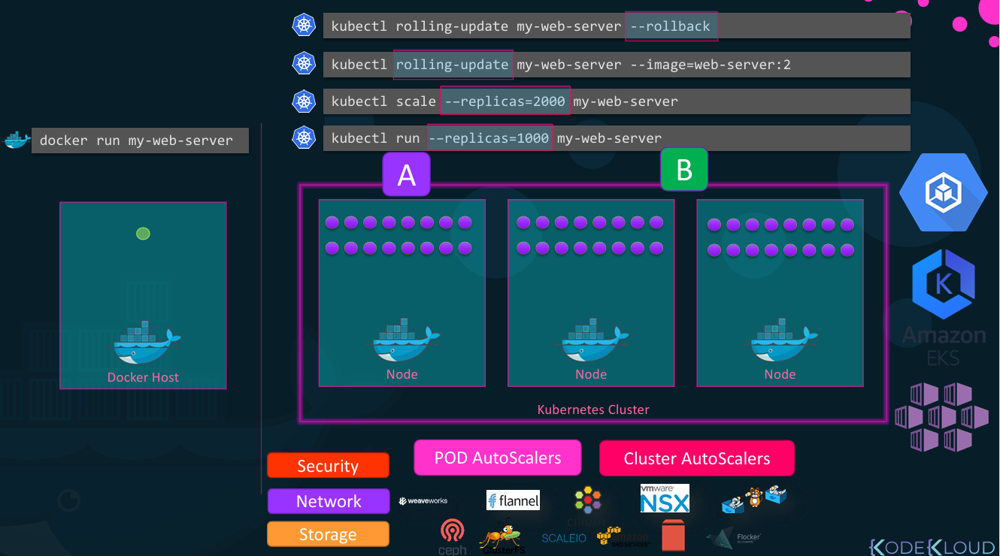

A Kubernetes cluster consists of a set of notes. A cluster is a set of nodes grouped together this way even if one node fails you have your application still accessible from the other nodes.

**Worker Node**: A node is a machine physical or virtual on which a Kubernetes is installed. Node is a worker machine and that is where containers will be launched by Kubernetes

**Master Node**: The master is a node with the Kubernetes control plane components installed. The master watches over the nodes in the cluster and is responsible for the actual orchestration of containers on the worker nodes

**Kube-apiserver**: The API server acts as the front end for Kubernetes the users, management devices, command-line interfaces all talk to the API server to interact with the kubernetes cluster.

etcd is a distributed reliable key value store used by Kubernetes to store all data used to manage the cluster

The **scheduler** is responsible for distributing work or containers across multiple nodes. It looks for newly created containers and assigns them to nodes. The controllers are the brain behind orchestration.

The container runtime is the underlying software that is used to run containers in our case it happens to be Docker.

kubelet is the agent that runs on each node in the cluster the agent is responsible for making sure that the containers are running on the notes as expected.

kube control tool (kubectl) is the Kubernetes CLI which is used to deploy and manage applications on a Kubernetes cluster

**Docker Swarm:**

Docker swarm is a container orchestration tool. Swarm Mode in Docker was introduced in version 1.12, enabling the ability to deploy multiple containers on multiple Docker hosts. For this Docker uses an overlay network for the service discovery and with a built-in load balancer for scaling the services. One of the key advantages of docker swarm is that the configuration of the docker services such as volume and network can be modified without the need to manually restart the service Docker will update the configuration, stop the service tasks with the out-of-date configuration and create new ones matching the desired configuration.

A Docker Swarm is a container orchestration tool running the Docker application and allows multiple Docker hosts (machines) to work together as a single cluster. The activities of the cluster are controlled by a **swarm manager**, and machines that have joined the cluster are referred to as **nodes**. With Docker swarm you could now combine multiple Docker machines together into a single cluster. Docker swarm will take care of distributing your services or your application instances into separate hosts for high availability and for load balancing across different systems and hardware.

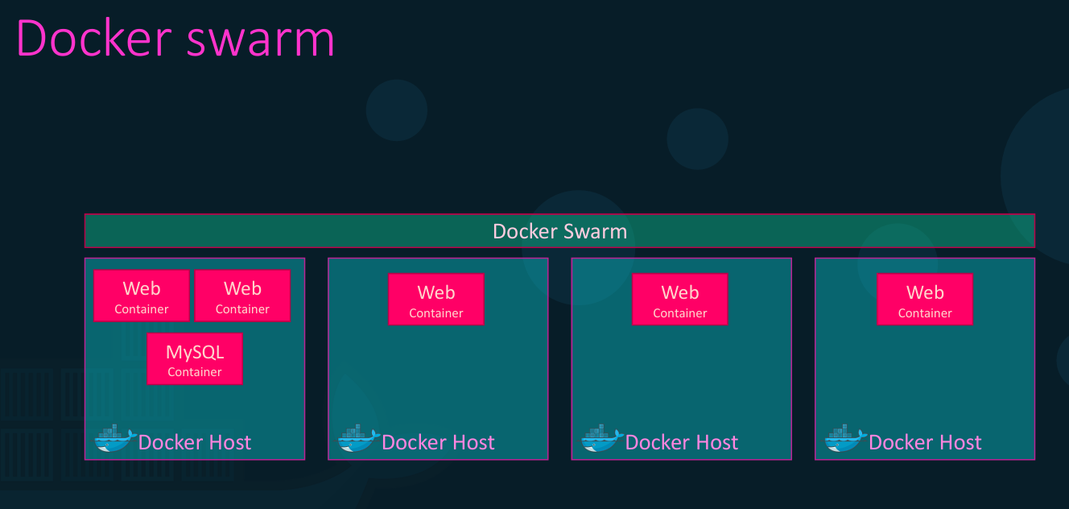  
  
To set up a Docker Swarm, one or more hosts must have Docker installed. One host is designated as the manager node (swarm manager), while the remaining hosts are designated as worker nodes. The swarm manager is responsible for managing the cluster and distributing tasks to the worker nodes. Once the roles are decided, the swarm can be initialized.

To initialize the docker swarm cluster we use the command called**"docker swarm init".**For converting the docker engine to the swarm manager we will use this command after converting into the swarm mode then you will able the manager and the worker nodes then the swarm will distribute the work across them. (Run the **docker swarm init** command on the swarm manager and that will initialize the swarm manager. The output will also provide the command to be run on the workers to copy the command and run it on the worker nodes to join the manager. After joining the swarm the workers are also referred to as **nodes** and you're now ready to create services and deploy them on the swarm cluster.)

**After initializing the Swarm Mode**

* After initializing the **docker swarm init** it will bring the swarm into existence.
* After bringing the swarm into existence know it will turn the current node into a manager node. And also it will generate one token.
* The token that is generated will be used for the further joining of the worker nodes and master nodes.

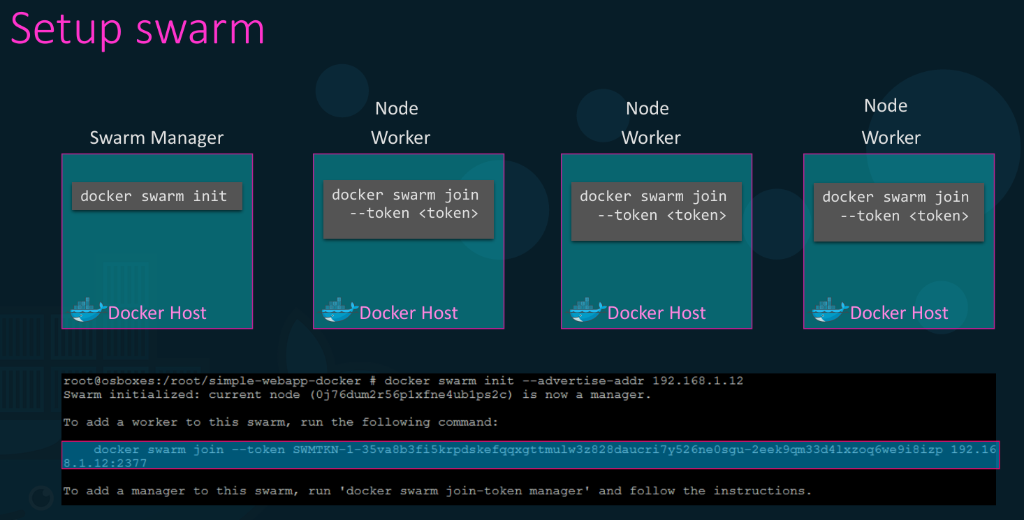

**Tasks and Services in Docker Swarm**

In Docker Swarm, a **Service** is a higher-level abstraction used to define how containers should be deployed, managed, and scaled across a swarm of Docker nodes. It includes specifications like the number of replicas, networking, and load balancing.

A **Task** is an individual instance of a container that is created and managed by a service. Each task represents a single unit of work and is scheduled to run on one of the nodes in the swarm. Tasks are the actual running containers that fulfill the requirements specified by the service.  
  
**For example**: I want to utilize my cluster to run multiple instances of my web server. Now one way to do this would be to run the docker run command on each worker node. But that's not ideal as I might have to log into each node and run this command and there could be hundreds of nodes. I will have to set up load balancing myself allowed to monitor the state of each instance myself and if instances where to fail I'll have to restart them myself. So, it's going to be an impossible task and that is where Docker swarm orchestration concern. Docker swarm orchestrator does all of this for us.

The key component of swarm orchestration is the docker service. Docker services are one or more instances of a single application or service that runs across the nodes in the swarm cluster. For example, in this case, I could create a Docker service to run multiple instances off my web server application across worker nodes in my swarm cluster. For this I run the **docker service create** command on the manager node and specify my image name there which is my web server in this case and use the option replicas to specify the number of instances of my web server I would like to run across the cluster. If three replicas are specified, Docker Swarm automatically schedules and distributes three instances of the web server across the available worker nodes in the cluster. It is important to note that Docker service commands must be run on the manager node and not on worker nodes. The **docker service create** command is similar to the **docker run** command in terms of available options. It supports options such as -e for environment variables, -p for publishing ports, and network options for attaching containers to a specific network.

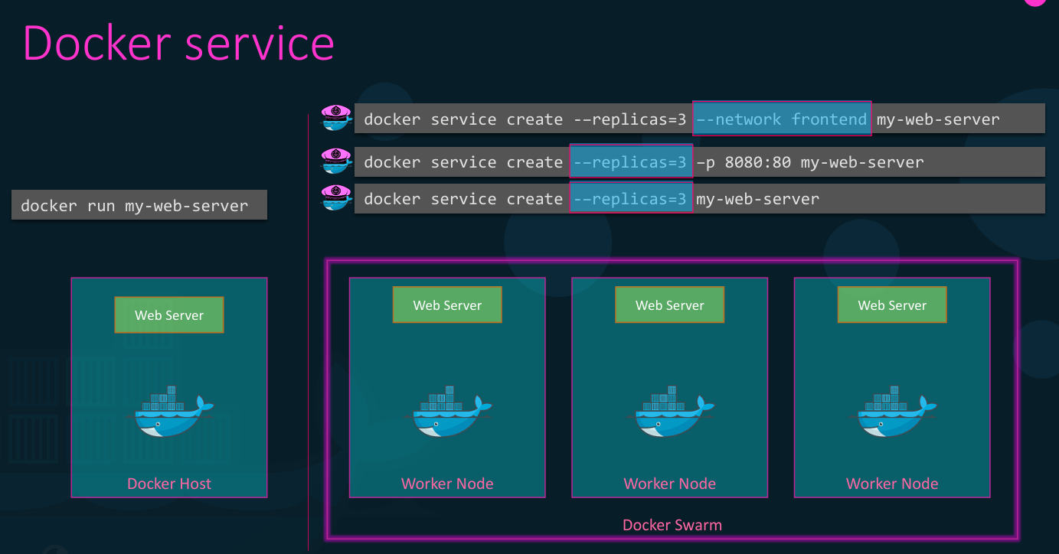

**Working of Docker Swarm**

When you want to deploy a container in the swarm first, you have to launch services. Service consists of multiple containers of the same image. These services are deployed inside a node so to deploy a swarm at least one node has to be deployed. As you see below diagram the manager node is responsible for the allocation of the task, dispatch the tasks, and schedule the tasks. API in the manager is the medium between the manager node and the worker node to communicate with each other by using the HTTP protocol. The service of one cluster can be used by the other. All the execution of the task is performed by the worker node.

**Docker Swarm Architecture**

There are two types of nodes in Docker Swarm:

1. **Manager node:** Carries out and oversees cluster-level duties.
2. **Worker node:**Receives and completes the tasks set by the manager node.

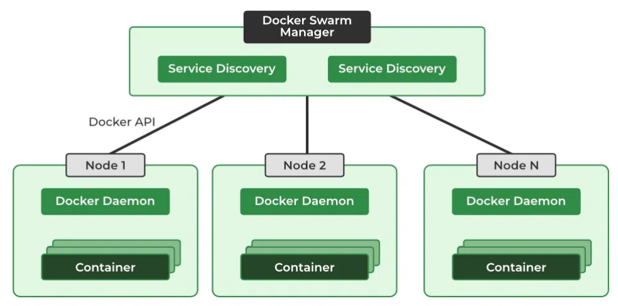

A single manager node can be created but the worker node cannot be created without a manager node. The ideal number for the count of the manager node is seven. Increasing the number of the manager node does not mean that the [scalability will increase](https://www.geeksforgeeks.org/software-engineering/overview-of-scaling-vertical-and-horizontal-scaling/).

**Features of Docker Swarm**

The following are the features of Docker Swarm:

* **Cluster management:** To create Swarm you can use the [Docker engine CLI](https://www.geeksforgeeks.org/techtips/tips-to-manage-docker-containers-using-cli/) where you can deploy the applications. Additional orchestration software is not required to manage a swarm.
* **Multi-host networking:**Swarm can contain multiple overlay networks so while deploying the service you can specify the network on which you want to deploy your service. The swarm manager automatically assigns addresses to the containers on the overlay network when it initializes or updates the application.
* **Load balancing:** While deploying any service on a particular port the swarm automatically balances the load of these ports.
* **Scaling:** When you scale up or down, the swarm manager automatically adapts by adding or removing tasks to maintain the desired state.

**Why can’t I connect to my web application running in a container?**

By default, containers are secure and isolated from outside network traffic – they do not expose any of its ports by default. Therefore if you want to be able to handle traffic coming from outside the container, you need to expose the port your container is listening on. For web applications this is typically port 80 or 443.

To expose a port when running a container, you can pass the –publish or -p flag.

For example:

$ docker run -p 80:80 nginx

This will run an Nginx container and publish port 80 to the outside world.

You can read all about Docker Networking in our documentation.

**How do I run multiple applications in one container?**

This is a very common question that I get from folks that are coming from a Virtual Machine background. The reason being is that when working with VMs, we can think of our application as owning the whole operating system and therefore can create multiple processes or runtimes.

When working with containers, it is best practice to map one process to one container for various architectural reasons that we do not have the space to discuss here. But the biggest reason to run one process inside a container is in respect to the tried and true KISS principle. Keep It Simple Simon.

When your containers have one process, they can focus on doing one thing and one thing only. This allows you to scale up and down relatively easily.

Stay tuned to this blog and my twitter handle (@pmckee) for more content on how to design and build applications with containers and microservices.

**How do I persist data when running a container?**

Containers are immutable and you should not write data into your container that you would like to be persisted after that container stops running. You want to think about containers as unchangeable processes that could stop running at any moment and be replaced by another very easily.

So, with that said, how do we write data and have a container use it at runtime or write data at runtime that can be persisted. This is where volumes come into play.

Volumes are the preferred mechanism to write and read persistent data. Volumes are managed by Docker and can be moved, copied and managed outside of containers.

For local development, I prefer to use bind mounts to access source code outside of my development container.

For an excellent overview of storage and specifics around volumes and bind mounts, please checkout our documentation on Storage.